Evolutionary Robotics:
A new scientific tool for studying cognition

Inman Harvey^{1*}, Ezequiel Di Paolo¹, Elio Tuci ^{1,2},
Rachel Wood¹ and Matt Quinn¹

(1) Centre for Computational Neuroscience and Robotics (CCNR)
Evolutionary and Adaptive Systems Group (EASy)
COGS/Informatics
University of Sussex
Brighton BN1 9QH, UK
Phone: +44 1273 678431
Fax: +44 1273 671320

and (2) IRIDIA
Universite Libré de Bruxelles
Avenue Franklin Roosevelt 50
CP 194/6
B-1050 Brussels - Belgium
Phone: + 32 2 - 6502730
Fax: + 32 2 - 6502715
emails: inmanh@susx.ac.uk, ezequiel@susx.ac.uk, etuci@ulb.ac.be, rachelwo@susx.ac.uk, matthewq@susx.ac.uk

* Corresponding author.

Keywords: Evolutionary Robotics, Cognition, Dynamical Systems, Homeostasis, Learning, Development

Abstract:

We survey developments in Artificial Neural Networks, in Behaviour-based Robotics and Evolutionary Algorithms that set the stage for Evolutionary Robotics in the 1990s. We examine the motivations for using ER as a scientific tool for studying minimal models of cognition, with the advantage of being capable of generating integrated sensorimotor systems with minimal (or controllable) prejudices. These systems must act as a whole in close coupling with their environments which is an essential aspect of real cognition that is often either bypassed or modelled poorly in other disciplines. We demonstrate with three example studies: homeostasis under visual inversion; the origins of learning; and the ontogenetic acquisition of entrainment.

The recent history of Evolutionary Robotics

Evolutionary Robotics (ER) is a term that has gained currency since the early 1990s for the study and application of an artificial analogue of natural Darwinian evolution to the design of robots or simulated agents; usually to the design of their control systems or ‘artificial brains’, but sometimes also to their bodily and sensorimotor design[1, 2]. This was not a new idea – nearly 50 years earlier Alan Turing talked of designing brain-like networks through “genetical search” [3] – but a combination of factors perhaps made the conditions friendly to the re-emergence of such an approach.

After decades of dominance by the computational paradigm of Good Old Fashioned Artificial Intelligence (GOFAI), in the 1980s there was a resurgence of interest in Artificial Neural Networks (ANNs), Admittedly, as the phrase “Parallel Distributed Processing” indicates [4], this was thought of by most of its proponents as some new form of “biologically plausible” computational processing, and for the most part went along with similar Cartesian assumptions to GOFAI. But this did at least open some people’s eyes to the possibility that brains, both real and artificial, were possibly not doing anything like computation at all – computation in the sense that Turing defined. At the same time in the 1980s the development of personal computing power made it possible for many more people to be ambitious in their simulations and experimentation.

Turning from simulated brains to real robots, also in the 1980s Brooks developed a behaviour-based approach to robotics using subsumption architecture [5]. He designed minimal “insect-like” robots in an incremental fashion explicitly modelled on the process of natural evolution. A simple robot was constructed with sensors, motors and just about the smallest conceivable amount of “artificial nervous system” so as to perform in real time the simplest possible of behaviours; for instance, forward movement avoiding obstacles. Only after this simplest level of behaviour was tested and debugged on the real robot was the next stage attempted: adding a next simple layer of behaviour that interacted with the environment and the pre-existing behaviour so as to slightly extend the robot’s repertoire. Although successive levels of behaviour, and their associated extra components of “nervous system”, were designed by hand, the emphasis was on testing, debugging and modifying on the real robot. Through this process, mimicking the phylogeny of real creatures, the designs after several layers had been added bore little resemblance to any top-down designs produced on GOFAI principles.

Again in the 1980s the field of evolutionary algorithms started to receive wider attention. After perhaps 20 years of being hardly noticed, Holland’s Genetic Algorithms [37] merited a first international conference in 1985 [6]. As the field came into wider prominence, other flavours such as Evolution Strategies, and Evolutionary Programming also became recognised. As with ANNs, this came to be seen by many as an alternative form of computation, and indeed the field as a whole has come to be called Evolutionary Computation. But it is worth noting that Holland’s 1975 book was entitled “Adaptation in Natural and Artificial Systems”, and was to a large extent aimed at generating adaptive cognitive systems; albeit in silico rather than in real robots [7].

Coming from a particular philosophical perspective in the 1980s, influenced by people such as Rosen and Pattee, Cariani wrote an unpublished paper in 1987 entitled “Why Artificial Life Needs Evolutionary Robotics” in the context of the first Artificial Life workshop. This may be the earliest use of the phrase “Evolutionary Robotics”; the philosophical issues raised were presented in his 1989 doctoral thesis [8] and in later papers such as at the first European Conference on Artificial Life [9].

Motivation for doing ER

So by 1990 the stage was prepared for a number of people and research groups to investigate in the field of using artificial evolution to design “nervous systems” for real robots or simulated agents. There is a range of different motives for such work, both within and between different research groups. In this paper we shall focus primarily on motivation for much ER work at Sussex, which started in 1989; but in particular we should mention three other groups who have worked with a broadly similar or at least overlapping motivation: Beer and colleagues at Case Western Reserve [10, 11]; Floreano, Nolfi and colleagues working at EPFL in Lausanne and at Institute of Cognitive Science and Technologies C.N.R., Rome [12]; Pfeifer and colleagues at Zurich [13].

This motivation is concerned with the understanding of cognition in its most basic sense, and sees ER as a useful testbed, a methodology for generating synthetic or artificial agents in a relatively prejudice-free fashion that can then be investigated and analysed. As such, ER clearly should be considered a core methodology for Artificial Life.

But there is plenty of scope for interpretation here, to make clearer what we might mean by “cognition”, and to what extent ER can be seen as “prejudice-free” – and indeed why that might be considered a desirable property when making models of cognitive systems.

So when we say ER is a new scientific tool, we are documenting a trend over the last 15 years with distinctive features: emphasis on minimal cognition, on existence proofs, on reduction of bias. These emphases had not existed to the same degree before, they may (now) also be shared by other methods, but we draw attention to this as a movement of significance.

Minimal Cognition

For a large number of cognitive scientists cognition means centrally human cognition, and in this they primarily mean what distinguishes humans from other species. In contrast, in the work discussed here the focus of attention is on the kinds of cognition that humans have in common with other species: the organisation of the behaviour of an organism, in interaction with its environment, so as to safeguard and promote its interests. In the context of Darwinian evolution, we currently understand that an organism’s primary interests include all that is necessary to maintain its identity and survival in a changing world that contains other organisms with sometimes competing interests; to eat, to avoid being eaten, to anticipate events and cooperate with others where this is necessary; and to leave offspring that will continue the lineage beyond the death of an individual.

This all-embracing view of cognition can be taken to the extreme in the slogan “Life = Cognition” [14]. But such a view needs defence from those cognitive scientists who see human capacities as the touchstone for what counts as cognition. To a large extent such an argument over the meaning of the word are purely definitional, but it then needs to be made very clear what definition is being used in the work covered here. In particular, those studying “minimal cognition” with ER sometimes need to defend their work from cognitive scientists who mistakenly assume that if a study of cognition is not exclusively concerned with humans, then it has no relevance at all to humans. From an evolutionary perspective, our own species with its peculiarly human characteristics has only been around for the last few tens of thousands of years of life’s 4 billion year history, and our human capacities are built on top of those of our pre-human ancestors. It makes sense to try and study and understand the relatively simple first, and this is the motive for using ER to study models of “minimal cognition”. In the examples discussed below, these will be minimal models of homeostasis under sensory distortion, of the origins of learning, and of interactions between evolution and development, but in each case the models are deliberately simplified so as to be potentially relevant to all potential life-forms, whether real or artificial.

Cognition, consequently, can be broadly defined as the capability of an agent of interacting with its environment so as to maintain some viability constraint. It is not an internal property of the agent, but a relational property that involves both the agent, its environment and the maintenance of some constraint. Living organisms are naturally cognitive according to this definition as they need to engage in interaction with their environment so as to stay alive - but the term can also be applied to some artificial non-living systems, as long as we can clearly treat them as agents and their viability constraints are well specified (and these could be as artificial as maintaining certain relations with the environment, self-preservation, or the fulfilment of a pre-specified goal).

Minimal prior assumptions: Dynamical Systems

It also makes sense to try and minimise the prior assumptions that are built into a model. If one hopes to learn something new and perhaps unexpected about some aspect of cognition, then every assumption and prejudice built into the model as a constraint reduces its potential to inform. Of course it is not possible to start in a vacuum, but one should attempt to make ones prior assumptions both explicit and as few as possible. For the work reported here, the basic assumptions are:

- An agent (… human, animal, robot …), and the world it lives in, is made of physical materials obeying the laws of physics, chemistry etc.
- Through the subtleties of assembly and design of these physical materials, it exhibits robust adaptive behaviours, such as goal-seeking and other intentional behaviour.

Though these are materialist assumptions, it is does not follow that the terms mind and brain can be used interchangeably. Much confusion is avoided if mental terms such as mind, intentions, goals, learning, are reserved for descriptions of an agent as an agent, the behavioural level of description; whilst the brain or nervous system and body is described in terms of physical components, the physical or mechanistic level of description.

These basic assumptions or hypotheses underlie what is sometimes called the Dynamical Systems (DS) approach to cognition [11, 15, 16]. As used here, it means no more than the pragmatic assumption that where we build artificial nervous systems, for real or in simulations, the mechanisms can be considered as composed of a finite number of interacting components, the state of each of which can in principle be specified by some real number at any instant of time. The current state of the mechanism as a whole can be specified by the instantaneous values of all these variables; mathematically speaking, a vector.

It should be emphasised that the DS notion of state here refers to the instantaneous state of the whole physical mechanism, specified in physical terms. This should not be confused with the very different use of the term state in mental or behavioural descriptions, such as “in a state of hunger”, “in a goal-seeking state”, and so on.

The variables refer to the current physical state of a component, and applying Occam’s Law we try and get away with as few components as possible. It is our decision as to which physical parts we shall classify as components, and typically we will do so at a fairly macroscopic level, rather than at the level of atoms or electrons. Neuronal activations, real or artificial, the position of a relay, the output of a photoreceptor or the voltage applied to a motor could be appropriate components, depending on the context.

Our decision as to what counts as a component is not arbitrary, however, since as far as possible we choose macroscopic components whose interactions can be reliably described by laws based ultimately on the laws of physics. When we can do this really reliably, then typically we can specify some function f() for each of the n state variables x_{i} (i = 1 to n) in this form:

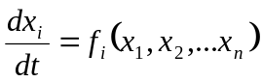

The function may be deterministic, but pragmatically it may also include a term for noise. A fine-grained description of a system with many components whose interactions are described by deterministic laws may under some circumstances be usefully described at a coarser level, with fewer components whose interactions are only approximately described by deterministic laws, and here the addition of a noise term to the equations can account for these approximations.

=================== Figure 1 around here ====================

An agent, as caricatured in Figure 1, can be thought of as a bag of physical components describable in such a way, a dynamical system. But we must consider not just internal interactions, but also interactions with the agent’s environment, an environment that is also made up of further dynamical systems. These external interactions can be thought of as a coupling of the agent-DS with the environment-DS through sensory and motor interactions.

Since a DS is basically no more than a list of variables together with the differential equations describing how they interact over time, the combination of two DSs into a single system, taking account of the coupling interactions, is in fact a new combined DS. One of the important lessons learnt through practical experience with DSs is that a combined DS often behaves in a fashion that is counter-intuitive, even when one is familiar with the behaviour on one of the sub-DSs in isolation. Multiple feedback loops and circular causation often lead to surprises.

The Dynamical Systems Approach to Cognition

For some advocates of the DS approach to understanding cognition, this implies a commitment to explaining cognitive phenomena in the mathematical language of DSs: for instance attractors, both stable and unstable, basins of attractions, trajectories through phase space. Whilst not ruling out such explanations, the commitment can be much weaker. In the examples given below, the commitment is little more than that of describing, explaining, and implementing in simulation the physical mechanisms of an agent in terms of the equations of a DS, including noise where appropriate. This is one way of respecting the principle of minimising the prior assumptions that are used.

A computational system is defined in classical computer science as something functionally equivalent to a Universal Turing Machine (UTM), and belongs to a specialised subclass of DSs. It is deterministic, the state at any time can be uniquely specified by the values, typically binary, of all its component parts: in the case of a UTM, the values of the cells on its tape, the position of the reading head, and the current rule to be applied from the rule table. Unusually for a DS, the updates are done discretely in sequence, with no direct reference to any time interval. In the practical implementations of TMs that are desktop computers, the updates are timed sequentially by a clocking chip, but this speed is basically an artefact of the implementation rather than part of the definition of the computational system.

So a distinguishing feature that usually highlights the distinction between a DS approach to cognition and a GOFAI approach is that in the former case time, real wall-clock time, is introduced explicitly in the differential equations, whereas in the latter case it is often ignored or left as an accidental artefact of the implementation. More generally, computational systems are indeed a subset of DSs but a rather specialised and bizarre subset. The DS approach as advocated here is much wider and embraces more possibilities, imposes fewer constraints, than the computational GOFAI approach.

There are many practical implementations of DSs that may be used in ER. One method advocated by Beer, that has been used, sometimes with variations, at Sussex, is that of Continuous Time Recurrent Neural Networks (CTRNNs) [17]. These consist of a network of n fully connected nodes or artificial neurons, with time parameters τ_{i} at node i, and with weighted connections w_{ij} between node i and node j. For each node the relevant differential equation for its activation y_{i} is:

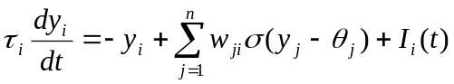

where σ() is a sigmoid function 1/(1+e^{-x}), θ_{j} is a bias term, and I_{i}(t) refers to a possible sensory input to that node. The firing rate of a node z_{i} is calculated as σ(y_{i} - θ_{i}). Some nodes are designated as motor nodes, and their activations, varying in real time, are passed on to the relevant motors.

This formalism provides a relatively convenient class of dynamical system, which can be parameterised by specifying the number of nodes, and the specific values for time parameters, weights and biases; it is these values that the genotypes will encode. This class of DS also has the advantage of being universal, in the sense that it has been formally proved that any DS can be approximated to any desired degree of accuracy by a CTRNN with a sufficient number of nodes [18].

It is perhaps unfortunate that CTRNNs are described as (artificial) neural networks, because there is no particular reason to identify the nodes with anything analogous to neurons in real brains.

Generation of Existence Proofs

When an ER experiments replicates some cognitive capacity of a human or animal, typically in simplistic and minimal form, what conclusions can be drawn from this? The environment of the artificial agent will have been grossly simplified, and the synthetic nervous system will bear only the sketchiest caricature of a resemblance to the nervous system of any real organism. So it would be foolish and unjustified to claim that this gives us some direct insight into the actual physical mechanisms of real biological organisms.

Nevertheless a successful experiment has taught us something, which basically takes the form of an Existence Proof. We will have demonstrated cognitive capacity or phenomenon X under clearly specified conditions and constraints, hence showing that these provide sufficient conditions for X. Since the underlying philosophy of ER is typically to find minimal conditions for phenomenon X, then often the target of the experiment may be some alternative theory to the effect that phenomenon X necessarily requires condition Y. An ER experiment may enable us to refute this, by demonstrating an existence proof of phenomenon X without Y.

For this reason, it is not necessary (though certainly possible) to aim at modelling specific animal behaviour so as to validate the model with empirical data. This approach can be successfully implemented using ER or autonomous robotics in general (see for instance [34]), but the production of proofs of concept has a different scientific function: that of catalysing theoretical re-conceptualizations and facilitating the production of novel hypotheses which then need to be appropriately translated to domain-specific cases and tested empirically (for further discussion see [35]).

ER thus can allow the exploration of the minimal conditions for a given behavioural capability. But it would be unwarranted to suggest that minimal here will necessarily imply general. This is again an empirical matter and in each case the ultimate test will be in the validity of the conceptual re-organization provoked by the minimal model. Such validity may be general or specific as the case may be.

The Evolutionary Algorithm

The DS approach covers the first part of our principles of minimal prior assumptions, but does not yet explain how we plan to design the DS of the agent nervous system and body, such that when coupled with its environment the agent demonstrates the desired adaptive behaviour. One possibility would be to design by hand, and indeed this is the approach of Brooks’ subsumption architecture. But there are two reasons to justify using artificial evolution as a design methodology.

Firstly, design of DSs is often counter-intuitive. The desired behaviour of the agent is that exhibited when coupled through sensorimotor interactions with its environment, and as discussed above this is notoriously difficult to predict and design for. Natural living systems are, so we assume, DSs designed through natural Darwinian evolution, so it makes sense to consider the artificial equivalent to this design process.

Secondly, and equally importantly, the use of artificial evolution minimises the incorporation of design prejudices and constraints, as the subtleties and tweaking of architectural detail is left to the blind forces of evolution, guided only by the selection constraints imposed by the experimenter on the behaviour, not on the mechanism.

It is the task of the experimenter to set up conditions whereby a population of agent-designs is bred, over successive generations, according to the experimenter’s desired selective conditions; much as a farmer might breed cows for good milk production and an equitable temperament. So some evaluation or fitness function must be devised, appropriate for the behaviours desired for the purposes of the experiment. Each agent-design in a population must be scored, or at least ranked in comparison with the others, so that the fitter ones can be selected for breeding from.

For a population to evolve there are just three requirements: Heredity, Variation, and Selection. The farmer really only has to worry about the last of these, since heredity and variation are provided ready-made in the biological world. In ER, however, the experimenter is required to set up suitable conditions for heredity and variation. This is done by deciding on an appropriate genetic encoding, whereby strings of symbols representing artificial DNA will be interpreted as potential designs for the agent.

The main target for evolution will be the artificial brain or nervous system of the agent, and one way of visualising the design process is in terms of a shelf-full of available components that have to be assembled somehow. The genetic encoding must allow the interpretation of the genotype (or artificial DNA) as giving instructions for which components are selected and just how they are connected to each other. If for example the genotypes are binary strings of length 100, then this means that potentially 2¹⁰⁰ different genotypes can encode for 2¹⁰⁰ different nervous system architectures. For some experiments the genotype may also determine body parameters or sensor characteristics, as well as the nervous system.

=================== Figure 2 around here ====================

ER can then be seen as some form of search through such an enormous search space. A population, which may be only 30 or 100, would only be a tiny sample of this search space, but successive generations of directed selection plus blind variation, as indicated in Figure 2, gives an effective evolutionary process. An initial population of randomly constructed genotypes is evaluated, and the fitter members are chosen to become parents of the next generation. Genotypes for the offspring are inherited from their parents, either by direct copying in the case of asexual reproduction, or when sexual reproduction is used then part is inherited from each parent. This mixing in sexual reproduction already introduces some variation, but random mutations applied to the offspring genotype at an appropriate rate introduce further variation.

The consequence of this is that a new generation of offspring is created, that inherit with some variation from the selected, fitter members of the parent generation. Since we have the three essentials of Heredity, Variation and Selection, we have the basis for an evolutionary process. When properly set up, this results in increasing fitness at the selected task as successive generations follow each other. Often thousands of generations may be needed, and this can be a lengthy process.

Only the bare essentials of artificial evolution have been sketched out here. There are many possible variations and subtleties, but the core methodology is always based on this.

Simulations and Reality

When the ultimate goal is to build real robots and demonstrate results on them, then ER can be practised without any form of simulation. Since evaluations must be carried out on many robots for many generations, this can be expensive and time-consuming, so frequently simulations have been used as an intermediary step. Making simulations, of both the robot and its dynamic environment, can also be time-consuming and difficult if high standards of accuracy are required. The only ultimate test for the adequacy of such simulations is whether the evolved control systems actually work on the real robot, and historically there have been many problems in achieving this. In particular, robot control systems built on GOFAI principles have often completely underestimated the issues involved in turning abstract ideas into physical reality.

Fortunately it turns out that when doing ER one can often get away with minimal simulations, and still produce results that work on a real robot. At Sussex Jakobi took ideas about adding appropriate types of noise to a simulation and developed a principled approach of minimal simulation [1, 19, 20]. This allows for simplified simulations that ignore all the irrelevant details of the real world, can run extremely fast, yet have a track record of producing ER control systems that transfer directly to the real robot.

Many ER experiments, including examples below, are done in simulation only. Such experiments are potentially open to the charge laid against many GOFAI simulations, that it may be that the simplifications involved have omitted some of the really difficult and important issues to do with physical embodiment. The type of simplifications where this is seen in GOFAI examples include grid-worlds where robot-agents move in simple jumps from one square to the next; and magic sensors that indicate infallibly the presence, or direction and distance, of some object or target. These are symptoms of glossing over the distinction between the mechanical/physical level of description (appropriate to values of sensor-variables) and the behavioural level of description (appropriate to recognition of objects by the agent).

Such distinctions are kept very distinct in the ER/DS approach as outlined above, and this together with the track-record of successful transfers gives us some degree of confidence in the results obtained through simulations. Although they may be idealised existence proofs, we are confident that in principle with some extra work the results will be capable of validation on real robots.

Examples

As examples of the breadth of possible fields to investigate using the ER methodology, we give brief details of three areas where these techniques have been used at Sussex.
- Homeostasis under sensory distortion (Ezequiel Di Paolo)
- The origins of learning (Elio Tuci with Matt Quinn)
- Interactions between evolution and development (Rachel Wood)

Homeostasis

In order for an organism to survive, its essential variables – such as temperature, oxygenation in the bloodstream, energy reserves – must be kept within viable limits. Otherwise the organism faces the possibility of disintegration and/or loss of identity – meaning dissolution or death. The renowned early cybernetician W. Ross Ashby [21] developed a theory to explain how an organism could be capable of adapting appropriately and adaptively so as to maintain this homeostasis. Inbuilt reactions, such as instinctive withdrawal of a limb from a dangerous heat source, may be fairly easy to account for, but animals are typically much more adaptive than this.

Even when faced with unforeseen circumstances, where the consequences of actions may not be familiar to the animal, nevertheless the appropriate action may be taken after some experimentation. An adaptive system is a stable system, the region of stability being that part of the state space where all essential variables are within physiological limits. Depending on ones point of view, a stable system may be regarded as blindly obeying its nature and also as showing great skill in returning to equilibrium in spite of disturbances.

A classic and extreme example in humans is their ability to adapt to inversion of the visual field. When experimental subjects wear distorting goggles that may, for example, reverse left/right or reverse top/bottom in the visual field, then after days and weeks of continual use they begin to adapt to these unusual circumstances [22, 23]. Gradual behavioural and perceptual adaptation takes place. Initially the disorientation leaves the subjects confused and unable to move around without crashing into objects or falling over, but slowly their performance improves. Eventually not just their behaviour, but their reported perceptions become more normal. Whereas initially the world may be seen as upside-down, eventually they report that the world has become normal, the “right-way-up” again.

Ross Ashby put forward a possible explanation for such phenomena in terms of “Ultrastability”, a form of double feedback between environment and organism; he was using the language and concepts of a DS approach to cognition. Normal sensorimotor coupling with the environment, such as walking down the road with normal vision, requires one feedback loop so as to adjust ones path and maintain progress. When there is the drastic disruption in this feedback through wearing inverting goggles, there must be a second feedback loop that triggers changes in the internal organisation of the brain, until eventually, perhaps with some luck as well as effort, a freshly organised stable primary feedback loop is put in place. Drawing on these ideas, together with extensions to the theory by James Garden Taylor[23], Di Paolo set out to replicate a simplified version of these phenomena using ER [24].

=================== Figure 3 around here ====================

The agent was modelled as a circular object on an infinite two-dimensional plane, on which a single light source popped up at a random position relative to the agent. Visual sensors were just 2 photoreceptors facing forward to the left and right; a left and right motor provided power to the wheels on either side, allowing motion and turning. The primary task for the agent was to perform phototaxis, to move towards the light as quickly as possible. On reaching the light it would disappear, to reappear in another random position, requiring the agent to track it down again.

To evolve a CTRNN so as to generate such phototactic behaviour in an agent is relatively easy. However the purpose of this experiment was to go further and evolve some form of homeostasis. So the CTRNN was adapted to allow local plasticity of each node, a (genetically-specified) weight-changing mechanism that modified incoming weights and cut in whenever the node’s activation was too high or too low. Similar mechanisms of regulatory synaptic scaling have been found in real cortical neurons [25].

The internal activity of all the nodes was then treated as a proxy for the essential variables that homeostasis had to maintain within bounds, neither too high nor too low. In order to achieve this, the fitness function used for selection within the genetic algorithm had to be modified so as to simultaneously select both for phototaxis and for homeostasis of these essential variables. This was done by including a term in the fitness calculation that corresponded to the time-average of the proportion of nodes that had stayed within their preferred range without inducing the local plasticity triggered by going out of range.

Fitness is calculated by adding three terms. F_{D} corresponds to the proportion of reduction between the final and initial distance to a source, 1 - D_{F}/D_{I}, (D_{F}: final distance to source, D_{I}: initial distance to source). This term is taken as 0 if D_{F} > D_{I}, and it is calculated for each source and then averaged for the whole evaluation. F_{P} indicates the proportion of time (over the whole evaluation) that the agent spends within a distance of 4 body radii of a source, and F_{H} indicates the time-average of the proportion of neurons that have behaved homeostatically (that is, without inducing plasticity). These factors (all between 0 and 1) can be differently weighted. Typical weights for F_{H} are between 0.15 and 0.2. Of the other two components, permanence near the source is favoured with typical weights between 0.64 and 0.68.

=================== Figure 4 around here ====================

After between 1000 and 2000 generations, high fitness was usually achieved. High performance agents were then subjected to further tests without further evolution. Firstly they were exposed to an extended trial where between 100 and 400 presentations of the light source were made, as compared to the 5 successive presentations used during the evolutionary stage. Those agents that demonstrated long term stability were then subjected to the equivalent of inverting goggles: the connections were swapped between left and right photoreceptors. This is done after a short initial period of normal phototaxis at the beginning of the trial, and unsurprisingly the immediate effect is that the agent veers away from the light rather than towards it. But for around half the individuals tested, after a long period of successive presentations with the inverted vision, the behaviour switches to become perfect phototaxis again; the agents have adapted to the new sensorimotor regime.

=================== Figure 5 around here ====================

Interestingly, the time to adaptation is an increasing function of the time of normal “development” before inversion, as demonstrated in Figure 5. This indicates that the capacity for plastic change is “hardened”, and there is a critical period for adaptation in these agents thus reproducing known features of animal development and adaptation. Ashby’s theory could well explain this phenomenon. If the space of changing parameters (connection weights in this case) is populated with “pockets of stability” within which the system is stable for a range of conditions, and if different pockets have different ranges for those conditions of stability, then those pockets with the larger ranges will tend to be selected for over time. The overall effect is that if a system is left to develop under constant conditions (levels of noise, randomness in source positioning, etc.) it will progressively find parameter sets with larger ranges of stability, thus making it harder to “jump out of them” when a novel condition (e.g., sensor inversion) is met. Even at this abstract level, the model permits the exploration of a general hypothesis for critical developmental periods in real animals.

It is clear that this minimal model does not fully explain how radical adaptation occurs in human subjects, but it provides a working proof of concept that support the idea of ultrastability playing a potentially central role in the real case. Further work along these lines is currently addressing several open issues in this model such as the role of internal variability in the rules of reconfiguration, the kind of relation between behaviour and internal homeostasis (whether it's arbitrary or not), the amount of time it takes for adaptation to occur, and the lack of guarantee that adaptations will be accumulated. Solving these problems will probably mean evolving more complex kinds of ultrastable systems, but it is thanks to the simpler model that these research issues stand out.

The Origins of Learning

This example is work done by Elio Tuci with Matt Quinn, as part of an investigation into the evolution of learning from an ecological perspective [26, 27, 28]. Most studies of learning in artificial agents provide explicit learning mechanisms, often in the form of weight-changing rules at the synaptic connections in ANNs. However, if one is studying the origins of learning, then providing such mechanisms in advance seems to beg the question. Rather than providing the agents with the ability to learn, we wish to provide it with low level mechanical components that are not committed to any particular architecture, and examine the conditions under which the mechanisms that allow for learning may evolve.

The use of CTRNNs avoids the question-begging problem, as on the one hand they have no explicit learning mechanism: the genetically-specified weights are fixed and unvarying throughout an agent’s lifetime. But on the other hand, because of the universal approximation property of CTRNNs, they can, when suitably parameterised, approximate any DS including a DS capable of learning behaviour. Some ANN practitioners seem to find this possibility of an ANN with fixed weights being capable of learning behaviour rather troubling; it may assist them if they appreciate that the nodes of a CTRNN could represent any part of a DS, including the weights or some function of the weights of an ANN as well as its activations.

=================== Figure 6 around here ====================

Yamauchi and Beer [29, 30] designed a task for an agent to perform, that could require a combination of reactive (non-learning) and learning abilities. They used an ER approach to evolve CTRNNs as control systems, leaving it to the “discretion” of the evolutionary process to decide what combination was appropriate for the task. The environment was one-dimensional, a line where the agent started off each trial at the centre. Its goal was to reach an invisible target placed randomly at the start of each trial at the left or right end of the line, guided only by a light that it could sense. For some periods of time, covering a succession of trials, the light was placed on the same side as the target, whereas for other periods the light was placed on the opposite side. So to anthropomorphise the task: for an initial trial, the agent has no idea whether the light is associated or anti-associated with the target, and must choose a direction at random. But feedback from reaching the target can indicate which regime is current, and following trials can be guided by relying on the type of correlation that held on the previous occasion. This can result in reliable target-finding, until at some unannounced moment the light-target regime is changed to the opposite polarity, and there will be an inevitable mistake before the agent can adapt to the new regime.

Yamauchi and Beer succeeded in evolving CTRNNs to produce high-scoring behaviour at this task, but only after they were forced to divide the control system into three separate modules: one that was evolved first on its own, in effect to assess what the current regime was, marker-near-to-target or marker-far-from target: the second for guiding the agent under the light-correlated-with target regime: and a third for the anti-correlated regime. Despite the lack of success in evolving a fully integrated control system, once this modular approach was adopted success came fairly easily and quickly.

The aim of Tuci and Quinn’s experiments was to replicate a version of the Yamauchi and Beer version, but without explicitly dividing the control system into modules. This necessitated making some changes to the experimental setup, offering an opportunity to analyse why the earlier experiment had not worked, and to see just which changes made the difference.

=================== Figure 7 around here ====================

The main visible difference is that the one-dimensional world is replaced by a two-dimensional arena, with a simulated circular agent that can manoeuvre freely in any direction. The agent is a simulated Khepera, with infra-red sensors that can detect walls, three light sensors that are sensitive to the light (one each side at the front, and one facing back), and a further light-sensor directed downwards that is sensitive to the dark stripe on the floor that represents the target. Apart from this, the experimental regime follows very closely that of Yamauchi and Beer; except that the agent is started towards one side of the arena (randomly chosen), and it is only once it has reached the central portion that the target is placed randomly towards one end or the other of the arena; and simultaneously the light is switched on, placed according to whichever regime is current. The spatial relationship between the light and the target is selected randomly and kept fixed for 15 trials. The agent is evaluated in both types of environment: in an environment in which the light is associated and in an environment in which the light is anti-associated with the target.

The genotype specifies the parameters for a 13-node fully connected CTRNN. Unlike Yamauchi and Beer’s model, the agent has no dedicated sensor for a reinforcement signal, nor is there any explicitly provided reinforcement signal provided when it finds the target. The evaluation function has been designed to provide a selective pressure favouring those agents that perform well, but this evaluation is not available as any form of feedback to the agent; it is merely used, after the trials are completed, to assess its chance of becoming a parent to the next generation.

The first evaluation function sums a number of different scores: the evaluation is increased for motion towards the centre at the beginning of the trial; thereafter for movement towards the target after it and the light have appeared; an additional bonus is received for finding the target and staying over it; the evaluation function penalises such behaviours as colliding with the walls, failing to reach the centre at the beginning, and moving into the non-target end of the arena after reaching the centre.

It was hoped that the changes from the Yamauchi and Beer version would make possible the evolution of an integrated control circuit without resorting to the explicit modularisation that they used; the arena was more complex, the sensorimotor coupling was richer, the evaluation function was designed to allow partial scores for partial success rather than an all-or-nothing evaluation. Nevertheless the experiments using this first evaluation function failed, necessitating some analysis and consideration of what further changes were needed.

Observation showed that basically the agents evolved so as to ignore the light signal completely. For a non-learning agent, the light provides no useful information, since on any one trial the light is equally likely to be correlated or anti-correlated with the target. But unless the agent does pay attention to the light, it will be unable to evolve so as to learn from the relevant relationship between light and target positions. Once this was worked out, it was clearly seen to be necessary for the light to have some adaptive significance before any learning that relied on seeing the light was expected to take place.

Hence a second evaluation function was devised, that biased the value of successful trials by a factor of 3 on those occasions where the light was correlated with the target. In the majority of runs using this new method of scoring, the agents soon came to use the light to navigate towards the target, as an initial strategy of heading towards the light on average paid more dividends than a random strategy. Although this strategy means heading in the wrong direction on those 50% of occasions when the light is anti-correlated, nevertheless the evaluation regime allows them the possibility of returning from the wrong end and belatedly picking up a few extra points if they manage this. Furthermore, they are capable of “learning from their mistakes” and subsequently switching their behaviour to a strategy of moving away from the light.

=================== Figure 8 around here ====================

An analysis of the best of each generation over a run of 5000 generations clearly shows (Figure 8) how phototaxis develops in the early stages of this phylogeny, gaining high scores in the light-correlated regime but failing in the anti-correlated regime. Between 1250 and 3000 generations, performance and hence scores start to improve also in the anti-correlated regime, until an abrupt leap in performance indicates that the agents are now performing near-perfectly under both regimes.

So the final outcome of these experiments can be summarised as, firstly: a successful replication of a version of Yamauchi and Beer’s task, demonstrating learning behaviour using a CTRNN with fixed weights. Secondly, to do so without the explicit use of modularisation and provision of feedback that they were forced to use, hence providing a more principled study of one potential ‘Origin of Learning’ (an Existence Proof) in a system that was not pre-provided with explicit learning mechanisms. And thirdly, it gave an opportunity to gain some insight into the sorts of selective pressures and ecological contingencies that are required.

Minimal developmental systems and the ontogenetic acquisition of entrainment

ER has been successfully used to investigate both science and engineering type questions about adaptive behaviour. Evolutionary methods have thus enabled the discovery of new solutions to old adaptive control problems and the formulation of new answers to questions about how adaptive responding might be implemented in natural systems. One area which has been less explored is the application of evolutionary approaches to the design of developmental systems. This, slightly counterintuitive approach, involves using evolution to find parameters for on-line self-organisation and is founded on notions of exploiting the integral coupling between evolution and development in natural adaptive systems. In animals and infants, adaptation at the ontogenetic scale interlocks with evolutionary adaptation in a relationship of mutual constraint. Developmental processes are evolutionary artefacts: the systems which enable lifetime function acquisition were themselves constructed, over generations, through the action of natural selection. On this view, developmental processes are necessarily constrained to be evolvable - in the sense that individual plasticity inevitably entails costs which must be offset by a higher-level regularity in developmental outcome. In the same way, evolution exploits the adaptive design advantages of plasticity but is always constrained by what is developmentally possible.

On this view, using ER as a framework for studying developmental systems allows the coupling between evolutionary and ontogenetic adaptation to be explored and exploited. There are methodological advantages to be had from this approach by focusing on the applications for which ER methods have already proved to be most appropriate. Fundamentally, ER methods are useful for allowing efficient negotiation of complex problem spaces; evolved solutions are often sub-optimal but embody an “as-good-as-it-gets” compromise between constraints operating at many levels. ER uses highly abstract, simplified models to capture the essential dynamics of interaction between agents and their environments. This approach is thus especially suitable for experimenting with evolved ontogenies; it offers a possible route to untangling the behavioural effects of evolutionary and developmental interactions. In essence, these methods can enable the construction of models which are abstract enough to be achievable and simply enough to be analysed. More specifically, this “evo-devo” flavoured ER looks to minimise the design assumptions incorporated into the model while still instantiating embodied situated systems whose dynamics are determined by a plausible physics.

=================== Figure 9 around here ====================

The work presented in this section thus centres on evolving minimal developmental systems, i.e. modelling at the minimal level of complexity necessary to instantiate “interestingly” developmental processes. This approach seeks to unite Beer’s minimal cognition paradigm [10, 31] with developmental systems approaches to ontogenetic adaptation [32]. The model is an extension of Di Paolo’s simulation studies of coordination and entrainment in agents performing an acoustic approach task [33]. Here, the agents are controlled by plastic CTRNNs with evolved, broadly Hebbian learning rules obtained from genetically specifying the parameters in the following polynomial:

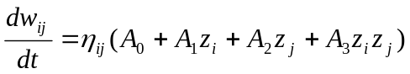

where z_{i} and z_{j} are the firing rates of the pre- and post-synaptic neurons respectively and all parameters can be positive or negative. The task requires that the agents should locate and remain in close proximity with each other via acoustic signals. It is nontrivial in that each must modulate its own sound production in order to hear the other and discrimination of the direction of a sound source is affected by self-motion. Thus efficient performance entails discrimination of self versus other and sustained behavioural control in order to act on perceived signals successfully.

=================== Figure 10 around here ====================

It was found that agents were able to acquire entrained signalling behaviour through lifetime interaction with a conspecific. Evolved solutions to the task environment consisted in the acquisition of a distributed strategy whereby each agent predicates its behaviour directly on that of its “life partner”. It might be expected that the task would be most easily solved by some initial allocation of roles, (i.e. a pursuer which doesn’t signal and a signaller which doesn’t move). However, in this case the task was solved via the acquisition of turn-taking in signalling behaviour whereby signals were emitted in almost perfect anti-phase (figure 9). Having come together the agents move in regular, spiralling paths within close proximity of each other (figure 10). In addition, by manipulating the interaction history of an individual we can manipulate the behavioural strategies it adopts. These experiments have generated a new set of questions about the role of noise in evolved developmental systems. We have found that varying the levels of noise in the system during development has a profound effect on the behavioural strategies produced.

Conclusions

What do these examples show? How can these findings be related to actual cognitive systems? Unlike modelling efforts in cognitive science where the objective is to build a system that can be directly compared with empirical data, ER has a different sort of use as a scientific tool. The homeostatic agent is not meant to be a good model of how humans adapt to visual inversion (crucial factors such as kinaesthetic and tactile modalities are ignored), the origin of learning study did not pretend to establish how learning happens in actual small nervous systems, and the minimal developmental systems example has factored out essential aspects of real development such as morphological changes induced by growth.

These systems then will not tell us how real cognitive systems work but they will do something very useful nonetheless. They provide us the proofs of concept and exploratory studies that can challenge existing views and unwritten assumptions in a healthy manner. Additionally, these existence proofs can provide further lessons since it is possible to manipulate and understand them in dynamical terms to some extent. The potential scientific role of such examples should not be underestimated.
They can help us re-organise our conception of a problem (e.g, origin of learning), bring added importance to factors previously considered of little relevance (e.g., neural homeostasis), and explore situations too complex even to start asking the right questions about using traditional tools, (e.g., minimal developmental systems).

ER as a scientific tool is therefore quite different from the typical idealized and disembodied modelling that is found in connectionism or computational neuroscience (let alone GOFAI). This is an advantage shared with other approaches in robotics, but the removal of design constraints in ER allows for a fruitful exploitation of embodiment - such as innovative forms of sensorimotor coordination - beyond what is typically achieved with other methods in robotics. ER has advantages over computational neuroscience, but it also has disadvantages. The main advantage is that the method is capable of generating integrated sensorimotor systems with minimal (or controllable) prejudices. These systems must act as a whole in close coupling with their environments which is an essential aspect of real cognition that is often either bypassed or modelled poorly in other disciplines. We must emphasize that ignoring embodiment and situatedness is not simply a valid modelling simplification, but it amounts to ignoring definitional aspects of cognition (a model of the solar system that ignores gravity is not a simplified model, but simply no model at all!) Computational neuroscience, for instance, will look at a sub-system (say vision) with an enormous richness of detail which is unbalanced by gross assumptions such as independence from motor systems, arbitrary external control signals, or artificial uncorrelated random inputs. ER cannot do this if the desired outcome is a whole agent that performs a behaviour autonomously (the acid test of all the work in this area).

Evolution can bridge the difficulty of designing an integrated and situated system, thus providing quite a different perspective from models where the sensorimotor loop is opened, but at the cost of simplifications and certain degree of opaqueness which is the inevitable consequence of passing a good part of the design job to an automated process. These costs are important. We cannot evolve systems with an internal complexity resembling that of animals, even insects. And even if we succeed in evolving an integrated and situated system, we cannot immediately know how it works or whether unwanted regularities have been taken advantage of by evolution, but must often resort to psychophysical experiments, lesion analysis and dynamical studies, [36].

Fortunately, being aware of these disadvantages does not prevent the exploitation of the benefits of ER - proofs of concept and exploratory studies require only minimal understanding of how a system works to have some impact, and the role of certain mechanisms can be studied using comparative approaches or building in further constraints in an evolutionary process that will prevent those mechanisms from working in the hypothesized way. It is, however, a crucial task for ER practitioners to be able to clarify in each case how the method is used so as to communicate effectively with other disciplines as experience shows that motivations for ER are often misunderstood.
1. Harvey I., Husbands P., Cliff D., Thompson A. and Jakobi, N. (1997). Evolutionary Robotics: the Sussex Approach. Robotics and Autonomous Systems, 20, 205-224.

2. Nolfi, S. and Floreano, D. (2000). Evolutionary Robotics: The Biology, Intelligence, and Technology of Self-Organizing Machines. Cambridge, MA: MIT Press/Bradford Books.

3. Turing A. M. (1992). Intelligent Machinery. In: Ince DC, editor. Collected works of A. M. Turing: Mechanical Intelligence. Elsevier Science Publishers. (Written in 1947).

4. Rumelhart, D.E., Hinton, G.E., and McClelland, J.L. (1986). A general framework for parallel distributed processing. In D. E. Rumelhart, J. L. McClelland, and the PDP Research Group (Eds.). Parallel distributed processing: Explorations in the microstructure of cognition. Vol. 1: Foundations. Cambridge, MA: MIT Press

5. Brooks, R. A. (1991). How to build complete creatures rather than isolated cognitive simulators, in K. VanLehn (ed.), Architectures for Intelligence, pp. 225-239, Lawrence Erlbaum Assosiates, Hillsdale, NJ.

6. Grefenstette J. J. (1985). Proceedings of the 1st International Conference on Genetic Algorithms, (Ed). Pittsburgh, PA, USA, July 1985. Lawrence Erlbaum Associates.

7. Holland J.H. (1975). Adaptation in Natural and Artificial Systems. The University of Michigan Press, Ann Arbor.

8. Cariani P. (1989). On the Design of Devices with Emergent Semantic Functions,
Ph.D Thesis, (State University of New York, Binghamton: 1989).

9. Cariani P. (1991). Some epistemological implications of devices which construct their own sensors and effectors. In: Varela F, Bourgine P eds. Towards a practice of autonomous systems. Cambridge, MA: MIT Press, 484-493.

10. Beer, R. D. (1996). Toward the evolution of dynamical neural networks for minimally cognitive behavior. In P. Maes, M. Mataric, J. Meyer, J. Pollack and S. Wilson (Eds.), From animals to animats 4: Proceedings of the Fourth International Conference on Simulation of Adaptive Behavior (pp. 421-429). MIT Press.

11. Beer, R. D. (2000). Dynamical approaches to cognitive science, Trends in Cognitive Sciences 4(3):91-99.

12. Nolfi S. and Floreano D. (2000). Evolutionary Robotics: The Biology, Intelligence, and Technology of Self-Organizing Machines. Cambridge, MA: MIT Press/Bradford Books.

13. Pfeifer R. and Scheier C. (1999). Understanding Intelligence. Cambridge, MA: MIT Press

[14] Stewart, J. (1992). Life = Cognition: The Epistemological and Ontological Significance of Artificial Life. In Francisco J. Varela and Paul Bourgine, eds. Toward a Practice of Autonomous Systems: Proceedings of the First European Conference on Artificial Life. MIT Press (A Bradford Book), 475-483.

15. Port, R and van Gelder, T. (1995). Mind as Motion: Explorations in the dynamics of cognition. Cambridge, MA: MIT Press/Bradford Books.

16. Thelen, E, and Smith, L.B. (1994). A dynamic systems approach to the development of cognition and action. Cambridge, MA: MIT Press/Bradford.Books
17. Beer, R.D. and Gallagher, J.C. (1992). Evolving dynamical neural networks for adaptive behavior. Adaptive Behavior 1(1):91-122.

18. Funahashi KI and Nakamura N. (1993). Approximation of dynamical systems by continuous time recurrent neural networks, Neural Networks, 6, 801-806.

19. Jakobi, N (1998). Minimal Simulations for Evolutionary Robotics. PhD thesis, COGS, University of Sussex 1998.

20. Jakobi, N. (1998). The minimal simulation approach to evolutionary robotics. In Gomi, T., editor, Evolutionary Robotics - From Intelligent Robots to Artificial Life (ER'98). AAI Books, Ontario, Canada.

21. Ashby, W. R. (1960). Design for a Brain: The Origin of Adaptive Behaviour. London, Chapman and Hall, Second Edition.

22. Kohler, I. (1964). The formation and transformation of the perceptual
world. Psychological Issues, 3, 1-173.

[23] Taylor, J.G. (1962). The Behavioral Basis of Perception. New Haven: Yale University Press.

[24] Di Paolo, E. A. (2000). Homeostatic adaptation to inversion in the visual field and other sensorimotor disruptions. In From Animals to Animats 6. Proceedings of the VI International Conference on Simulation of Adaptive Behavior, (J-A Meyer, A. Berthoz, D. Floreano, H.L. Roitblat, and S.W. Wilson eds.), Cambridge, MA: MIT Press, pp. 440-449.

25. Turrigiano, G. G. (1999). Homeostatic plasticity in neuronal networks:
The more things change, the more they stay the same. Trends Neurosci.,22, 221-227.

26. Tuci, M., Quinn, M. and Harvey, I. (2002). Evolving fixed-weight networks for learning robots. Proceedings Congress on Evolutionary Computation (CEC) 2002, Honolulu, Hawaii, May 12-17, 2002

27. Tuci, E., Harvey, I. and Quinn, M. (2002). Evolving integrated controllers for autonomous learning robots using dynamic neural networks. In Proceedings of The Seventh International Conference on the Simulation of Adaptive Behavior (SAB'02), 4-9 August 2002, Edinburgh, UK,

28. Tuci, E., Quinn, M. and Harvey, I. (2003). An evolutionary ecological approach to the study of learning behaviour using a robot based model, Adaptive Behavior 10:201-222.

29. Yamauchi, B. and Beer, R. (1994). Sequential Behavior and Learning in Evolved Dynamical Neural Networks, Adaptive Behavior, Vol. 2, 219-246

30. Yamauchi, B. and Beer, R. (1994). Integrating Reactive, Sequential, and Learning Behavior Using Dynamical Neural Networks. In D. Cliff, P. Husbands, J. Meyer and S. Wilson (Eds.), From Animals to Animats 3: Proceedings of The Third International Conference on the Simulation of Adaptive Behavior (SAB 94), Brighton, England, MIT Press, July 1994

31. Slocum, A.C., Downey, D.C. and Beer, R.D. (2000). Further experiments in the evolution of minimally cognitive behavior: From perceiving affordances to selective attention . In J. Meyer, A. Berthoz, D. Floreano, H. Roitblat and S. Wilson (Eds.), From Animals to Animats 6: Proceedings of the Sixth International Conference on Simulation of Adaptive Behavior (pp. 430-439). MIT Press.

32. Oyama, S. (1985). The Ontogeny of Information: Developmental Systems and Evolution. Cambridge University Press.

33. Di Paolo, E. A. (2000). Behavioral coordination, structural congruence and entrainment in a simulation of acoustically coupled agents .Adaptive Behavior 8, 25-46.

34. Webb, B. (2000). What does robotics offer animal behaviour? Animal Behaviour, 60, 545-558
35. Di Paolo, E. A., Noble, J. and Bullock, S. (2000). Simulation models as opaque thought experiments In M. A. Bedau, J. S. McCaskill, N. H. Packard, & S. Rasmussen (Eds.) Artificial Life VII: The Seventh International Conference on the Simulation and Synthesis of Living Systems, Reed College, Portland, Oregon, USA, 1-6 August (pp. 497-506). MIT Press/Bradford Books, Cambridge, MA.
36. Beer, R. D. (2003). The dynamics of active categorical perception in an evolved model agent. Adaptive Behavior 11(4):209-243.

37. Holland J. H. (1962). Outline for a logical theory of adaptive systems. Journal of the ACM 9, 297-314

LIST OF FIGURES:

Figure 1: A cartoon view of a Dynamical Systems approach to cognition. The “Brain and Body” of an agent (human, animal, robot) can be considered as a bag of physical components whose internal dynamics are governed by physical laws, a Dynamical System. The rest of its “World” can be considered as another DS. These two DSs are coupled through sensory and motor interactions. The challenge for ER, when designing artificial agents, is to get the dynamics of interaction “right”, so that the whole coupled DS generates appropriate behaviour in the agent.

Figure 2: The basics of a Genetic Algorithm. An oval indicates a population of genotypes, represented by the horizontal lines. One generation consists of a cycle anti-clockwise, through Evaluation (allocating fitness measures to each genotype on the basis of the robot behaviour it generates); Selection (biased towards the fitter scores); Reproduction and Mutation (producing offspring genotypes for the next generation inheriting, with variation, from the selected parental pool). The initial population is often generated at random, and thereafter each cycle or generation is intended to produce on average increased fitness in the population.

Figure 3: A top-down view of the simulated agent, showing bilaterally symmetric sensors (“photoreceptors”). Reversing the sensor connections will initially have a similar effect to moving the light source as shown.

Figure 4: On the left, a plot of distance from light source against time, for the lifetime of a successful agent under normal conditions. Each vertical spike represents the arrival of a new light source at some distance from the agent, and also indicates the subsequent rapid decrease in distance as the target is approached. On the right (showing a longer timescale and a very different vertical scale of distance), an initial short series of normal presentations (at the very left hand end of the plot) is followed by visual inversion applied to the agent. It can be seen that this causes the agent to move away from the source each time it is presented, until around 38,000 timesteps (detail in insert) the robot reverts to phototactic behaviour.

Figure 5: Time taken to adapt to visual inversion, plotted against the length of time that the agent experienced normal presentations of the light source before the visual inversion was imposed upon it.

Figure 6: Yamauchi and Beer’s original one-dimensional task. A is the agent that starts in the centre, G is the Goal and L the light. In the 2 examples on the left, the Light is on the same side as the Goal; 2 examples on the right, the Light is on the opposite side.

Figure 7: Tuci and Quinn’s revised two-dimensional version, The dark stripe on the ground represents the Target, which may be correlated (“Landmark-near”) or anti-correlated (“Landmark-far”) with the Target. The robot is initially presented with an empty arena, and it is only after it has reached the centre region that the Target and Landmark (Light) appear.

Figure 8: Plots of Success/Failure under Landmark-near and Landmark-far conditions for the best of each generation over 5000 generations. Detour behaviour refers to those unsuccessful strategies in which the agent finds the target having previously explored the wrong end of the arena.''

Figure 9: Plot of signalling behaviour over time by an adult/infant pair during interaction.

Figure 10: Plot showing agent positions during an 'adult/infant' trial (fixed weight controller agent paired with plastic controller agent). The time axis runs vertically from the bottom of the plot: at the outset the pair are some distance apart, having come together they remain in close proximity for the remainder of the trial.
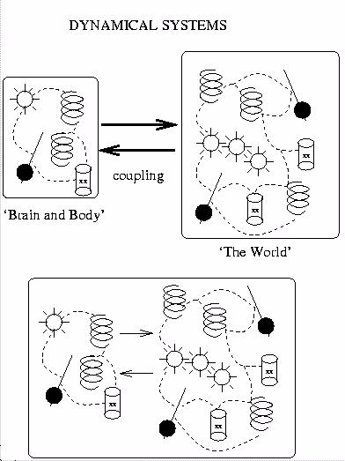

Figure 1:

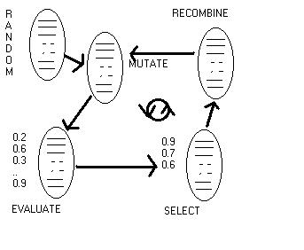

Figure 2:

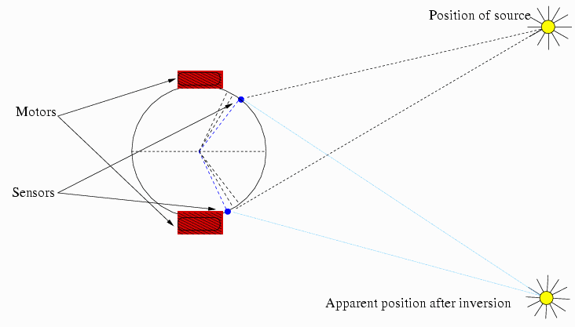

Figure 3:

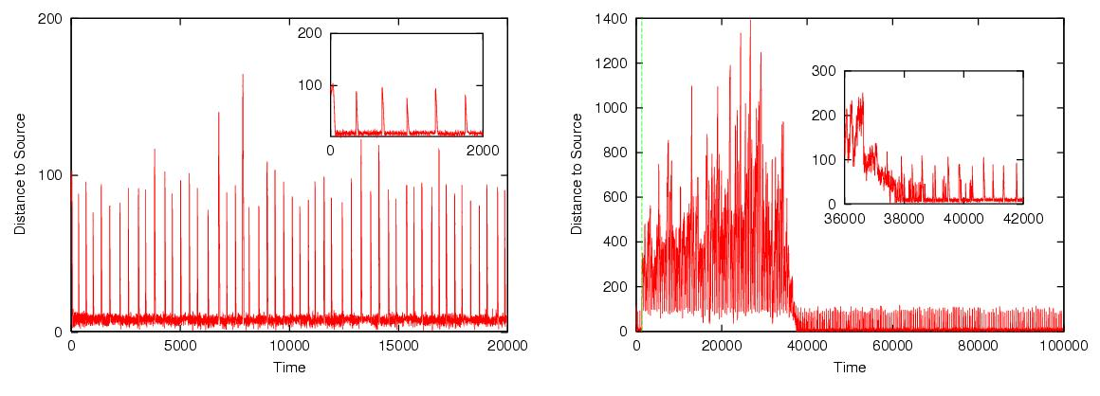

Figure 4:

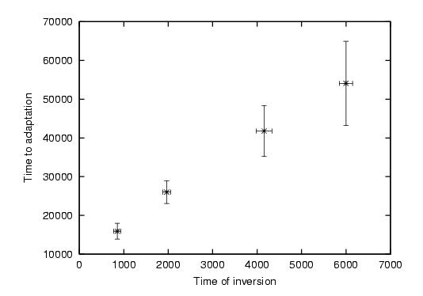

Figure 5:

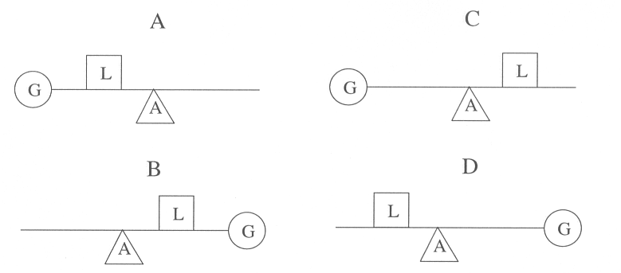

Figure 6:

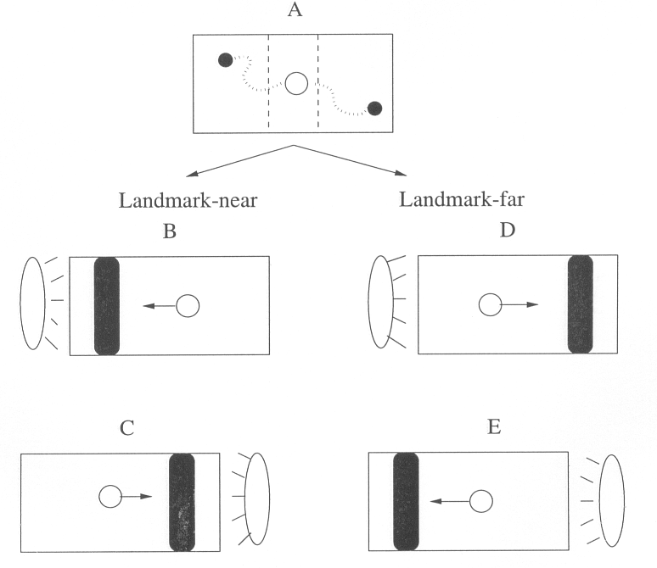

Figure 7:

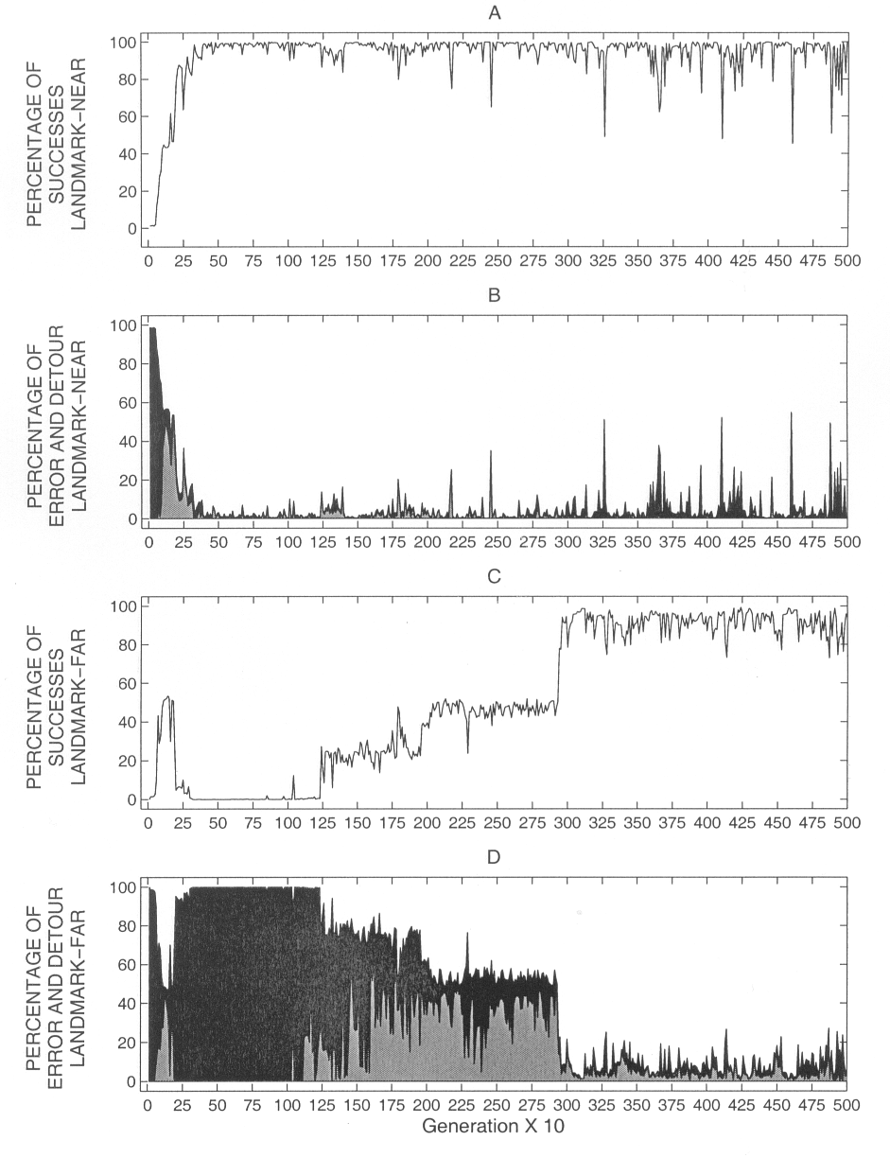

Figure 8:

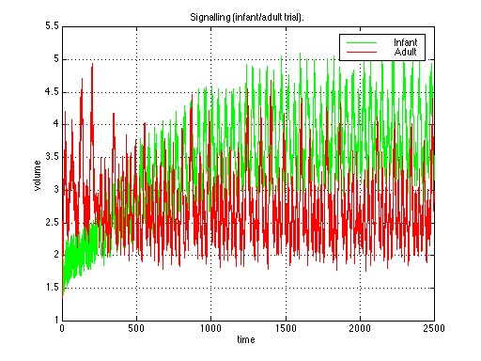
Figure 9:

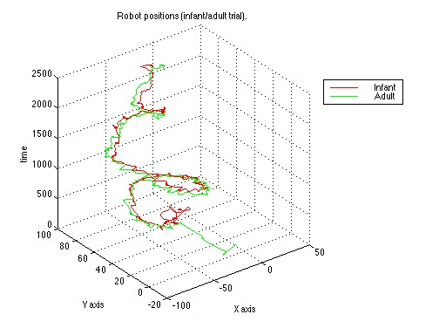
Figure 10:

