The maximum mass for a neutron star

The diagram below shows schematically the mass radius-relationship all the way from planetary densities to beyond nuclear densities. Note that the white dwarf radius does not actually go to zero at the Chandrasekhar mass: instead, neutronisation sets in at a finite density and there is a maximum mass at a finite radius rather than a limiting mass approached asymptotically. The same thing happens for neutron stars.
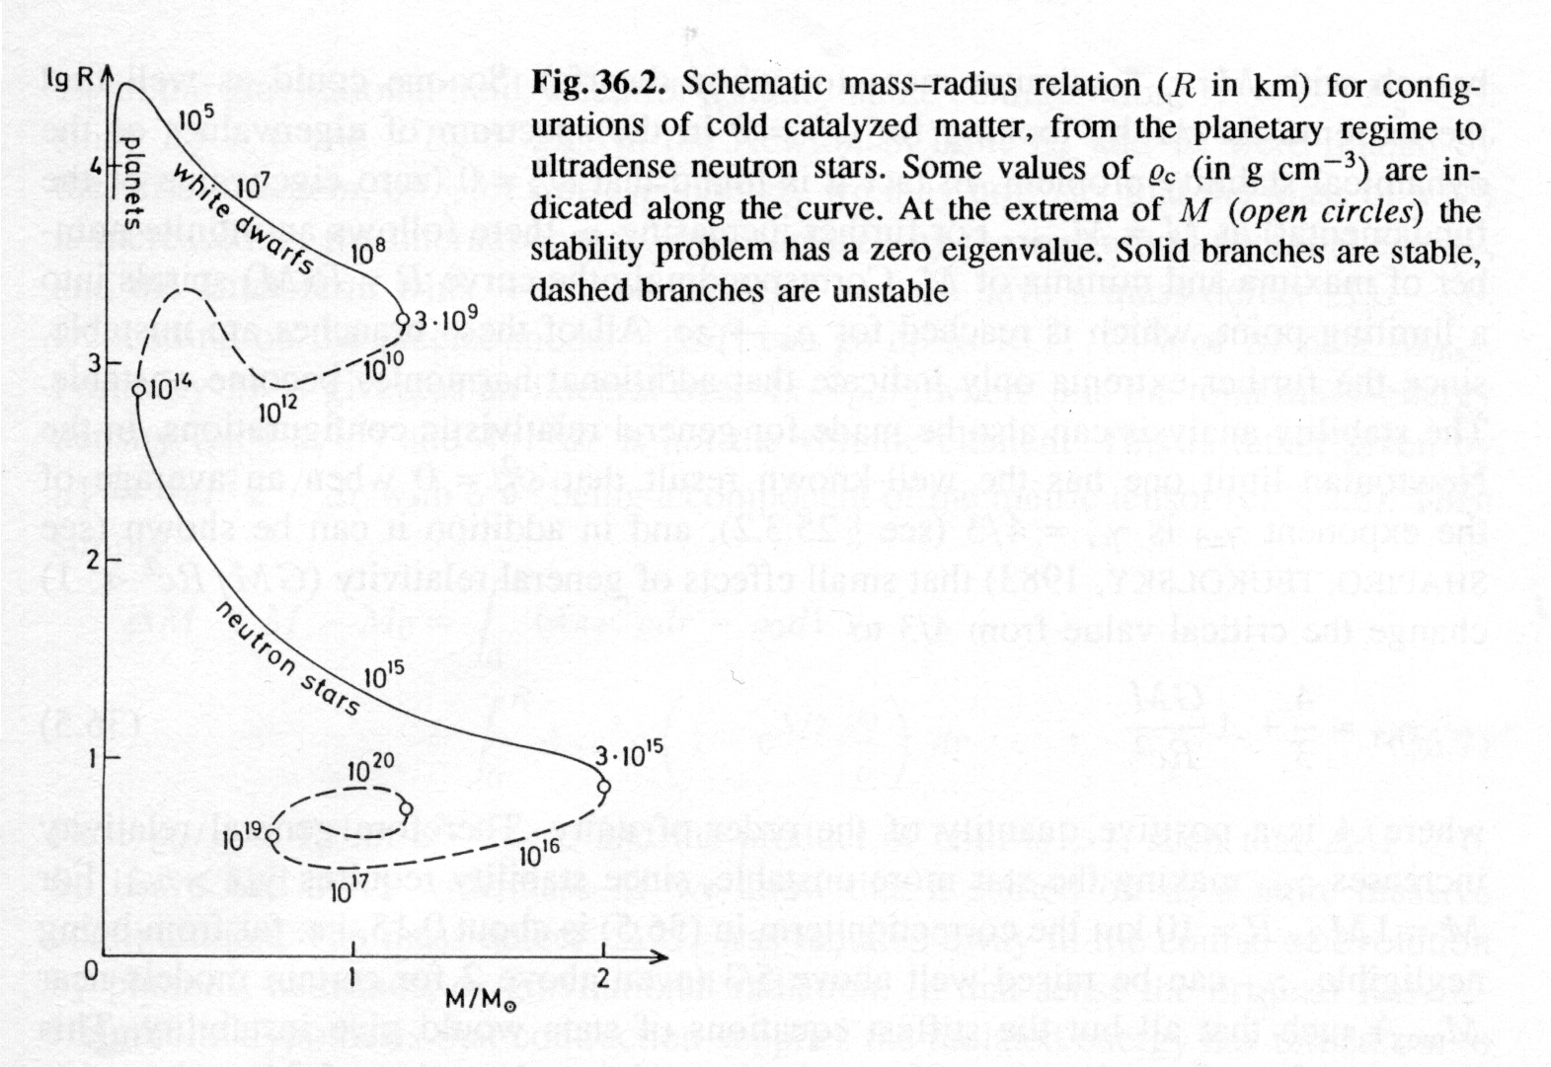

The following diagrams show how the properties of a neutron star vary according to the model chosen for the equation of state – all models show a maximum mass, but the value varies from about 1.5 to about 2.8 M and they occur for different radii and central densities. The only constraint from observations is that neutron stars in binaries seem to have masses of around 1.5 M, so equations of state that make the maximum mass less than that are ruled out.


