Evolution from the Zero Age Main Sequence to the final state

Schematic evolution for a solar-type star:

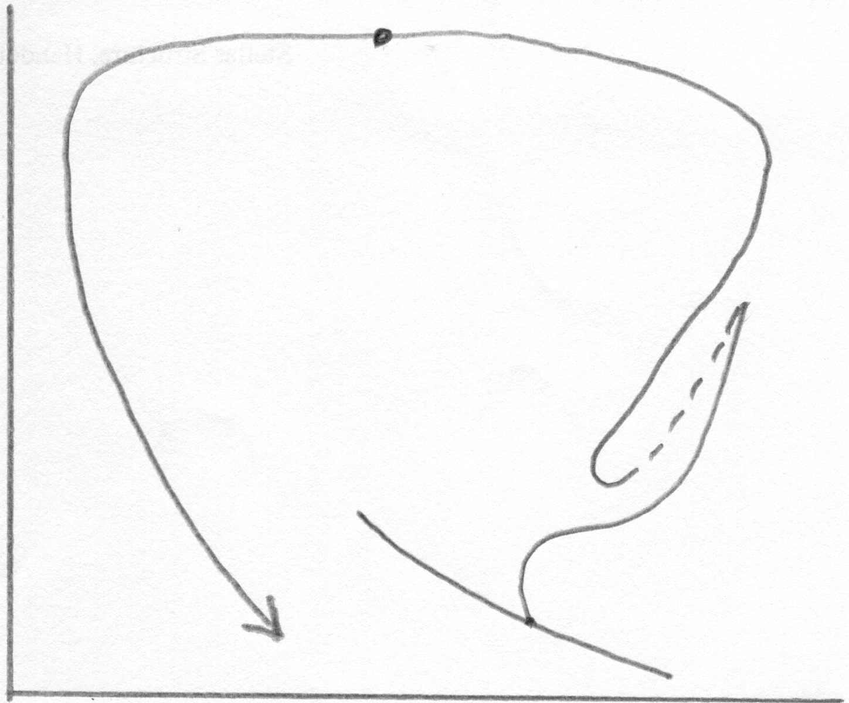
Star hot enough to ionise ejected shell

log L
Observed
central stars Mass ejection
of planetary ~0.3 M in ~10³ years
nebulae

Mass loss
(winds)

~0.3 M in
~10⁶ years

Evolve to
WD region
in ~10⁵ yr

M_{init} ~ 1.2 M
M_{WD} ~ 0.6 M
ZAMS

log T_{eff}

Evolution for a range of masses:
(Figure 15 from Icko Iben (Jr), Quarterly Journal of the Royal Astronomical Society, Vol. 26, pp. 1-39, 1985)


