The where and when of consciousness in the brain

Dennett & Kinsbourne Behavioural and Brain Sciences 1992

Pöppel 1985
Simple reaction times for auditory stimuli about 30-40ms faster than to visual stimuli. Thus, the “horizon of simultaneity” for visual and auditory stimuli ≈ 10m. Can we make the estimate more accurate?

In recognizing objects, the brain determines shape, colour, motion, in that order.
Where does it all come together?

Cartesian Theatre:
A place in the brain where events become conscious, where the discriminations in all modalities are put together and “presented” for subjective judgement. The order in which representations of events occur in the theatre determine subjective order.
“Temporal anomalies” of consciousness

- Colour Phi

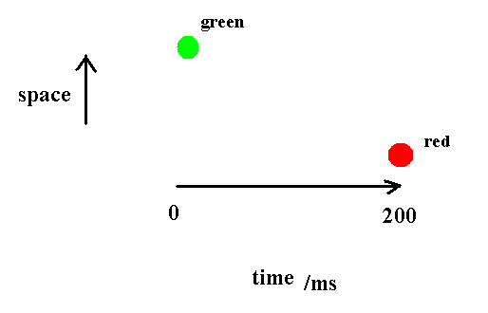

On first trial, spot changes colour abruptly in the middle of its illusory path.

How can we fill in the intervening path before the second spot occurs?
- Cutaneous rabbit (Geldard & Sherrick, 1972)

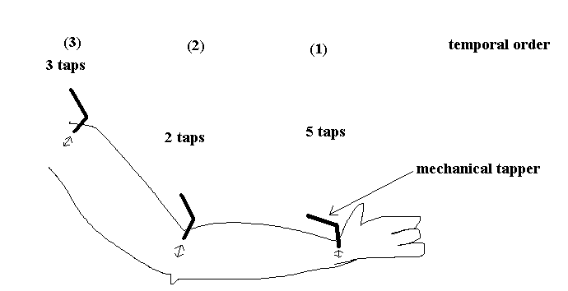

One tap every 50-200 ms

Taps appear to travel over equidistant points up the arm.

If stop after 5 taps on the wrist, appear to be only on the wrist.

How does the brain know if the taps are going to be on the elbow or not??

Orwellian and Stalinesque revisions

(Is the revision made before or after the Cartesian Theatre?)

Orwellian revision of memory:

You first consciously and accurately perceive an event, but then your memory is altered.

(cf the Ministry of ruth in 1984 who busily rewrote history.)

Stalinesque revision:

The revision is incorporated into the information prior to consciousness and so the initial perception is inaccurate.

(cf Stalin’s trying to fool posterity by staging show trials with bogus confessions and false evidence.)

Are the distinctions meaningful on microscopic time scales?

1. Colour phi.

Stalinesque explanation

Perception is delayed for a few hundred milliseconds which gives censors in the control room time to edit in intervening motion before the sequence is played out in the Cartesian Theatre.

Orwellian explanation

After awareness of both spots, a revisionist historian in the memory library notices that history does not make enough sense, and so makes up a narrative about the intervening passage.

Both explanations are consistent with what the subject says and remembers.
=> there is no fact of the matter. No subjective, physiological, or behavioural data can distinguish the alternatives.

Need to distinguish the medium from the content of a representation.

Representing “A before B”

does not need to be accomplished by

first, representing A
second, representing B

Temporal properties could be inferred by

1. “date stamps”
2. “context sensitive settling”

Multiple drafts model

The conscious point of view is “smeared” over the brain;
different parts of the brain are responsible for different discriminations, and they make (and edit) their discriminations at different rates.

In contrast to the Cartesian Theatre view,

1) Localized discriminations are not precursors or re-presentations of the discriminated content for consideration by a more central discriminator.

2) The objective temporal properties of discriminatory states may be determined, but they do not determine temporal properties of subjective experience.

3) The “stream of consciousness” is not a single, definitive narrative. It is a parallel stream of conflicting and continuously revised contents, no one narrative thread of which can be singled out as canonical – as the true version of conscious experience.

