Interdisciplinary studies II: Summer Term 2002

Sperm competition:

Competition between sperm from different males for fertilization of eggs produced by a single female (i.e. it is inter-ejaculate competition).

“...one of the most potent selective forces to shape all aspects of the sexual programme of modern humans” Baker and Bellis 1995

1) How much opportunity is there for sperm competition in humans?

2) What evidence is there that sperm competition affects human sexual response and behaviour?

3) How do the sperm compete with each other?
1) What is the opportunity for sperm competition in humans?

How long do sperm last in the female reproductive tract?

i) Semen is deposited in the upper part of the vagina (~400 million sperm);
ii) the cervix dips into the seminal pool to create interface between the semen and the cervical mucus columns;
iii) Most of the seminal fluid and 1/3 sperm are ejected from the vagina (“flow back”) within ~ 30 minutes;
iv) most sperm remain in cervical mucus or deposit in cervical crypts;
v) sperm leave crypts at different times to re-enter the mucus. Peak numbers are found in the mucus 2 hours and again 24 hours after insemination;
vi) Peak numbers in the oviduct ~ 5000, the first appearing in ~ 5 minutes, and then following a constant supply.

Live sperm have been found
in the vagina, only after 12 hours (too acidic);
in the cervix, after 10 days.
Fertilisation can occur 5 days after copulation.

=> For sperm competition to occur, there must be a double mating with a maximum gap of ~ 5 days.
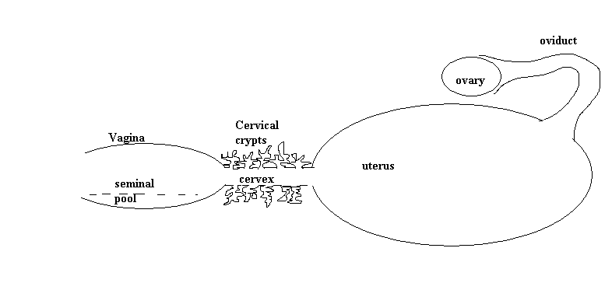

Types of double mating:
cryptic polyandry (infidelity), overt polyandry (e.g. wife swapping), forced copulation (rape).

Baker and Bellis (1993) Survey of 3587 women (who read Company magazine) (all types combined):
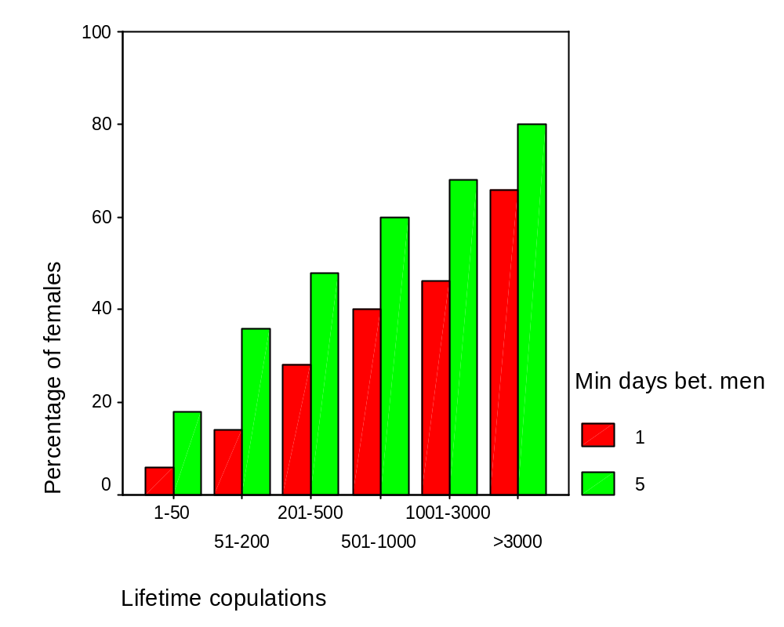

NB: couples aged 14-25 with sex life, average copulations/week ~ 3.5 (Kinsey)
In first year of relationship, mean inter-copulatory interval ~ 2 days (Baker and Bellis)

Kinsey report (USA 1940s):
25% of female partners had extra-pair copulations (EPC); 50% of males partners had EPCs.
Baker and Bellis: 50% of EPCs involved double mating (i.e. copulating with different partners within five days).
2. How does sperm competition affect human sexual response and behaviour?

a) males

Prediction: The greater the risk of sperm competition, the more sperm should be inseminated during copulation

Baker and Bellis (1989, 1993):

35 couples (staff and students from the University of Manchester). Men collected their semen in condoms as part of an on-going diary study;

the amount of sperm inseminated in different situations (coded as different proportions of time the partners spent together between copulations) could hence be measured.

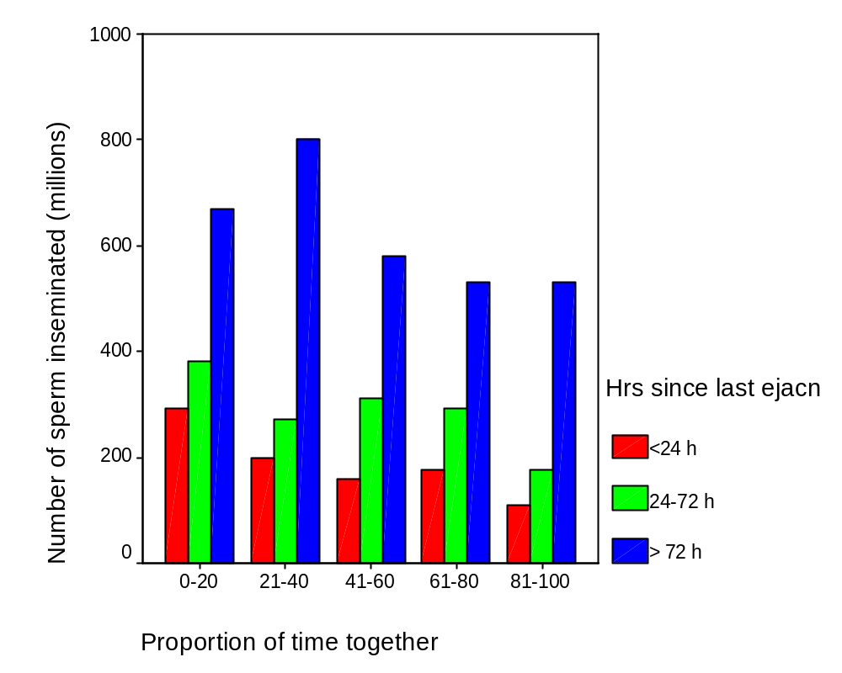

The less time the couple has spent together (i.e. the greater the risk that the female has copulated with another male)
the more sperm the male ejaculates

(even controlling for time since last ejaculation).

NB: The amount of sperm in masturbatory ejaculates does NOT depend on proportion of time together (whether the female is present during the masturbation or not).
This is all as is predicted by sperm competition theory. But why does the male masturbate at all?
Baker and Bellis’ Manchester study (1993):

1) If inter-copulation interval < 4 days, masturbation rare;
inter-copulation interval >= 10 days, masturbation ~100% of occasions
When males masturbated, mean inter-copulation interval = 7-8 days

2) BUT when a male masturbated between copulations, mean interval from copulation to first masturbation only 2-3 days.

=> Males not simply masturbating in response to a long time since last copulation.

If copulations had intervened randomly between masturbations, mean time from last masturbation to next copulation should be about half mean time between masturbations.
INSTEAD mean time from last masturbation to next copulation (51 hr) ~ mean time between consecutive masturbations (49 hr).

=> Males time masturbation-copulation interval to be about 2 days (51 hr).

WHY?
After masturbation, the male will ejaculate fewer sperm into the female (by ~228 million and recovering to baseline by some time after about 72 hours, still ~ 150 million short after 2 days)).
So why masturbate?

Masturbation will eject mainly older sperm; leaving younger sperm behind.
Conjecture: Male masturbation is a way of titrating sperm quality so that it is optimal for next copulation (Baker and Bellis).

In flow back studies, the number of sperm ejected by the female can be determined and hence the number retained by the female estimated:

Time since last ejaculation does NOT affect number of sperm retained by female (non-sig increase in amount retained with time since last ejaculation).
=> after masturbation, the male ejaculates “fitter” sperm. The female will have a greater proportion of young fit sperm in her reproductive tract if the male has inter-copulation masturbations than if he does not.
Conjecture: These sperm will be better at sperm competition.

NB: The first conjecture might be true without the second being true.
b) females

Predictions:
i) Females should encourage sperm competition to select males who are competitive
(don’t know any evidence)

ii) Females should have evolved various devices to bias sperm competition in favour of certain partners, e.g. extra-pair males (because they have different genes to the main partner).

Bellis and Baker (1990) Company survey:

2546 females stated when they last copulated, whether it was with the main partner or with a lover, and the day of their menstrual cycle on which it occurred.

Cycle split into three phases
I (days 1-5)
II (days 6-14)
III (days 15-28).

Phase II is the fertile phase.

Intra-pair copulations:
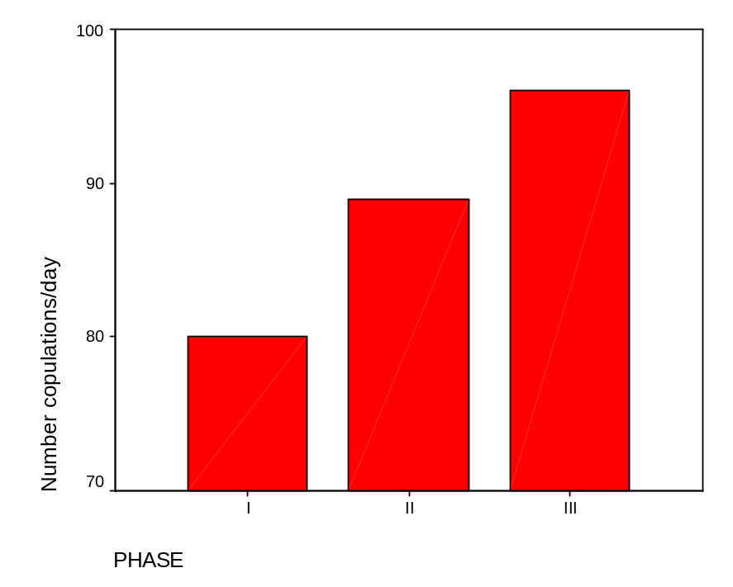

Extra-pair copulations: 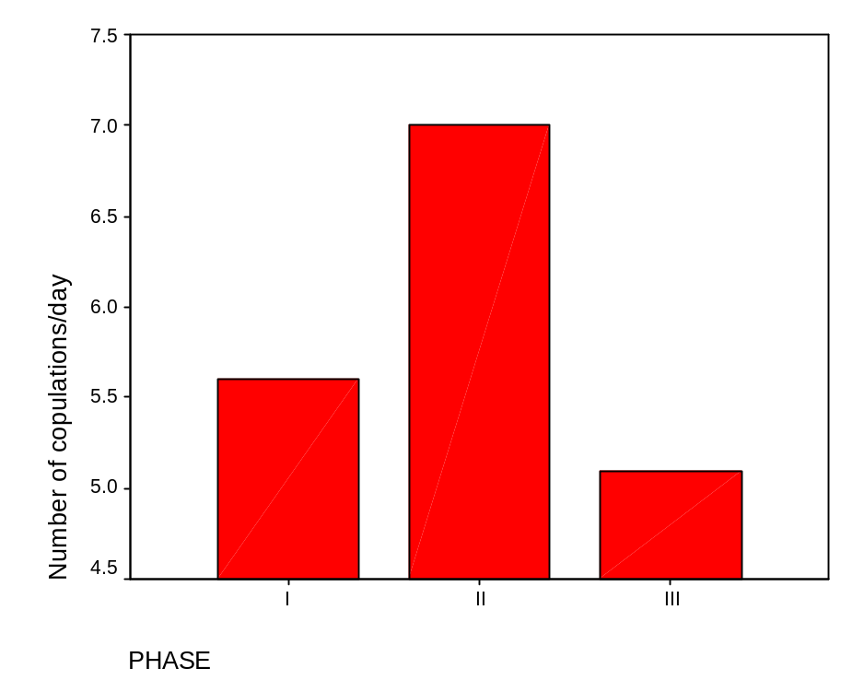

With their main partner, women were more likely to copulate in the final (infertile) phase.

With their extra-pair male, women were more likely to copulate in their fertile phase.

(For EPCs, this tendency is particularly strong for double matings, but the difference between double matings and non-double matings is not significant.)

The distribution of copulations over phase is unaltered by whether contraceptives were used or not.

24.7% of 162 EPC were unprotected;
only 15.4% of 2546 IPCs were unprotected.
Difference is significant, p = .005.

=> Through both when women choose to copulate and when they choose to use contraception, women bias the probability of conception to be higher for the extra-pair male rather than the intra-pair male.

NB: While these results are consistent with sperm competition theory, one does not need sperm competition theory to predict them, just the theory that women gain from genetic diversity in their offspring.
More data is needed to determine whether behaviour is different for double-mating and non-double mating EPCs
What is the function of female orgasm?
(Not needed for conception.)

Upsuck hypothesis: Female orgasm functions to suck up sperm during copulation (Fox et al, 1970).

(Not literal sucking, but orgasm leads the cervix to gape and dip into the seminal pool; Masters and Johnson, 1966.)

Baker and Bellis 1993, flow back studies.

Number of sperm retained relative to a “no orgasm” baseline:

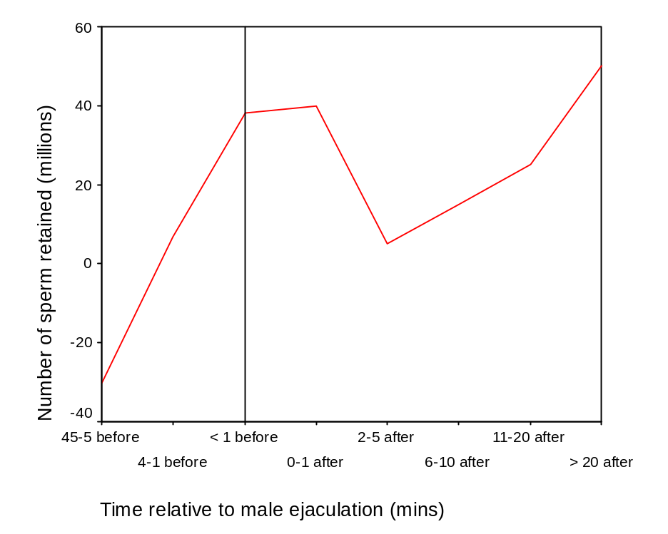
Time between ejaculations and % time together controlled for.
Vertical line indicates when male ejaculates.
The dip between 2 and 10 minutes post ejaculation corresponds to the time when the seminal pool has coagulated.
=> A copulatory orgasm from 1 minute before ejaculation until flowback facilitates the retention of sperm by the female
(supporting the upsuck hypothesis).

What then is the function of non-copulatory orgasms?

Baker and Bellis flowback study:

Number of sperm retained at next copulation (in millions) relative to when there is no intercopulatory orgasm:
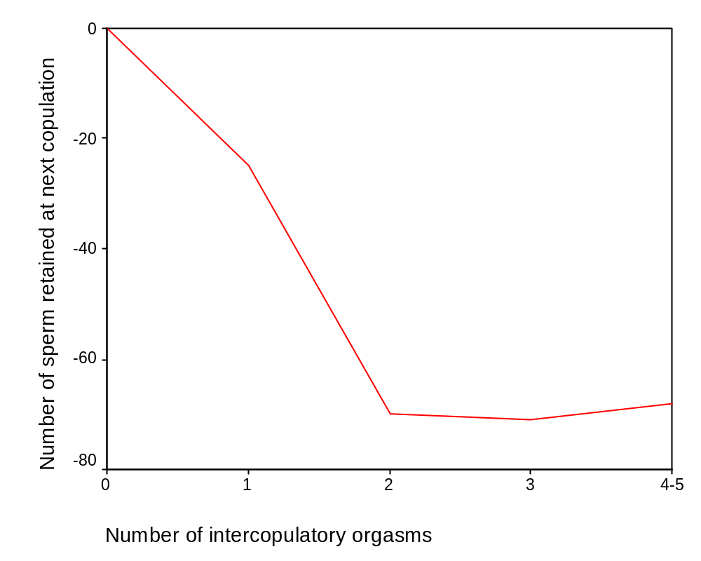
Independent of time between copulations. Time since last ejaculation and % time together controlled for.
=> A masturbatory orgasm produces a block for sperm.
(Baker and Bellis 1993 suggest the block lasts about a week)

How?
The vagina is acidic (pH 3.5 – 5.8). The pH of the cervix varies from 4.0 to 7.4. Sperm need an alkaline environment (above ~ 7.0) to function.
Conjecture: By dipping the cervix into the acid vagina during masturbatory orgasm, the cervix is made too acidic for sperm to function optimally.

In summary, a female can bias the probability of conception favourably by a high retention copulatory orgasm or adversely by a pre-copulatory masturbatory orgasm.

But do females use these responses strategically in sperm competition situations?
Polyandrous women in the Company survey reported on last copulation:

High retention copulatory orgasm in
EPC 33% (n= 75)
IPC 20% (n = 75) sig diff, p = .047

Median frequency of non-copulatory orgasm in preceding week:
EPC 2 (n = 51)
IPC 3.5 (n = 43) but difference non sig
NB: Data do not require sperm competition hypothesis
3. How do sperm compete in the female reproductive tract?

1. lottery
2. race
3. the Kamikaze Sperm Hypothesis: Sperm are differentiated according to whether they are “seek and destroy” (“killers”, putatively the most common), “blockers” (older sperm), or (the few) actual “egg getters”.

Direct test of killer sperm:
Mix two ejaculates together, either from the same male (homospermic) or two different males (heterospermic).

Baker and Bellis (1995) based on 132 males:
Within 3-6 hours, heterospermic rather than homospermic mixes have more dead/immobile sperm (p = .002) and the sperm on average move more slowly (p = .007). (No means or SDs given.)

Moore et al (1999): attempted replication with 10 males.
After three hours of mixing, no difference in viability (p =.29) or velocity (p=.37).

Kamikaze Sperm Hypothesis remains controversial.
Reading

Baker, R. R. (1996). Sperm Wars. Fourth Estate. (A popular account)

Baker, R. R., & Bellis, M. A. (1989). Number of sperm in human ejaculates varies in accordance with sperm competition theory. Animal behaviour, 37, 867-869.

Baker, R. R., & Bellis, M. A. (1993). Human sperm competition: ejaculate adjustment by males and the function of masturbation. Animal behaviour, 46, 861-885.

Baker, R. R., & Bellis, M. A. (1993). Human sperm competition: ejaculate manipulation by females and the function of the female orgasm. Animal behaviour, 46, 887-909.

Baker, R. R., & Bellis, M. A. (1995). Human sperm competition: Copulation, masturbation, and infidelity. Chapman and Hall.

Bellis, M. A., & Baker, R. R. (1990). Do females promote sperm competition: Data for humans. Animal Behaviour, 40, 997-999.

Moore, H. D. M., Martin, M., and Birkhead, T. R. (1999). No evidence for killer sperm or other selective interactions between human spermatozoa in ejaculates of different males in vitro. Procedings of the Royal Society of London B, 266, 2343-2350.

Thornhill, R., Gangestad, S. W., & Comer, R. (1995). Human female orgasm and mate fluctuating asymmetry. Animal Behaviour, 50, 1601-1615.

