Programme notes by Chris Darwin. Please use freely for non-profit activities **Anton von Webern (1883-1945) Langsamer Satz (1905)**

Webern was only 22 when he wrote this *Slow Movement*; it is a 10-minute late romantic treat reminiscent of Schönberg's *Verklárte Nacht* written 6 years earlier.

As a child Anton *von* Webern (his parents were minor aristocrats and he only dropped the '*von*' following an edict from the Austrian state in 1915) studied cello and piano. His first compositions were settings of songs, but while a music student at the University of Vienna between 1902 and 1906 he also composed various instrumental pieces including tonight's *Langsamer Satz* and also another longer single movement work, now known as his StringQuartet. In 1904, he answered an advertisement placed by the short-of-work Schönberg inviting composition pupils. Schönberg was to become the most important influence on Webern's life – his admiration bordered on infatuation. In the 1920s Webern became a more punctilious practitioner of Schönberg's 12-tone system than the master himself. But in 1905 such duodecanal rigours were unheard of, and master and pupil merely pushed provocatively on the constraints of tonality.

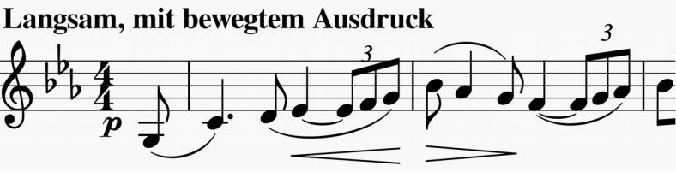

Tonally *Langsamer Satz* is a simple sandwich: Eb bread with a C filling - the rising triplets of the opening Eb melody ( *illustrated* ) contrasting with falling in the filling ( *illustrated*). The languid, expansive feel to this work gives no intimation of the revolutionarily atonal, aphoristic style that Webern was soon to develop. Sit back and enjoy those dying days of comfortable times.

