**Programme notes by Chris Darwin. Use freely for non-commercial purposes**

**Carl Maria von Weber (1786-1826) Trio in G minor, Op.63 for flute, bassoon and piano (1819)**

*Allegro moderato*

*Scherzo: Allegro vivace*

*Shepherd's lament: Andante espressivo*

*Finale: Allegro*

Weber's musician father had ambitions for his son to match the achievements of the husband of Constanza Weber, Carl's cousin. Though no Mozart, Carl Weber had an extensive and diverse influence over musical life at the start of the Romantic period.

Wagner, Liszt, Mendelssohn, Mahler, Glinka, Stravinsky, Berlioz and Debussy admired his orchestral and operatic writing, and, as a conductor, he introduced sectional rehearsals and transformed the conductor's role from mere time-beater to one who moulds the performance. His huge hands helped him become a formidable pianist, and some of his chords “cannot be played by normal human beings” (Harold Schonberg).

As a composer, he was precocious: an opera he wrote aged 14 was produced in Freiburg, Vienna, Prague, and Saint Petersburg, and four years later in 1804 he was appointed Director of the Breslau Opera. He was frustrated by his inability to reform that institution, and in 1806 while recuperating from an accidental dose of "engraver's" (nitric) acid, he saw his reforms set aside and he resigned. He became private secretary to the king's brother in Württemberg. There his father embezzled huge sums and Carl himself fell heavily into debt; they were both imprisoned and then banished. Undeterred he became director of the Prague theatre, successfully carrying out there his previously-frustrated anti-Italian reforms. In 1817 he moved to the Dresden theatre as director of the German repertoire (someone else did the Italian) and stayed there for the rest of his life.

Today's trio was composed in the early years at Dresden as he was starting to compose his best known work, the opera Der Freischütz. The trio was originally written for piano, flute and cello, probably in memory of convivial musical evenings in Prague with a couple of flute- and cello- playing friends. An inauthentic substitution of violin for flute followed after Weber's death, but the substitution of bassoon for cello is relatively recent.

The title of the third movement – The Shepherd's Lament – alludes to a 1802 poem by Goethe that was frequently set to music. The actual theme that

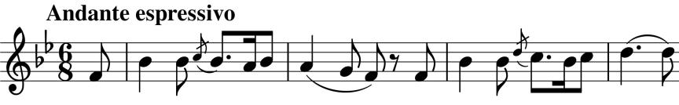

Weber uses (illustrated) is lifted from a song written in 1802 by a minor composer Wilhelm Ehlers. The Finale contains at least two allusions to motifs in Der Freischutz.