**Program Notes by Chris Darwin. Use freely for non-commercial purposes.**

William Walton (1902-1983) Piano Quartet (1918/1921, rev. 1974)

*Allegramente*

*Allegro scherzando*

*Andante tranquillo*

*Allegro molto*

After an early childhood in Oldham singing in his father's church choir, the ten year-old William Walton won a choral scholarship to Christ Church Cathedral, Oxford, despite arriving late for the auditions after his father had drunk their train fare. At Oxford he began to compose, in order, he said, to avoid having to return home. In 1918, aged 16, he was admitted to the university to read music thanks to the considerable financial support of Thomas Banks Strong the Dean of Christ Church, but left without a degree two years later, after failing the obligatory Greek and Algebra exams three times. Much of his time had been spent in the library studying scores by Debussy, Ravel, Prokofiev and Stravinsky. At Oxford he met the Sitwell siblings Sacheverell, Osbert and Edith, who housed him in the attic of their London home, and gave him a cultural education. He met Stravinsky and Gershwin, won the praise of Alban Berg for a string quartet, and listened to jazz at the Savoy. In 1920 he went with the Sitwells to Italy, whose music and sunshine captivated the Oldham boy and inspired the music of *Façade*, whose notoriety launched his international career.

Both his Piano Quartet and the early String Quartet that Berg praised date from his undergraduate years but they differ widely in style. In Walton's words the String Quartet is *'full of undigested Bartók and Schoenberg’;* despite Berg's approval Walton soon withdrewit. By contrast, the Piano Quartet, inspired by one written by Herbert Howells, has a melodic and rhythmic invention that came naturally to Walton the hedonist. It was written between 1918 and 1919, but revised in 1921 before publication in 1924. Walton dedicated it to Thomas Strong, who had by then left Christ Church to become Bishop of Ripon. In 1974 Walton again revised the work and it is this final version that is played tonight. It is undoubtedly a precocious piece for a 16-year-old, showing not only how much Walton had absorbed from his predecessors, but also the beginnings of his own voice.

The first movement is in conventional sonata form and opens (illustrated) in the same wistful mood as the Howells quartet which

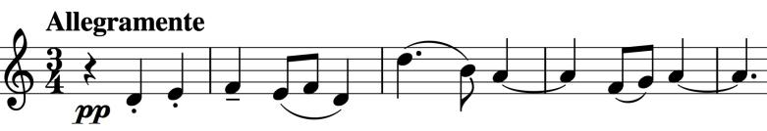

inspired it. The movement also has shades of Ravel, Vaughan Williams, Elgar ... The S*cherzo's* lively, pointed rhythms lead to a fugue derived from the work's opening theme and a rather grand well-contrasted second theme. The tender *Andante tranquillo* has clear Ravel moments and at least initially recalls the certainties of pre-first worldwar England. These certainties are broken by the harsh rhythms of the final *Allegro molto,* whose initial material again is built on that of the opening movement, but this time with a harder more slavic edge.

If you would like to revisit the Notos' interpretation of this varied and interesting work, you can at: www.youtube.com/watch?v=SDdDeuTaDsk