Programme Note by Chris Darwin: please use freely for non-commercial purposes

**Johann Sebastian Bach (1685-1750) Concerto for solo organ in D minor BWV 596 (1717)** being a transcription of

**Antonio Vivaldi (1678-1741) Concerto for Two Violins and Cello Op. 3 No. 11 (*L'Estro Armonico*, Bk 2) RV 565 (published 1711)**

*Allegro - Grave – Fuga*

*Largo e spiccato*

*Finale: Allegro*

In 1844 an edition was published of an Organ Concerto nominally by J.S. Bach's eldest son Wilhelm Friedemann (1710-1784). The concerto became very well known in this form. But in fact the work was a transcription by his father of a Vivaldi concerto for two violins and cello, which the son had intentionally misattributed to himself, perhaps to increase his income and prestige during his unsuccessful declining years.

Vivaldi's original concerto was the eleventh of a set of twelve concertos for different string combinations published by the Amsterdam firm of Estienne Roger as *L'Estro Armonico* (Harmonic Inspiration). Roger not only had an extensive distribution network throughout northern Europe, but also used modern copperplate technology, which produced a superior print to the clumsy one-note-one-block method of contemporary Venetian printers. Vivaldi's choice of publisher was a good one: *L'Estro Armonico* transformed Vivaldi's career and set the pattern for instrumental concerto writing. J.S. Bach's organ transcription is largely faithful to the Vivaldi original; he adds just a single bar to the opening *Allegro* and necessarily makes many detailed changes

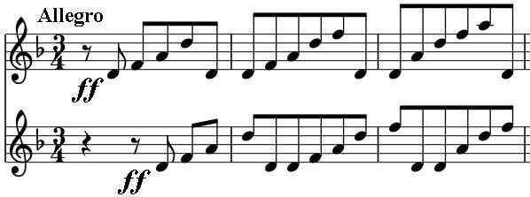

to suit the organ. Bach not only transcribed today's D minor concerto, but also five others that impressed him with their ingenious counterpoint. He also modelled his own concertos on them, imitating, for example, the *cantabile* style that Vivaldi had introduced in his slow movements.

Counterpoint is evident with a canon between the two upper soloists (violins in the original) at the start of the short introductory *Allegro.* A 3-bar

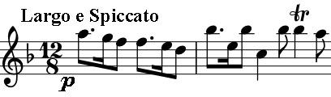

*Adagio* leads to a full-blown fugue introduced by the solo cello. The Sicilienne-style *Largo* gives the upper solo voice a beautiful long *cantabile* line and the work ends with a lively *Allegro*.