Programme notes by Chris Darwin. Use freely for non-commercial purposes

**Theo Verbey (1959-2019) Trio (1999)**

*Fast (7 mins) – slow (4m) – very fast (3m) – very slow (6m)*

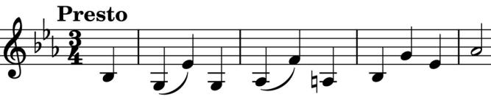

Theo Verbey was a Dutch composer noted not only for his numerous original and accessible chamber and orchestral compositions, but also for his highly

successful orchestrations of others' works. Verbey discusses the composition of tonight's Trio at <https://theoverbey.com/composition/trio/>which was useful in preparing these notes.

One of the compositional techniques that Verbey uses is to combine a repeating sequence of particular rhythmic durations with harmonic or melodic sequences that have different durations. Although this method certainly has a contemporary flavour, it dates back to the *talea* and *color* used by Ars Nova composers such as Guillaume de Machaut in the 14th century. However, Verbey extends this numerical method in a way that is related to Mandelbrot's fractals: the initial rhythmic pattern appears at different durational scales. So in the Trio, not only are the overall durations of the movements in the ratio 7:4:3:6, but also each movement is itself divided into sections in these ratios, and each section similarly divided, etc.

But more familiar forces are also at work. These mathematical structures can be embedded in classical musical forms (the first

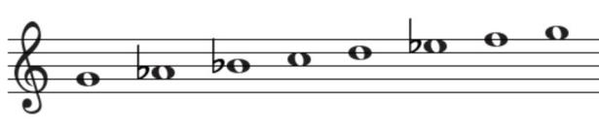

movement is in sonata form based on a Phrygian G-major scale - *illustrated*). They can also carry quotations from others' work: the second subject of the first movement contains

the opening of the *'O Isis und Osiris'* aria from Mozart's 'Magic Flute' in tribute to the Osiris Piano Trio for whom the work was written.

Of the other movements Verbey says:

"The second movement has a more abstract content in which various materials are juxtaposed according to the scheme: A B C A’. The third movement has the character of a scherzo with a small reference to early jazz. The motive from the first movement is used as basic material. The formal plan of the movement is A B A B’. The fourth and final movement has the same form as the second movement A B A’ B’ but has a severe and almost grim character and is, after the first movement, the longest."

If all this sounds rather daunting, ignore it; sit back and enjoy what turns out to be personal and accessible music.