**Programme notes by Chris Darwin: use freely for non-commercial purposes**

**Ralph Vaughan Williams (1872-1958) Piano Quintet in C minor (1903; rev 1904-5)**

*Allegro con fuoco*

*Andante; Lento*

*Fantasia (quasi variazioni): Moderato*

Ralph Vaughan Williams was not a composing prodigy. After learning the violin and piano at prep school in Rottingdean and switching to the viola at Charterhouse, he studied composition for two years at the RCM under Stanford and then read History, and Music under Charles Wood, at Cambridge. Though drawn to composing, progress was slow. His cousin Gwen Raverat recalled ‘overhearing scraps of conversation about “that foolish young man, Ralph Vaughan Williams”, who *would* go on working at music when “he was so hopelessly bad at it”'. But he persevered and returned to the RCM as a student of Hubert Parry, forming lasting friendships with Leopold Stokowski and particularly with Gustav Holst with whom he enjoyed unusually frank and productive mutual musical criticism until Holst's death in 1934. Vaughan WIlliams later studied with Max Bruch in Berlin (1897) and Maurice Ravel in Paris (1908). His discovery of English folksong in 1904 led not only to his finding his own individual composing style but also, as with Bartók and Kodály in Hungary, to collecting the songs of an oral tradition threatened with extinction.

The C minor piano quintet, though first performed in 1905 in the Aeolian Hall, was only published in 2002. It had been withdrawn by the composer along with most of the music he wrote at that time including an early string quartet, perhaps in consultation with Holst. It comes from a period where he had not yet found a personal voice. On Vaughan Williams' death his widow Ursula donated the unpublished manuscripts to the British Library but embargoed their performance, only relenting on the occasion of a celebratory conference on the composer in 1999 – its first documented performance since 1918.

The work has the same scoring as Schubert's Trout Quintet, shifting the tonal range down by removing the usual second violin from the conventional piano quartetand appending a double bass, a move which gives Vaughan Williams' own instrument, the viola, more prominence. The first movement is one of large Brahmsian or perhaps Bruchish gestures. Indeed when Bernard Benoliel was editing the manuscript for publication he realised that at some point Vaughan Williams must have performed it using a string band instead of single strings.

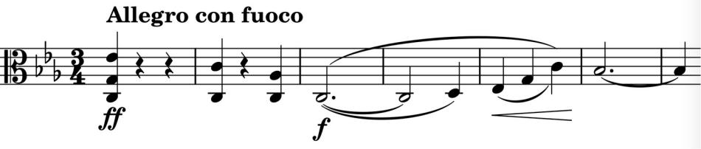

After the four descending chords of the opening, the viola, at the bottom of its range, sings the expansive arch-shaped theme

(*illustrated*), joined a third higher by the cello, it is then repeated by the violin paired with the viola. The theme ends in a version of the

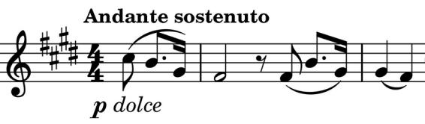

opening four chords which also form the *Andante* second subject (*illustrated*).

An interesting feature of the work is the variety of different textures the composer conjures from the

four wide -ranging strings. For instance, the *Andante* theme appears later played by viola, cello and double -bass creating a timbre that makes you think that the recording has suddenly halved its playback speed. The movement contrasts the different themes

interestingly and intersperses solo piano with varied string textures – the viola and the double-bass get particularly gratifying parts.

Two bars of *Andante* from the piano echoed by the strings introduce the main *Lento* of the slow movement. Again the piano leads

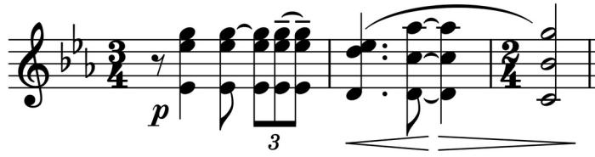

with the langorously expansive theme and the strings (*illustrated*) follow. The tempo picks up into a middle section that introduces more luscious string writing, builds to a climax and sinks back to the slower material of the opening.

The *Moderato* finale is a theme with five variations. Vaughan Williams reused the theme (*illustrated* ) for the final variations movement of his 1954 violin sonata.

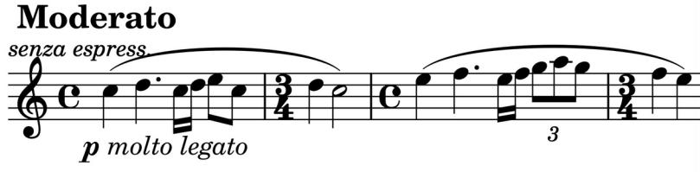

It has been a pleasure discovering this work, which has some glorious writing for a rare combination of instruments; it deserves more airings.