**Program note by Chris Darwin: use freely for non-commercial purposes**

**Joaquín Turina (1882-1949) Piano Trio No.2 in B minor Op.76 (1933)**

*Lento; Allegro molto moderato; Allegretto*

*Molto vivace; Lento; Molto vivace*

*Lento; Andante mosso; Allegretto; Meno mosso; Moderato; Allegretto; Allegro molto moderato; Allegro vivo*

Born in Seville, Turina initially followed his family's wishes by studying medicine, but could not stay away from music. Ambition drove him to Madrid in 1902 to study at the Real Conservatorio, where he became friends with Manuel de Falla. Discouraged by the failure of his efforts in the popular and potentially lucrative form of z*arzuela* comic operas (named after a royal hunting lodge that was thick with *zarzas -* brambles), he moved to Paris three years later. There he studied at the Schola Cantorum, an institution set up by Vincent d'Indy and others to counter the Paris Conservatoire's emphasis on opera. It provided a solid grounding in ancient and classical technique with a stolid diet of traditional church music. But Paris also introduced Turina (and de Falla who had followed in 1907) to Debussy, Ravel, Franck and Albeniz. Albeniz and de Falla advised Turina to enliven his Schola-influenced work with material from Spanish popular music. The advice was good and when the outbreak of WW1 forced both Turina and de Falla back to Spain, they were successful. Turina stayed in Madrid becoming professor of composition at the Madrid Conservatoire in 1930.

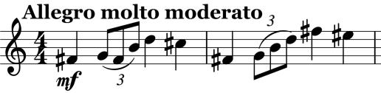

Turina's second Piano Trio laces his classical training with distinctive Spanish forms and material. We start with three wistful *Lento* bars complete with a characteristically poignant triplet; they lead into the flowing opening theme (*illustrated*).

The tempo drops to *Allegretto* and the second theme recalls the opening *Lento*. The tempo changes again to yet another melody combining ideas from the two preceding ones. The movement continues to move pleasingly between these different tempi and their related melodies.

The second movement is resembles a *Scherzo* and *Trio.* It starts fast in 5/8 (like a Castilian Rueda

dance), then a short slow section in 3/4 before recapitulating the fast section. The last movement

starts dramatically *Lento* then *Andante* with big

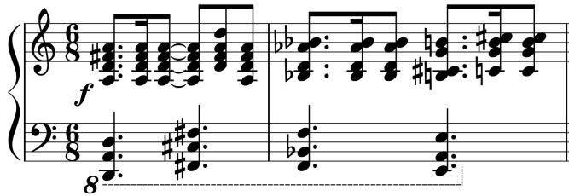

chords reminiscent of Brahms before the piano

plunges off into a hearty waltz-like *Allegretto*

(*illustrated*). Numerous varied episodes at different

tempi follow incorporating material from the

preceding movements.