Programme Note by Chris Darwin: please use freely for non-commercial purposes

**Michael Tippett (1905-1998) String Quartet No.4 (1977-8)**

*Molto legato (c. 3 mins)*

*Fast (c. 6 mins)*

*Moderately slow (c. 6 mins)*

*Very fast (c. 8 mins)*

Tippett's quartets all reflect in different ways the influence of Beethoven. His first three quartets were written between 1935 and 1946 around the same time as *A Child of Our Time* and just before *The Midsummer Marriage* whose demands prevented a planned fourth quartet being composed. His eventual fourth quartet was written more than 30 years later in 1977-8 and was given its first performance by the Lindsay Quartet in 1979. It is dedicated to his near-namesake, ex-pupil, amanuensis and friend Michael Tillett. Its style is more dissonant than that of the first three quartets, a change that had occurred in 1961 with *King Priam.* It also follows some of Beethoven's late quartets in being composed as an unbroken sequence of movements, a structure that Tippett also used in the contemporary *Fourth Symphony* and *Triple Concerto*, marking the start of his own 'late period'.

Tippett strove to attain the ‘purity and tenderness’ of Beethoven’s late work after an epiphanic moment watching a television documentary which ended with a series of Rembrandt self-portraits; in Tippett's words:

*At that moment, music started to play... of the utmost intensity and poignancy, the beginning of a late Beethoven slow movement. I said to myself: 'I must before I die find that sound in our own time! But I can't find that sound in our time, because it depends upon a purity of harmony and structure which is largely excluded from my own acidic, ironic world of harmony'... To try to find that sound meant to shut myself away and write my Fourth Quartet.*

Although still atonal and often astringent, the fourth quartet does regain some of the lyricism of his early, pre-Priam, period, with moments of tenderness such as the violin's *singing* line in the slow third

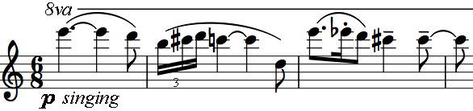

section. But tenderness is brutally banished at the start of the final section, with the angry quotation of the fugal subject from Beethoven's Great

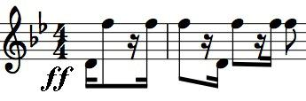

Fuge. Tippett does not treat the material fugally though he maintains the obsessiveness of the original. Tippett 'wanted to answer a final outburst of violence with an

overwhelming vision of lyricism and radiance': a chorale-like series of chords ends the work.