**Program note by Chris Darwin: use freely for non-commercial purposes**

**Pyotr Tchaikovsky (1841-1893) Trio in A minor Op 50 *"In memory of a great artist"* (1882)**

I . *Pezzo elegiaco. Moderato assai - Allegro giusto*

1. A. *Tema con variazioni*

B. *Variazione finale e coda*

Nadezhda von Meck's husband Karl made a vast fortune in the1860s investing in railway construction. He didn't want to make the investment, but his formidable wife made him do it. Not only did Nadezhda possess far-sighted business acumen, but she was also immensely cultured and an able pianist.

After her husband's death in 1876, Nadezhda was free to use their fortune to support not only the 11 of her 18 children who survived infancy, but also the Moscow Conservatoire and the Russian Musical Society, both of which had been founded by the pianist and conductor Nikolai Rubinstein (the St Petersburg Conservatoire was founded by Nikolai's pianist and composer elder brother Anton, who taught the young Tchaikovsky). Nadezhda enjoyed music making in their Moscow home and employed a select group of young musicians, including three of Tchaikovsky's pupils, together with the young Claude Debussy, Nikolai Rubinstein and Henryk Wieniawski. In 1876 she asked Tchaikovsky to supply arrangements for this ensemble.

Following her husband's death, Nadezhda became increasingly eccentric and reclusive, so that when she generously bestowed an annual allowance on Tchaikovsky, it was on condition that they never meet. Despite their friendship lasting almost 14 years, their exchanging hundreds of letters, and her son Nikolai marrying Tchaikovsky's niece Anna Davydova in 1884, they never did meet.

In a letter of November 1880 Nadezhda asked Tchaikovsky for a piano trio. He replied: *"You ask why I have never written a trio. Forgive me, dear friend; I would do anything to give you pleasure, but this is beyond me ... I simply cannot endure the combination of piano with violin or cello. To my mind the timbre of these instruments will not blend ... it is torture for me to have to listen to a string trio or a sonata of any kind for piano and strings. To my mind, the piano can be effective in only three situations: alone, in context with the orchestra, or as accompaniment, i.e., the background of a picture."*

However, her request was not fruitless since a year later Tchaikovsky did write a piano trio. The stimulus was the unexpected death in March 1881 in Paris of Nikolai Rubinstein, who had been Tchaikovsky's mentor and had become his close friend. On hearing that Rubinstein was ill, Tchaikovsky, who was wintering in Italy, had rushed to Paris but arrived after his death. Tchaikovsky returned to Moscow, sharing his train with Rubinstein's coffin.

The following winter Tchaikovsky was back in Italy and on 25 January 1882 wrote to

Nadezhda from Rome:

*"The Trio is finished ... now I can say with some conviction that my work is not all bad. But I am afraid, having written all my life for orchestra, and only taken late in life to chamber music, I may have failed to adapt the instrumental combinations to my musical thoughts. In short, I fear I may have arranged music of a symphonic character as a trio, instead of writing directly for the instruments. I have tried to avoid this, but I am not sure whether I have been successful."*

Whether Tchaikovsky was successful in this or not, it is beyond doubt that he wrote an impressive and emotionally powerful work. It was first performed in the Moscow Conservatoire on the first anniversary of Rubinstein's death, with Rubinstein's pupil, the composer Sergei Taneyev, on piano.

The form of the Trio is unusual, consisting of just two very substantial movements . The first movement is straightforward – a powerful, lyrical elegy exploiting the power of the piano and the melodic strings. The second movement is divided into two parts separated by a pause. The first part is a theme and eleven variations, the second part is a substantial twelfth variation which then develops into an extended Coda recalling material from the first movement.

The elegiac nature of the first movement is set by the opening theme on the cello (*illustrated*). Numerous other varied and

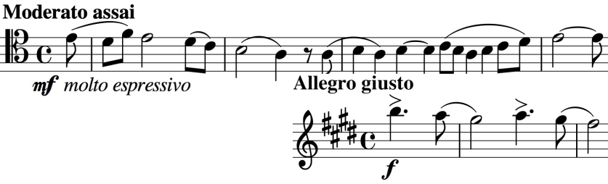

lyrical motifs appear including this triumphant one (*illustrated*) but sadness always returns.

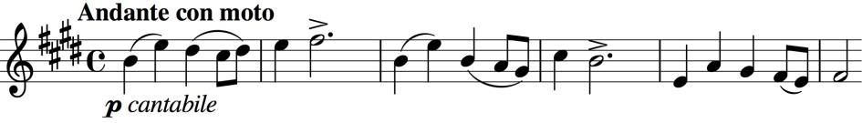

The theme of the second movement is a simple, sunny tune (*illustrated*) said to reflect

a happy day that the two friends once spent together in the country. It provides the basis for the eleven initial variations and for the substantial twelfth. The variations bring out Tchaikovsky's colourful symphonic talent even with the limited resources of the piano trio, evoking such things as bells, waltzes and mazurkas. At the end of the work, the main theme of the first movement returns in the strings against a funeral march in the piano.

The Trio became Tchaikovsky's most popular chamber work. A particular compliment was paid by Sergei Rachmaninov in 1893 who himself wrote an Elegiac Trio "To the memory of a great artist". This time the great artist was Tchaikovsky.