**Programme notes by Chris Darwin. Please use freely for non-commercial purposes**

**Pyotr Il’yich Tchaikovsky (1840-1893) String Quartet No 1 in D Op11 (1871)** *Moderato e simplice – Allegro non troppo ma con fuoco Andante cantabile*

*Scherzo & Trio: Allegro non tanto e con fuoco*

*Finale: Allegro giusto*

Though better known as a master orchestral writer of symphonies and ballet music, Tchaikovsky also published successful chamber music: three string quartets (1871, 1874, 1876), a piano trio in memory of Nikolai Rubinstein(1882) and a string sextet (*Souvenir de Florence*, 1892).

Although verbally precocious – he read in French and German aged six, and at seven wrote in French on metaphysical topics –Tchaikovsky had only above average musical ability as a child. His unusual musical talent only emerged in his twenties. Denied promotion as a qualified lawyer in the Department of Justice, in 1862 he joined Anton Rubinstein’s new ‘music school’, the St Petersburg Conservatory. There Rubinstein taught him good classical composing habits and he absorbed the craftsmanship of Western music: Haydn, Mozart, Beethoven and Schubert. One of his classmates prophesied *‘You are the greatest musical talent in present-day Russia … I see in you the greatest, or, better said, the sole hope of our musical future’.*

He moved to Moscow at the invitation of Anton’s brother Nikolai, to teach harmony at the Moscow Conservatoire, and in 1868 was introduced to “The Five” (aka “The Mighty Handful”): Mily Balakirev (the leader), César Cui, Modest Mussorgsky, Nikolai Rimsky-Korsakov and Alexander Borodin. The group aimed to produce a specifically Russian kind of art music, rather than one based on the Western European style taught in the conservatories. As a pupil of Anton Rubinstein, Tchaikovsky was initially a target for their antagonism. But Balakirev, who had had no formal musical training himself, crucially helped Tchaikovsky with his *Romeo and Juliet* overture, forcing numerous re-writings. Arguably Balakirev was responsible for the emergence of Tchaikovsky’s unique voice, incorporating some of the distinctively Russian musical elements promoted by The Five into forms grounded in his conservatory training.

By the time of Tchaikovsky’s first quartet, 1871, The Five had dispersed: Cui to fortifications engineering, Borodin to a chair of chemistry, Moussorgsky to the bottle, and the influential Balakirev to a nervous breakdown. Tchaikovsky was still teaching at the Moscow Conservatory, but was short of funds. Nikolai Rubinstein suggested he prepare a benefit concert of his own music. An orchestra would have been too expensive, so Tchaikovsky composed this D major string quartet to go with some solo piano items. The work is dedicated to his friend Sergey Rachinsky, a botanist who provided the libretto for Tchaikovsky's Chorus of Flowers and Insects – a scene for *Mandragora,* an uncompleted opera.

The quartet's long opening section of smooth syncopated chords inspired a Moscow

reviewer to give the piece its apparently derogatory nickname of “Accordion”, but

accordions are taken more seriously in Eastern than in Western Europe. A rapid

semiquaver figure is introduced in contrast to this slow-moving passage, which it

decorates as the music becomes more exciting. The second subject (illustrated) is

expansive, *largamente e*

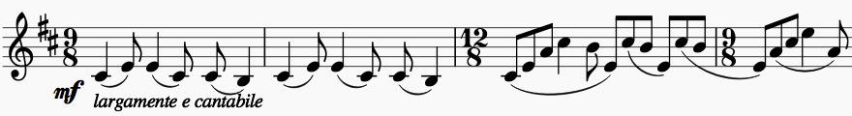

*cantabile*, and also gets

decorated with increasingly persistent and florid semiquavers. Notice the natural way that Tchaikovsky's melody embraces a change in the number of beats in the bar – a feature it shares with the famous tune of the second movement. The tempo increases to a fiery *Allegro* and accelerates to an exciting ending.

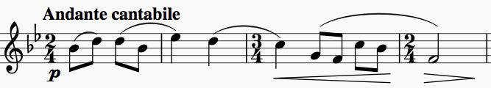

The success of the quartet both at its first performance, and ever since, is substantially due to its famous *Andante*

*Cantabile* (illustrated). Tolstoy heard it in 1876 at a musical evening organised by the Moscow Conservatoire in his honour and was moved tears. The theme is an old Russian folk song that Tchaikovsky had heard two years earlier from a carpenter on his sister’s Ukrainian estate and it contrasts with a minor section that uses a theme of Tchaikovsky’s own composition accompanied *pizzicato*. The *Scherzo* is a heavily accented peasant dance and the *Finale* a combination of Russian vigour and soulfulness, generously decorated with energetic semiquavers, but within an overall reworking of classical rondo and sonata forms – an effective combination of Rubinstein's and Balakirev's training.