**Igor Stravinsky** (1882-1971) Three Pieces for string quartet (1914, rev 1918)

1. *Dance*
2. *Eccentric*
3. *Canticle*

Stravinsky wrote these three pieces early in 1914 at the end of a period when he and his young family were spending summers in Russia and winters in Switzerland, a pattern that was about to be broken by the outbreak of war. They follow *Petrushka* and *The Rite of Spring* and are every bit as iconoclastic: they are short (roughly 1, 2 & 4 minutes) and unconnected. The individual instruments in the first piece also appear unconnected: a peasant fiddler (on first violin) keeps repeating a wild dance motif, the viola drones like a bagpipe with toothache, the cello plucks and the second violin intermittently interjects, all

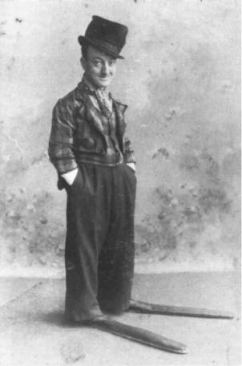

out of synchrony with each other until, after less than a minute it finally all comes together. The second piece shares its inspiration with Michael Palin’s contribution to the Monty Python “Ministry of Silly Walks” sketch: the polydactylic Little Tich whom Stravinsky encountered at a London music hall; the piece is an exploration of pathos and the grotesque. The third is a wordless chant, in glowing harmonies generated within a tightly controlled atonal system. When Stravinsky came to orchestrate the work, some years later, he added the titles: ‘Dance’, ‘Eccentric’ and ‘Canticle’.