**Programme notes by Chris Darwin, use freely for non-profit activities Richard Strauss (1864-1949) Serenade in E-Flat Major, Op. 7 TrV 106 (1881)**

Richard Strauss was a musical prodigy. He was the son of Franz, a superb horn player ('the Joachim of the horn') and tenaciously self-made man. His mother was the daughter of a wealthy local brewer. Richard enjoyed and, thanks to his inherited tenacity, exploited the opportunities of a cultured and affluent family life in Munich. He had his first piano lessons aged 4, first composed at 6, started the violin at 8 and at 11 began five years of composition lessons. The musical tastes of both his influential father and his composition teacher were conservative, so Richard's early works – predominantly for piano and for voice - reflect a solid grounding in classical musical forms . His interest in larger scale instrumental works was stimulated by attending rehearsals and later playing violin in an amateur orchestra, the Wilde Gungl, that his father conducted. Between the ages of 16 and 20 he wrote instrumental works which launched his career: two symphonies, his well-known concertos for violin and for horn and two pieces for 13 wind – today's Serenade and a later Suite which he was encouraged to compose by Hans von Bülow after he had heard the Serenade.

Although the Serenade has the same number of instruments as the well-known Mozart Gran Partita (which the RCM wind played last season), the structure and the scoring are quite different. The work is a single movement in sonata form. Strauss uses two each of flutes, oboes, clarinets and bassoons, with four horns and a contrabassoon or bass tuba – a more conventionally orchestral scoring than Mozart's use of bassett horns. Like Mozart however, Strauss relishes the range of timbres

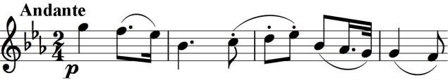

that different combinations of the instruments can produce: each phrase in the first 24 bars uses a different set of instruments before they

all combine for the first time at bar 24. A particularly distinctive scoring occurs where the oboe's opening theme (illustrated) is presented at the recapitulation by the four horns, with bassoons providing the bass.