**Programme notes by Chris Darwin. Use freely for non-commercial purposes**

**Dmitri Shostakovich (1906-1975) Piano Quintet in G minor Op 57 (1940)**

*Prelude. Lento*

*Fugue. Adagio*

*Scherzo. Allegretto*

*Intermezzo. Lento*

*Finale. Allegretto*

Eighty years ago tomorrow on 23 November 1940, the Beethoven Quartet were joined at the Moscow Conservatory by the 34-year old Shostakovich for the first performance of his Piano Quintet. Impressed by his first string quartet, they had asked him to write a quintet that they could play with him. This quintet was not only a great popular success, but also won the official approval, artistic prestige and 100,000 roubles of the inaugural Stalin Prize. Shostakovich donated the prize money to Muscovites impoverished by the effects of the 1941 German invasion.

Although Shostakovich had previously exhorted his fellow composers to compose more chamber music, his own output had been pretty sparse: a teenage piano trio (1923), a cello sonata (1934) and the first quartet (1938). By contrast he had written 6 symphonies and numerous film scores, ballets and operas. The opera Lady Macbeth of the Mtsensk District had unleashed the opprobrium of Stalin himself in 1936 during the Great Terror, but by 1940 his reputation had been restored - the popular acclaim of the 5th Symphony leading in 1937 to a teaching appointment at the Leningrad Conservatory. Perhaps encouraged by the success of the Piano Quintet, the 1940s saw a burgeoning of Shostakovich's chamber compositions: the 2nd piano trio (1944) and the 2nd, 3rd and 4th string quartets (1944, 1946, 1949).

Although the piano quintet's continued popularity is in part due to its harmonic and melodic accessibility, its style also has Shostakovich's engagingly distinctive blend of tragedy and satire that ties you to an emotional roller-coaster. One view of this style relates it to his admiration for Mahler. Shostakovich had been introduced to Mahler's symphonies by a polymath friend, Ivan Sollertinsky. Sollertinsky's description of Mahler has also been applied to Shostakovich: ‘*Dostoyevsky narrated in the language of Charlie Chaplin*’. Much has been written on the political nuances of the piano quintet, but what may well strike you is the beauty and the sheer emotional range and power of the work.

The five movements of the quintet all have classically familiar titles reflecting its structural as well as its harmonic and melodic

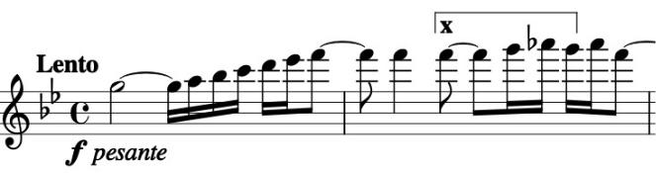

accessibility. The piano opens the *Prelude* boldly (*illustrated*) with a *forte* chord unambiguously in the home key of G minor followed by a boldly ascending

scale of G minor, which doesn't quite make it. It pauses on F against an F major chord which sinks to F minor against a three-note motif (under x), consisting of the first three notes of the minor scale. This motif recurs throughout the work, as in the subject of the second movement's fugue (*illustrated*). The fugue, which is the longest movement, builds from this fetal

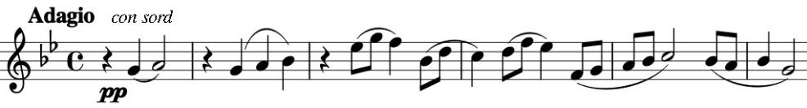

beginning to a huge climax that brings back the forceful

Prelude and then sinks back into the fugal subject.

The *Fugue's* intensity is spectacularly released by the manic rambunctiousness of the *Scherzo.* It exploits another aspect of the work's opening - the ascending scale. Herescales cavort about the page in crazy contrary motion. What could follow all this? A pause for thought in the form of an initially gentle *Intermezzo*: the scales slow to a gentle walking pizzicato bass supporting a simple melodic line. Inevitably the intensity increases to a substantial climax, and then dies away

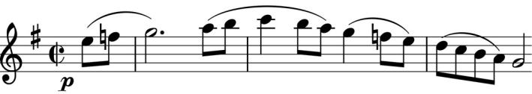

into the piano's simple *Allegretto* theme for the *Finale*. It gets transformed into this unashamedly positive C major,

scale-based melody (*illustrated* ). Tension does reappear, but then the clouds magically lift again and Shostakovich draws things abruptly to a happy ending before they have a chance to get worse.