**Programme notes by Chris Darwin. Please use freely for non-commercial purposes**

**Dmitri Shostakovich (1906-1975) String Quartet No 9 in E-Flat Op 117 (1964)**

*The five movements are played without a break:*

*Moderato con moto-*

*Adagio-*

*Allegretto-*

*Adagio-*

*Allegro*

There was almost a very different Ninth quartet. In 1960 Shostakovich wrote two markedly

personal quartets: the Seventh in memory of his remarkable and deeply-loved first wife

Nina who had died of cancer in 1954; and the intense and autobiographical Eighth.

Although subtitled '*To the victims of war and fascism*', the near-suicidal Shostakovich

regarded his Eighth quartet as his own epitaph 'One could write on the frontispiece:

"*Dedicated to the memory of the composer of this quartet" '*. A year later in 1961 he had

finished the first version of a new quartet, but in a fit of depression, or, to quote his own

words, '*in an attack of healthy self-criticism, I burnt it in the stove.*' His depression was

understandable. A second marriage to a minor party functionary proved disastrous and

ended in late1959; furthermore, in mid 1960 he gave in to pressure to join the Communist

Party: *"Then the heavy hammer of official honours, belated glorification, dealt*

*Shostakovich a much more terrible blow than all the criticism of the 1930s and 1940s"*

(Fyodor Druzhin).

However, his personal life improved in 1962 when he met and married his third wife, 27 year-old Irina Supinskaya: *'she is splendid: clever, cheerful, straightforward and very likeable'* - their close marriage lasted until his death with Irina caring for the composer ashis health deteriorated. The new Ninth Quartet, dedicated to Irina, shares the key of Eb with the original Ninth Quartet. This is not accidental. Shostakovich composed his quartets according to a plan: the key of a quartet is the sub-dominant of the key of its predecessor (so C → A → F etc), but not quite. He displaced the pattern at the 7th quartet, perhaps to ensure that the letters of his name "D, S(Es or E-flat), C, H(B natural)" fell on perfect squares: 4th, 9th, 1st, (16th in theory – he died after the 15th). The Ninth quartet thus had to be in E-flat.

Its five movements, which are played without a break, form an arch (ABCBA), albeit a rather asymmetrical one since the last movement is much longer than any of the others, and combines many of the ideas from the earlier movements. As is often the case with Shostakovich, the quartet makes reference to other

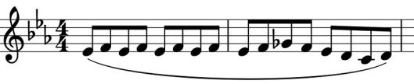

works. One reference that is frequently claimed, and has political significance, is to Moussorgsky's opera *Boris Godunov.* In particular, the very opening motif

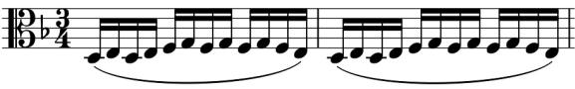

– creeping quavers in the second violin (illustrated)

– recalls the viola's introduction (illustrated) to the

monk Pimen's monologue in *Boris* as he chronicles the truth of past events. The violin's motif, particularly the Eb, F, Gb, F, Eb sequence of the second bar, recurs throughout the quartet, its dense closeness contrasting with new stylistic elements such as recitative and abrupt pizzicato.

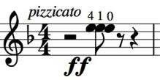At one particularly aggressive point in the middle movement, Shostakovich asks the player to pluck the same note on three strings simultaneously (illustrated). This middle movement is itself also in the

form of an arch. As an example of the extent to which this work is integrated out of a few components, watch out for an eerie section that comes at the return of this movement's initial section. Against

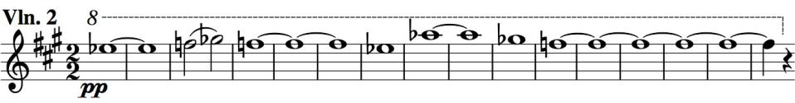

the bouncy galloping of the opening, the first violin and then the

second (illustrated) float a slow high theme that is a slowed-down version both of the accompanying figure and of those creeping quavers that opened the whole work (Eb, F, Gb, F, Eb); it also presages the theme of the following movement.