Programme notes by Chris Darwin. Use freely for non-commercial purposes

**Robert Schumann (1810-1856) Piano Trio no. 2 in F Op 80 (1847)**

*Sehr lebhaft*

*Mit innigem Ausdruck - Lebhaft*

*In mässiger Bewegung*

*Nicht zu rasch*

The 1840s started eventfully for Schumann. In September 1840 he finally achieved his goal of marrying Clara Wieck, against the wishes of her vindictive and spiteful father, Robert's erstwhile piano teacher. His compositions flourished. That year was his *Liederjahre,* with such masterpieces as *Dichterliebe* and *Frauenliebe und leben;* thefollowing year produced his first Symphony. 1842, after a depressive start, was his chamber-music year: 3 string quartets, the piano quartet and piano quintet and the *Fantasiestücke* for piano trio. But his health was starting to decline, so that in 1843 heresigned from the teaching post that Mendelssohn had created for him at the new Leipzig Conservatory and the following year the couple moved to Dresden in search of the health benefits of a quieter life (despite the presence of Wagner).

Schumann's first two piano trios both date from 1847, along with numerous part-songs written for the local choral society that he conducted. They are very different in mood. Where the first in D minor is by turns dramatic, passionate, gloomy and eventually life-affirming, the second in F major makes, in

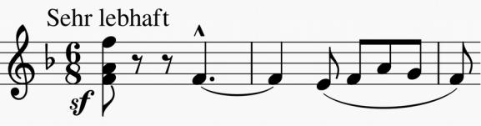

Schumann's own words, a "friendlier and more immediate impression". The work opens with robust open good cheer (*illustrated*) which is soon contrasted by a gentler rhythmic

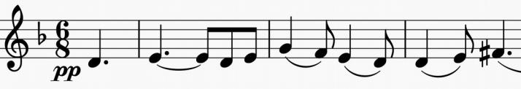

modification of itself (*illustrated*). An even

more beautiful *dolce* melody comes a little

later (*illustrated*) which is a quotation from

the second of

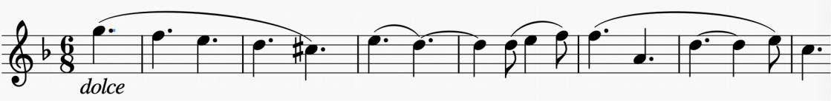

his Op 39

*Liederkreis*

songs

(Intermezzo:

"*Dein Bildnis wunderselig*" – Your wonderful portrait).

The second movement treats us to yet another wonderful melody, which is related to the descending scale of the *Liederkreis* melody. The violin sings it against an unusual accompaniment in which the left hand of the piano plays in canon, half a bar behind the cello. Starting in the five flats of Db major the movement wanders through what seems to the terrified amateur violinist every imaginable key before returning home. Schumann is good at that! The waltz-like third movement is also built on canons, starting with the piano and cello one bar apart.

The good-natured last movement is built on three two-bar ideas (*illustrated*), which are stated successively at the beginning by the piano, cello and violin respectively. Again the writing is predominantly contrapuntal extending the canonic writing of the earlier movements to build up to a triumphantly optimistic finish.

