**Robert Schumann (1810-1856) String Quartet Op 41 No 3 (1842)**

*Andante espressivo - Allegro molto moderato*

*Assai agitato - Un poco adagio - Tempo risoluto*

*Adagio molto*

*Finale: Allegro molto vivace – Quasi Trio*

Coming after his 'Liederjahre' of 1840 and the subsequent 'Symphonic Year' of 1841, 1842 was Schumann's 'Chamber Music Year': three string quartets, a piano quartet and the particularly successful piano quintet. Such creativity may have been due to Schumann at last winning, in July 1840, the protracted legal case in which his ex-teacher Friedrich Wieck, attempted to forbid him from marrying Wieck's daughter Clara. They were married on 12 September 1840, the day before Clara's 21st birthday.

1842, however, did not start well for the Schumanns. Robert accompanied Clara at the start of her concert tour of North Germany, but he tired of being in her shadow, returned home to Leipzig in a state of deep melancholy, and comforted himself with beer, champagne and, unable to compose, contrapuntal exercises. Clara's father spread an unfounded and malicious rumour that the Schumanns had separated. However, in April Clara returned and Robert started a two-month study of the string quartets of Haydn, Mozart and Beethoven. During June he wrote the first two of his own three quartets, the third following in July. He dedicated them to his Leipzig friend and colleague Felix Mendelssohn. The three quartets were first performed on September 13, for Clara's birthday. She thought them 'new and, at the same time, lucid, finely worked and always in quartet idiom' - a comment reflecting Schumann the critic's own view that the ‘proper’ quartet style should avoid ‘symphonic furore’ and aim rather for a conversational tone in which ‘everyone has something to say’.

In Schumann's third quartet as in his first two his wonderful lyrical gift sings out to us, and we are fooled by his rhythmic playfulness.

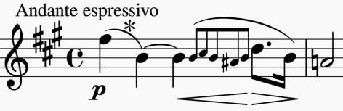

The brief introductory Andante opens with a sighing, falling fifth (*). It sets the mood and both opens the main Allegro and recurs throughout it in various guises.

*Schumann's rhythmic trickery pops up in the second subject of the Allegro. After a brief silence, the upper strings start their off-beat accompaniment just*

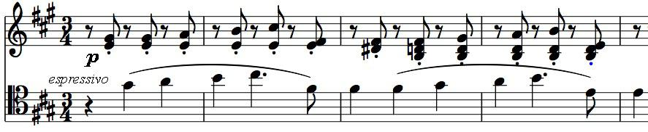

*before the cello enters with the theme; not only is this deceptive for the listener, but it is a notorious pratfall for the unwary amateur player.*

Another rhythmic trick starts the second movement. Here everyone enters on the last quaver of the bar, but the tune is tied over as if the first note were really the

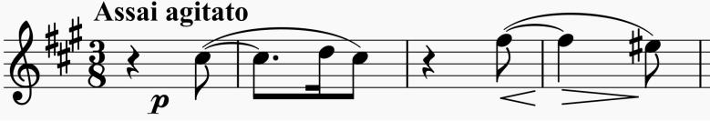

downbeat. The theme is a decorated descent over an interval of a fifth. There follows a set of entertaining variations culminating in one of huge and relentless energy with the accent resolutely on the offbeat, dominated by leaps that rework the opening falling fifth.

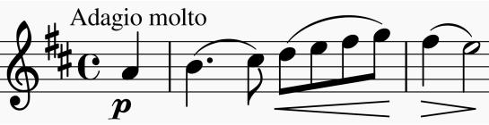A calming coda prepares us for the beautiful Adagio molto, whose opening theme is based on a rising figure that again embraces an interval of a fifth. The serenity of this idea is twice challenged by a

threatening transformation in the minor, but serenity prevails.

There are more rhythmic tricks in the Finale. The rustic dotted theme starts with an accented up-beat which sounds like a down-beat as if the rustics are also tipsy. The movement is a Rondo with the opening episode alternating with a variety of others, including a "Quasi Trio" - compensation for the absence of a traditional Minuet/Scherzo & Trio movement.