**Robert Schumann (1810-1856) String Quartet in F Op 41 No 2 (1842)** *Allegro vivace*

*Andante quasi variazioni*

*Scherzo. Presto - Trio. L'istesso tempo*

*Allegro molto vivace*

Coming after his 'Liederjahre' of 1840 and the subsequent 'Symphonic Year' of 1841, 1842 was Schumann's 'Chamber Music Year': three string quartets, a piano quartet and the particularly successful piano quintet. Such creativity may have been due to Schumann at last winning, in July 1840, the protracted legal case in which his ex-teacher Friedrich Wieck, attempted to forbid him from marrying Wieck's daughter Clara. They were married on 12 September 1840, the day before Clara's 21st birthday..

1842, however, did not start well for the Schumanns. Robert accompanied Clara at the start of her concert tour of North Germany, but he tired of being in her shadow, returned home to Leipzig in a state of deep melancholy, and comforted himself with beer, champagne and, unable to compose, contrapuntal exercises. Clara's father spread an unfounded and malicious rumour that the Schumanns had separated. However, in April Clara returned and Robert started a two-month study of the string quartets of Haydn, Mozart and Beethoven. During June he wrote the first two of his own three quartets, the third following in July. He dedicated them to his Leipzig friend and colleague Felix Mendelssohn. The three quartets were first performed on September 13, for Clara's birthday. She thought them 'new and, at the same time, lucid, finely worked and always in quartet idiom' - a comment reflecting Schumann the critic's own view that the ‘proper’ quartet style should avoid ‘symphonic furore’ and aim rather for a conversational tone in which ‘everyone has something to say’.

The first movement of today's second quartet, like many of Haydn's, is based substantially on a single

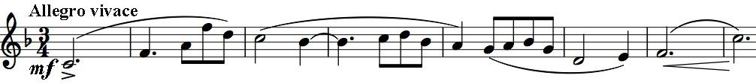

theme with which the first violin opens

the work. Sunny geniality pervades this movement, which though unambitious shows a mastery of the contrapuntal techniques necessary to let everyone have something to say. The next movement is more unusual – a set of variations, with a generally subdued mood. The first variation uses a device that Schumann was fond of: misleading the listener as to where the beat is – it is actually a quaver later than it sounds.

The Scherzo lightens the mood in a movement reminiscent of Mendelssohn. The Trio again plays a rhythmic trick

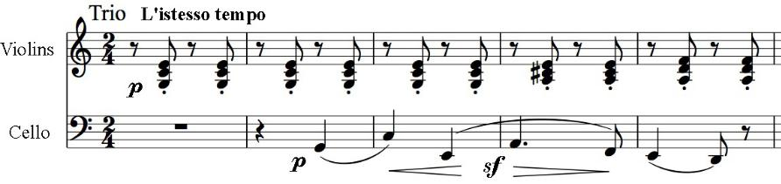

(illustrated), with the opening accompaniment sounding to be on rather than off the beat. (Schumann again uses this device in the first

movement of his third quartet, in a way which is even more awkward for the players.) The movement's brief coda unites material from the Scherzo and the Trio. The last movement is an energetic romp, with a fluent Mendelssohnian cheer triumphing over the darker, more sinister episodes characteristic of Schumann. Its opening employs another device of Schumann's: he doesn't start at the beginning – it is as if the players are already playing when you open the door on their performance.