Programme notes by Chris Darwin. Please use freely for non-profit activities

**Robert Schumann (1810-1856) String Quartet in A minor Op. 41 No. 1 (1842)**

*Andante espressivo — Allegro*

*Scherzo: Presto*

*Adagio*

*Allegro*

Coming after his 'Liederjahre' of 1840 and the subsequent 'Symphonic Year' of 1841, 1842 was Schumann's 'Chamber Music Year': three string quartets, a piano quartet and the particularly successful piano quintet. Such creativity may have been due to Schumann at last winning, in July 1840, the protracted legal case in which his ex-teacher Friedrich Wieck attempted to forbid him from marrying Wieck's daughter Clara. They were married on 12 September 1840, the day before Clara's 21st birthday.

The year 1842, however, did not start well for the Schumanns. Robert accompanied Clara at the start of her concert tour of North Germany, but he tired of being in her shadow, returned home to Leipzig in a state of deep melancholy, and comforted himself with beer, champagne and, unable to compose, contrapuntal exercises. His state of mind was not improved by Clara's father spreading an unfounded and malicious rumour that the Schumanns had separated.

However, in April Clara returned and Robert started a two-month study of the string quartets of Haydn, Mozart and, particularly for tonight's quartet, Beethoven, who had died 16 years earlier. During June he wrote the first two of his own three quartets, the third following in July. He dedicated them to his Leipzig friend and colleague Felix Mendelssohn, who as a teenager had been one of the few to appreciate late Beethoven. Schumann's three quartets were first performed on September 13, for Clara's birthday. She thought them 'new and, at the same time, lucid, finely worked and always in quartet idiom' - a comment reflecting Schumann the critic's own view that the ‘proper’ quartet style should avoid ‘symphonic furore’ and aim rather for a conversational tone in which ‘everyone has something to say’.

The first movement shows how well Schumann had assimilated the now-established sonata form. The long *Andante* introduction

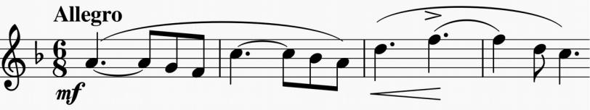

(recalling Beethoven's later quartets) leads to a genial theme (*illustrated*) with a characteristically Schumann off-beat accent (bar 3) trying to throw you. This off-beat phrase is developed later in its own right, when the temptation to mentally shift the bar line becomes stronger. There is a contrasting motif announced by a 'rum-ti-tum' figure that provides contrast for the classically-structured development.

That the *Presto* Mendelssohn-like *Scherzo* comes second promises great things for the subsequent slow movement. It does not disappoint: its opening strongly recalls that of the slow movement of Beethoven's last symphony, with its serene slow melody (*illustrated*) after a 3-bar introduction.

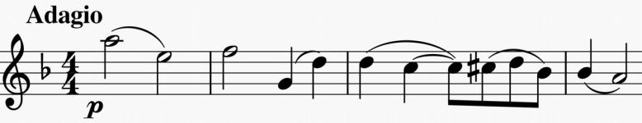

However, this introduction, with its arch-shaped semiquaver phrase on the cello and then the violin, is more than it seems. After the

glorious slow theme has been celebrated by the violin and then, aah, the cello!, there is a change of mood and the semiquaver arch now reappears asserting its right to a proper hearing. It takes us on an intense journey through remote keys before calm is restored by the slow theme playing us out against a rhythmically enriched background.

The last movement rollicks along with the same good-natured energy as the last movement of Schumann's Piano Quartet, also composed in 1842, which was played for us in March by the Notos Quartet. Just before the end, late Beethoven reappears in the form of a curious bagpipe-like *Musette* reminiscent of the middle movement of his Op 131.