**Programme notes by Chris Darwin. Use freely for non-commercial purposes**

**Robert Schumann (1810-1856) Fantasiestücke op. 88 (1842)**

*Romance: Nicht schnell, mit innigem Ausdruck*

*Humoreske: Lebhaft - Etwas lebhafter*

*Duet: Langsam und mit Ausdruck*

*Finale: Im Marsch Tempo - Dasselbe Tempo*

*(YouTube has a fine performance by Martha Argerich* [*here*](https://www.youtube.com/watch?v=qcROBUnll3g)*, with simultaneous score pages displayed)*

Although it is much less well known than either his piano quintet or quartet or indeed his three string quartets, this A minor piano trio was also written in Schumann's 'Chamber Music Year' of 1842. Such creativity may have been due to Schumann at last winning, in July 1840, the protracted legal case in which his ex-teacher Friedrich Wieck, attempted to forbid him from marrying Wieck's daughter Clara. They were married on 12 September 1840, the day before Clara's 21st birthday. The 'Chamber Music Year' of 1842, however, did not start well for the Schumanns. Robert accompanied Clara at the start of her concert tour of North Germany, but he tired of being in her shadow, returned home to Leipzig in a state of deep melancholy, and comforted himself with beer, champagne and, unable to compose, contrapuntal exercises. Clara's father spread an unfounded and malicious rumour that the Schumanns had separated. However, in April Clara returned and Robert started a two-month study of the string quartets of Haydn, Mozart and Beethoven.

The musical term Fantasia goes back at least to the 16th Century, when Thomas Morley described it as where "*… a musician taketh a point at his pleasure wresteth and turneth it as he list … and what you list*." However, Schumann's relationship with *Fantasiestücke* originates with an essay of that name by E.T.A.Hoffmann which introduced the character of Kreisler – Hoffmann's moody, asocial composer alter ego. Schumann's 1838 *Kreisleriana* contains eight piano Fantasias which allow Schumann's fancy to wrest and turn as he list.

Tonight's 1842 Fantasiestücke Trio similarly contains four strongly contrasted character

pieces, more freely constructed than a 'proper' piano trio and mostly on a small scale – the

first movement is less than three minutes long and each of the last two not much more.

The second – Humoreske – clocks in at

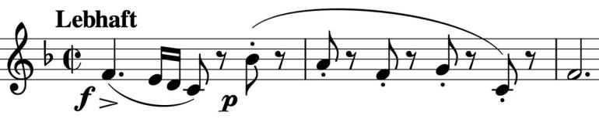

about 7 minutes and catches the

attention with chipper tune that you

may well feel you have heard before.

There are a number of contrasting

episodes before this theme returns at the end.

The following Duet has the cello and violin really wanting to get closer than social distancing allows. How could you not love a

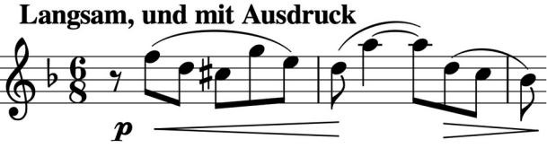

husband who writes this for you? Incidentally, the Trio was dedicated to Frau Sophie Petersen *née* Petit from the Hamburg suburb of Altona.

Tantalisingly I can tell you nothing more of her. Anybody know her?