**Erwin Schulhoff (1894 – 1942) String Quartet No 2 (1925)**

*Allegro agitato*

*Tema con variazioni. Moderato -Tempo di Fox – Tempo primo*

*Allegro gajo*

*Finale. Andante quasi introduzione - Allegro molto*

Born in Prague to a musical German family, the young Schulhoff was a prodigiously gifted pianist. Dvořák heard the 7-year old play and was so impressed that he gave him two pieces of chocolate and encouraged him to become a musician. Aged 10 he studied at the Prague Conservatory before going on to Vienna, Leipzig and Cologne, where he briefly studied with Debussy. His early compositions were influenced by Debussy, Reger, Richard Strauss and Scriabin. However, his experiences as a conscript in the first world war had a profound effect: angry and disillusioned, he became a convinced socialist and was unable to continue to compose in a post-romantic idiom. In the words of art historian Bert Olivier: ‘the society that could countenance (and give rise to) the advent of something as inhuman as the First World War, was in dire need of destruction, so that it could be re-built in a radically different way’.

In 1919 he found two incompatible new directions. In Dresden he championed the Second Viennese School, organising concerts of Berg and Schoenberg, whilst in Berlin through his friendship with George Grosz, he discovered both Dadaism and, thanks to Grosz's wonderful record collection, jazz. Schulhoff's Dada-influenced works from 1919 include *Fünf Pittoresken* for piano; its third movement *In Futurum* consists of 29 bars of minutelyand ridiculously scored rests. Although Alphonse Allais had composed a totally silent piece in 1897 (*Funeral March for the Obsequies of a Great Deaf Man)*, Schulhoff was still 33 years ahead John Cage's more famous 4'33". Another Dada -esque work written in 1919, but in a rather different vein, is Schulhoff's *Sonata Erotica* for solo female voice; again carefully scored, it is 70 years ahead of Sally's infamous delicatessen monologue to Harry and similarly available on YouTube.

On his return to Prague in 1923 Schulhoff settled into a productive period, writing mostly chamber music, whose generally tonal base is invigorated by the influence of a wide diversity of dance, jazz and folk music and by the music of Janáček and Bartók. His first and second string quartets come from the beginning of this period (1924-5). After a visit to Moscow in 1933 Schulhoff espoused Socialist Realism, writing symphonies and also a cantata setting parts of the Communist Manifesto in a serious, heroic style. The German occupation of Czechoslovakia threatened Schulhoff's life - he was both a Jew and a communist. In 1941 he obtained a visa to emigrate to the Soviet Union; a week later Germany invaded the Soviet Union. Unable to leave Prague, Schulhoff was arrested for being a Soviet citizen and deported to a concentration camp in Bavaria, where in August 1942 he died of tuberculosis.

Schulhoff's second, and last, quartet is less often played than his first, but has the same rhythmic strength and harmonic directness, building on jazz, Janáček and Bartók, and in particular the folk music which was also influencing them.

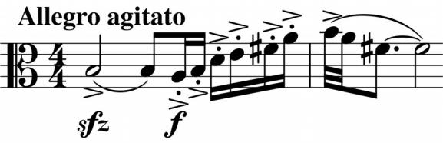

The solo viola fires the starting pistol on the short (4'), first, *perpetuum mobile*-style movement, starting an engine that produces a rhythmic pulse of semiquavers across the instruments that lasts (excepting 6 beats of

unison rising triplets) right through to the final bars. Against this relentlessly driving

background the viola's initial idea is developed: for example, the violin initially throws it back, but inverted. There is a brief, gentler middle section when the tempo slackens and the dynamic reduces as if the train is gently crossing a more pastoral landscape, but the relentless drive returns and powers to the finish.

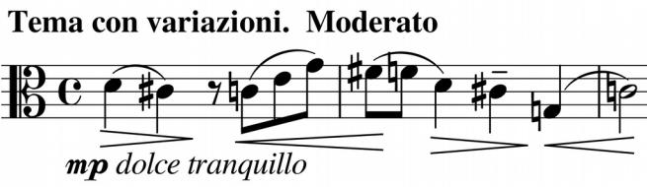

The solo viola again opens the second movement, with the theme for its variations; this theme is related to the one at the opening of the work. The mood of the movement is generally wistful and

tender but interrupted by a rapid dance middle section marked *Tempo di Fox*. The solo high cello finally restates the theme, which dies away leading straight into the lively *Allegro gajo* third movement. "Gajo" is an old spelling of "gaio" – cheerful. The third movementunexpectedly dies away, while the last movement contrasts lively energy with nostalgic elegy.