**Programme notes by Chris Darwin. Use freely for non-commercial purposes**

**Franz Schubert (1797-1828) Piano Quintet in A major, D.667 ‘Trout’ (1819)** *Allegro vivace*

*Andante*

*Scherzo. Presto*

*Tema con variazione. Andantino*

*Finale. Allegro giusto*

Although written only 7 years after the 'Sonatensatz' trio that we heard before the Interval, the exuberant 'Trout' quintet of 1819 is the work of a master. Together with the 'Quartettsatz' written in 1820 it sets the scene for the great chamber works of his later years: in 1824 the Octet, the A minor “Rosamunde” quartet and the D minor 'Death and the Maiden'; in 1826 the G major quartet; in 1827 his two piano trios; and in his last year, 1828, the incomparable C major two-cello quintet.

The 22-year old Schubert's cellist friend Sylvester Paumgartner commissioned the 'Trout' quintet while Schubert was visiting his home town of Steyr in Upper Austria. Paumgartner asked Schubert to include material from his 1817 song '*Die Forelle'. A*s their mutual friend Albert Stadler, later wrote: *'[it was] the particular*

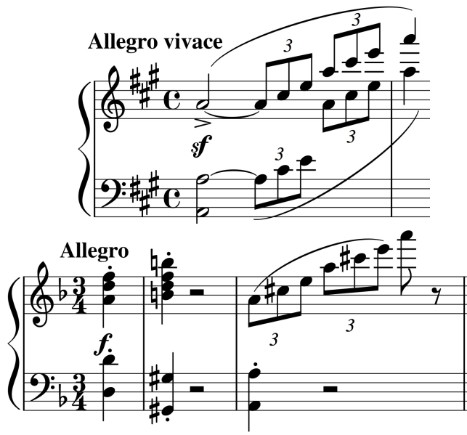

*request of my friend Sylvester Paumgartner, who was quite taken with the delicate little song. The Quintet, according to his wish, was to adopt the structure and instrumentation of Hummel's Quintet, originally Septet, which was then still new.'* Paumgartner had invited friends round to play this Hummel quintet, an arrangement, probably by Hummel himself, of

the Op 74 Septet of 1816. The *Allegro vivace* opening flourish of the Trout quintet (*illustrated*) has a clear resemblance to the triplet arpeggio at the start of the Hummel quintet's *Allegro* second movement (*illustrated*). These arpeggios are major motifs of both works.

The rather curious instrumentation of the Trout quintet – adding a double-bass to the conventional piano quartet's violin, viola and cello - had been used by Hummel back in 1802 for an original piano quintet as well as for the later septet arrangement that brought together Paumgartner's friends and spawned the Trout. The addition of the double-bass raises all sorts of possibilities for Schubert particularly in the well-known fourth movement with its variations on the '*Die Forelle*' theme. It allows him for example to liberate the piano from providing the deep bass, and (in the third variation) send it off on brilliant high octave passage work while the cello and bass, also in octaves, growl the theme. They stay together for the fourth variation doing unexpectedly nimble fortissimo triplets, even finishing with that A-major triplet arpeggio that the piano

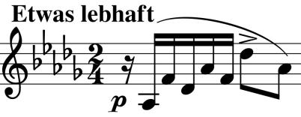

flourished right at the work's opening. Happily, a related arpeggio that starts the piano accompaniment to *'Die Forelle'*

(*illustrated*), leaps into action in the final variation. The success of a movement consisting of variations on one of his songs may have encouraged Schubert to repeat the recipe 5 years later in the *"Death and the Maiden"* string quartet.