**Programme notes by Chris Darwin. Please use freely for non-commercial purposes. Franz Schubert (1797-1828) Piano Trio No.1 in B-flat major, D.898 (1827)**

*Allegro moderato*

*Andante un poco mosso*

*Scherzo & Trio: Allegro*

*Rondo: Allegro vivace*

Schubert's two Piano Trios date from the final years of his life when, frustrated by his lack of success at opera and dissatisfied with his song writing, he returned to instrumental music, overcoming the daunting shade of Beethoven to compose a series of masterpieces. His two piano trios were written after the octet and the late string quartets (including *'Death and the Maiden'* and the G major quartet) but before the 2-cello string quintet. The trios are both very substantial works, matching his contemporary 'Great' C major symphony in length and musical depth. Schubert was known to Viennese concert-goers almost exclusively as a writer of songs: many male-voice part songs plus the *Erlkönig* (and a few others). By the end of 1827 the only public performances of his chamber music had been of just three of his works (including the first Piano Trio) in the Schuppanzigh Quartet's subscription concerts.

Despite Schubert's failing health and erratic mood swings, the B-flat Trio is radiant. Robert Schumann wrote of it: “*One glance at Schubert’s*

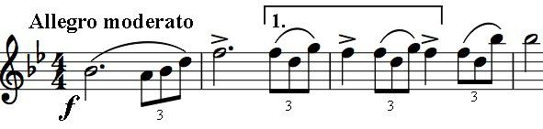

*Trio and the troubles of our human existence disappear and all the world is fresh and bright again.*” The glorious opening theme (illustrated) in unison on violin and cello is confident and optimistic. It also contains two ideas, one local,

one global, which reappear in various forms throughout the piece. The local idea is the triplet – crochet pattern under [1]. The global idea is the pattern of the first four bars: simply put, “slow, slow, quick, slow”. The same

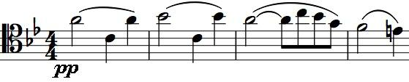

pattern reappears immediately in the tender second theme (illustrated) introduced by the cello. After an expansive development of this material Schubert

gives us three false starts for the recapitulation in 'wrong' keys.

The glorious *Andante* with its opening cello theme joined rhapsodically by the violin was, incredibly, an afterthought. Schubert originally wrote a slow *Adagio,* which was posthumously published as a *Notturno* in E-flat D.897. The *Notturno's* opening theme (illustrated) is a slowed down version of the opening

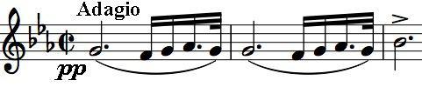

of the first movement. It is not clear why Schubert rejected it, but we are lucky that he did since the replacement *Andante* is one of those movements

that you cannot imagine being without – and we do still have the *Notturno*.

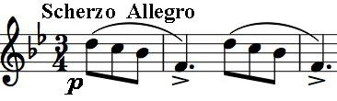

The *Scherzo and Trio* are based on the *Ländler* and the waltz

respectively. The opening figure of the *Scherzo* (illustrated) is

based on the local triplet-crotchet figure of the first movement,

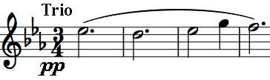

whereas the first four bars of the Trio (illustrated) are in its

global 'slow, slow, fast, slow' pattern. This global pattern also

appears in 2-bar

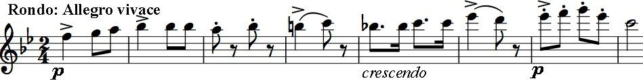

units in the 8-bar

opening of the Rondo last movement (illustrated) with the dotted rhythm providing the 'quick' quality.