**Franz Schubert (1797-1828) Piano Trio No 2 in E-flat major D.929 (1827)** *Allegro*

*Andante con moto*

*Scherzo: Allegro moderato*

*Allegro moderato*

Schubert's two Piano Trios date from the final years of his life when, frustrated by his lack of success at opera and dissatisfied with his song writing, he returned to instrumental music, overcoming the daunting shade of Beethoven to compose a series of masterpieces. His two piano trios were written after the octet and the late string quartets (including *'Death and the Maiden'* and the G major quartet) but before the 2-cello string quintet. The trios are both very substantial works, matching his contemporary 'Great' C major symphony in length and musical depth.

Schubert was known to Viennese concert-goers almost exclusively as a writer of songs: many male-voice part songs plus the *Erlkönig* (and just a few others). By 1828 the only public performances of his chamber music had been of just three of his works (including the first Piano Trio) in the Schuppanzigh Quartet's subscription concerts between 1824 and 1827. However, on 26th March 1828, choosing the date to be precisely on the first anniversary of Beethoven's death, Schubert organised a benefit concert of his own music. He could now present a wider range of his music to the public, and the E-flat Piano Trio was the centrepiece. It was performed by the pianist Carl Maria von Bocklet, with Schuppanzigh and his quartet's cellist Josef Linke. In January, this group had previously played the trio at a private party to celebrate the engagement of Schubert's school-friend Josef von Spaun. The Trio exists in two versions: the original, in manuscript form, and the published, which has a shortened last movement. We are not sure why, or indeed when Schubert made the changes, but it is likely they occurred after these concerts.

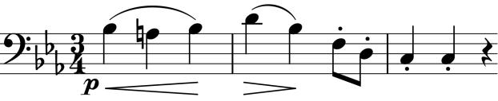

The first movement opens with a bold flourish, shortly followed by a more singing theme on the cello (*illustrated*), and a little later by a

tripping figure of crotchet and four quavers (*illustrated*) which is a modification of the opening flourish. The material is

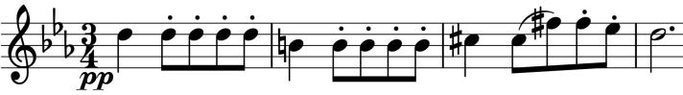

expounded, developed and recapped at glorious Schubertian length before a final

outburst of the opening flourish, and a wistful off-stage echo of crotchet and four quavers.

Those quavers are transformed into the opening accompaniment of the beautiful *Andante.* The movement takes some of its material from a Swedish folk-song '*Se solen sjunker'* ('Look, the sun is setting'), which Schubert encountered when the Swedish singer Isak Albert Berg visited Vienna.

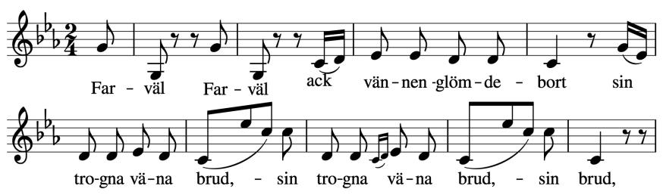

Schubert adapts its repeated quaver piano accompaniment, but most strikingly, at bar 13 the cello takes the song's octave descent (on the word 'Farewell')

and the subsequent phrase with a leap of a tenth (*illustrated*) almost verbatim. The 'Farewell' octave fall, which also poignantly ends the movement is likely in tribute to Beethoven, the sun that has set.

The romping *Scherzo* starts as a canon with the piano leading the strings by a bar, but then naughtily slides up a semitone from E-flat to E major (a Beethoven trick) for a different canon this time at an interval of two bars. The second half of the Trio sees the crotchet and four quavers motif return in a different guise.

The *Finale* is unusually long, even for Schubert and even in the revised, shorter, 748-bar form played today (no requested repeat of the first 230 bars and a further 90-odd bars cut from the original). It is in a combination of sonata form (like a conventional first movement) and the more usual last movement form of a *Rondo*. After the unpromising opening theme, which sounds like it might have been overheard in a well-used bar, the second theme of the movement is more exotic. The time-signature shifts from 6/8 to 2/2, squashing 8 quavers into the time previously taken by 6, and the rapid repeated quavers on the violin and later in octaves on

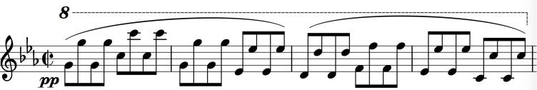

the piano (*illustrated*) produce an effect like a Hungarian cimbalon.

Anticipating the 'cyclic form' later used extensively by César Franck and others, Schubert revisits the cello's theme from the opening of the *Andante;* a further recurrence adds the cimbalon-style accompaniment. After a careful and exhaustive analysis of this movement, the musicologist John Gingerich writes: *'Is the finale of the E-flat Trio too long? In its published form, I would have to say a grudging “yes”; in its original* [longer] *form, in which it was first successfully performed, it was just the right length.'* Opinions differ.