Programme Note by Chris Darwin: please use freely for non-commercial purposes

**Franz Schubert (1797-1828) Octet in F D.803 (1824)**

*Adagio – Allegro – Più allegro*

*Adagio (*or *Andante un poco mosso)*

*Scherzo: Allegro vivace*

*Andante - Un poco più mosso – Più lento*

*Menuetto: Allegretto*

*Andante molto – Allegro – Andante molto – Allegro molto*

Schubert wrote his Octet in 1824, the same year as the A-minor “Rosamunde” and D-minor “Death and the Maiden” quartets. They were followed in 1826 by the G-major quartet; in 1827 by his two piano trios; and in his last year,1828, by the incomparable C-major two-cello quintet. This creativity in writing instrumental music was born of frustration: *'...I have composed two operas to no purpose whatever. I have done very little new in the way of songs; but to make amends, I have made several attempts in instrumental things, for I have composed two Quartets, beside an Octet...'.* Writing theOctet absorbed him; one of his friends wrote to another in March 1824 *'He has now long been at work on an Octet with the greatest zeal. If you go to see him during the day, he says, “Hello, how are you? –-- Good!” and goes on writing, whereupon you depart.'*

The Octet was written at the request of Count Ferdinand von Troyer, an officer in Archduke Rudolf's household. Troyer played the clarinet and asked for a work modelled on Beethoven's popular Septet of 1800. Schubert perhaps felt that such a piece might bring him the popular acclaim that he felt he lacked. The structure and key relationships of the Octet are closely modelled on Beethoven's Septet, which in turn is similar in structure to Mozart's renowned String Trio K.563. Schubert adds an extra violin to the septet to give a full string quartet plus bass, clarinet, horn and bassoon.

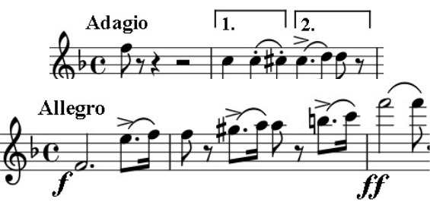

That the work has an opening *Adagio* is unique in Schubert's chamber music. Its second bar contains two rhythmic motifs which not only dominate the intro-duction but pervade the whole work. The second motif is evident in the main theme of the following *Allegro* (illustrated) as well as the second theme in-troduced by the clarinet. In fact, there is scarcely a bar in the whole movement that does not have the dotted quaver rhythm somewhere in it. Well into the de-velopment the clarinet introduces a new idea (illus-trated) that is modelled on both motifs 1 and 2.

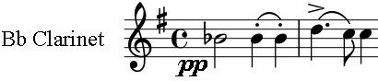

The slow movement, which is either *Adagio* or *Andante un poco mosso* depending on your edition and its interpretation, opens with a serene 12-bar melody first on the clarinet, then lovingly paired with the violin. Towards the end of the movement the serenity is broken by a solitary plucked *sforzando* bottom F on cello and bass and the movement ends without regaining its previous optimism. The shattering of serenity recurs in Schubert's late cham-ber music, often terrifyingly, as in the later G major quartet. His mood was often low and the symptoms of syphilis were apparent. Shortly after finishing the Octet he wrote to a close friend “*every night when I go to sleep I hope never again to awake, and every morn-ing renews afresh the wounds of yesterday*”.

There is no hint of melancholy though in the vigorous third movement; it is based on two peasant dances, the vigorous dotted rhythm steps of the *G'stampfter* and the gentler

*Ländler* of the trio section. The fourth movement is a set of variations based on the theme of a duet in the Singspiel “*The Friends from Salamanca*” that Schubert wrote nine years before the Octet. Whether Schubert consciously re-used it is debatable since he had a habit of not recognising his own work: '*Very nice – who wrote it?*' The octet version of the theme has more dotted rhythms than the sung original, integrating it more with the previ-ous movements. The dots get exaggerated by the wind in the spiky second variation and then smoothed back to single dots by the horn in the third while the first violin dashes off arpeggios up to great heights. In the faster seventh variation the violin provides demi-semiquaver pyrotechnics while the clarinet chugs out the tune; the demis gradually lose energy as the tempo slows, with the horn laying them to rest after a tricky two-octave downward plunge.

The fifth movement is a classically-structured Minuet and Trio with both sections starting with a version of the dotted motif 2, a movement of relative simplicity after the complex variations, preparing us for the further complexities of the last movement. The *Andante molto* introduction to the last movement is grief-stricken and again features the dotted rhythm motif. But, as in the last movement of Mozart's G-minor string quintet, the com-poser thumbs his nose at fate, and cavorts off in what sounds like it will be boisterous *fi-nale*. After a while though, tensions appear. The first violin squeals in anguish in one of the most awkward passages in all chamber music, not once but twice. The music drives on into remote keys, calms, drives on again, and abruptly halts: with a growling tremolo we are back to the despair of the movement's introduction, sweetened now by increasingly conciliatory violin arpeggios. With a switch to *Allegro molto* the original energy returns to triumphant violin arpeggios and a thankfully happy ending.