**Programme notes by Chris Darwin. Use freely for non-commercial purposesFranz Schubert (1797-1828) String Quartet No. 9 in G minor, D173 (1815)**

*Allegro con brio*

*Andantino*

*Menuetto. Allegro vivace — Trio*

*Allegro*

The autumn of 1814 was the start of one of the most extraordinary burgeonings of creativity music has ever seen. Over 15 months, the teenage Schubert not only produced around 150 songs (including *Gretchen am Spinnrade* and *Erlkönig*), but also two string quartets, two symphonies, two masses and four Singspiele. He composed at a rate of over 65 bars a day despite being a full-time teacher at his father's school, having composition classes twice a week with Salieri, and being so short-sighted that he even wore his glasses when he was asleep.

Today's G minor quartet was written in the 8 days between 25 March and 1 April 1815; it was the penultimate of his early quartets, the first dating from 1811. These quartets would have been played within the family: Franz on viola, his brothers on violin and father on cello. They reflect a rapidly developing musical personality which by 1815 had substantially turned into his mature voice.

A favourite symphony of Schubert's was Mozart's #40 in G minor and the start of its *Allegro assai* last movement (*illustrated*) probably inspired the opening of his own G minorquartet (*illustrated*).

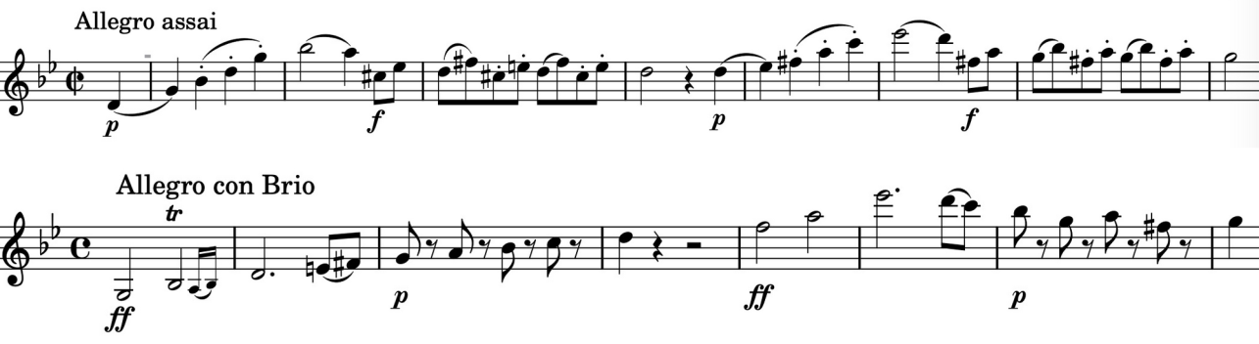

The movement has great drive with recognisably unpredictable Schubertian modulations. It has the unusual feature of the recapitulation starting, after the briefest of developments, in the major rather than the home minor. A surprise for the first violin is being sent up to the instrument's highest D three bars before the end.

The B-flat major *Andantino* perhaps pays homage to Mozart; it is based on the simplest of phrases which the young Schubert is not afraid to explore thoroughly in a way that is reminiscent of the B-flat *Andante* from Mozart's last string quintet.

The *Menuetto* returns to G minor with a forthright tune based on the material of the work's opening; it contrasts with a gently persuasive trio. The work ends with a cheekily boisterous rondo.