Programme Note by Chris Darwin: please use freely for non-commercial purposes

**Franz Schubert (1797-1828) String Quartet in D minor, D.810 (Death and the Maiden)**

**(1824)**

*Allegro*

*Andante con moto*

*Scherzo: Allegro molto*

*Presto*

At the age of eight, Schubert started to learn the violin from his father; six years later he was composing for the family string quartet: brothers Ignaz and Ferdinand on violin, Franz on viola and his father on cello. However, the eleven or so quartets that Schubert wrote between the ages of 14 and 20 are now, like Mozart's early quartets, rarely played. The exuberant “Trout” piano quintet of 1819 and the surviving first movement of a C minor quartet (“Quartettsatz”) written in 1820 set the scene for the great chamber works of his later years: in 1824 the Octet, the A minor “Rosamunde” quartet and tonight's D minor “Death and the Maiden”; in 1826 the G major quartet; in 1827 his two piano trios; and in his last year,1828, the incomparable C major two-cello quintet.

The opening four bars of the D minor quartet set it in a different world from the understated charms of the “Rosamunde” quartet. The

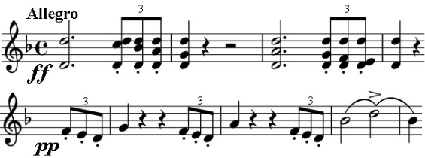

hammered out *fortissimo* triplet figure demands our serious attention, but is immediately transformed into an almost apologetically tender *pianissimo* phrase. After a pause, the tension mounts, driven by the triplets, to a reinforced version of the

opening. This emotional roller-coaster continues throughout the movement. The triplets sometimes give way to the dotted rhythm of a

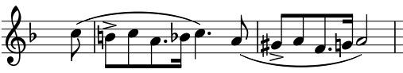

yearning tune that Jack Westrup attributes to Schubert's admiration for Rossini; this theme in turn

gets transformed into more serious matter against running semiquavers. The emotional intensity and tightness of construction of the movement recall the later Beethoven but it was written the year before the first of Beethoven's late quartets. The repeated notes of the opening bars and their rhythm are echoed in the themes of the other three movements.

The theme for the variations of the G minor *Andante* comes from Death's contribution to a short Schubert song of 1817, inviting a terrified

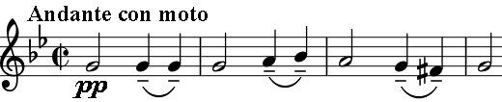

young girl to sleep safely in his arms. The quartet version is altogether lighter: a fourth higher, more transparently scored and *con moto*. Resignation

has replaced the sinister threat of the song. The calm of the first two variations is shattered by the brutal dactyls (–!!) of the third, a more rapid version of the rhythm of the theme; calm returns only to be broken again by the long crescendo of the repeat of the fifth variation to yet more terrifying dactyls. The terror subsides to a serene end and a Schubert hallmark switch to the major.

The fiercely syncopated energy of the *Scherzo* and its tranquil *Trio*, lead to the tarantella-form finale. The tarantella folk-dance hails from Taranto in southern Italy: a courting couple dance encircled by others as the music gets faster and faster. Taranto independently gave its name to the tarantula spider, the effects of whose allegedly serious bite could, it was thought, be ameliorated by wild dancing. Pepys records tales of itinerant fiddlers cashing in on this belief especially during the harvest when bites were more frequent. It is quite possible that Schubert intends the allusion to cheating death, but either way this energetic dance with its *prestissimo* ending provides a rousing climax to the quartet.