Programme Note by Chris Darwin: please use freely for non-commercial purposes

**Maurice Ravel (1875-1937) String Quartet in F (1903)**

*Moderato très doux*

*Assez vif-Très rythmé*

*Très lent*

*Vif et agité*

Ravel’s only string quartet dates from 1902-3 while he was still (aged 28) a student at the Paris Conservatoire. It was dedicated to his teacher Fauré and the first movement was submitted to the annual composition contest at the Conservatoire. The contest’s judges rejected Ravel’s work, and he was expelled for the third and last time. Fauré was more appreciative, though he did not like the last movement: "*stunted, badly balanced, in fact a failure*." Debussy was more prescient: "*In the name of the gods of Music and for my sake personally, do not touch a note of what you have written.*" First performed in 1904, thequartet was not published until 1910 after Ravel had in fact made some changes. Quite what these changes were, we don’t know, since the original score is lost.

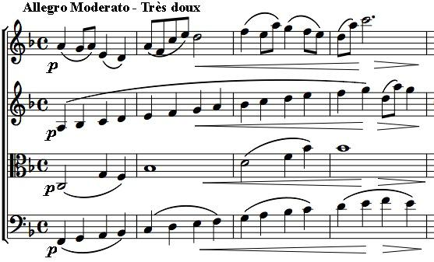

The opening is one of the most memorable in the quartet literature, transporting at least this listener to the balmy warmth of a French summer. The cello and second violin play a simple rising scale an octave and a third apart, while the viola with another rising figure fills out the harmonies to the first violin's simple tune. In the next four bars the three lower parts just go down a scale. But the overall effect? Magic!

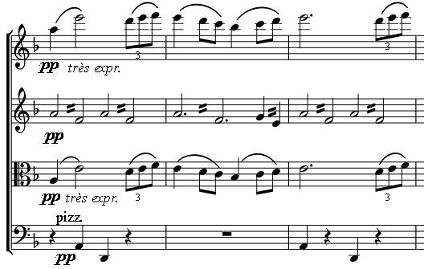

The quartet has great thematic unity, with the two main themes of the first movement returning in various guises in the other three. But the treatment of the material is wonderfully varied – rhythmically, harmonically and in tone-colour. Notice particularly the second theme in the first movement with the first violin and viola two octaves apart (*illustrated*); the exciting pizzicato cross-rhythms of the second movement and the complex 5-beat rhythms of the last.