**Maurice Ravel (1875-1937) Piano Trio in A minor (1914)**

*Modéré (A minor)*

*Pantoum. Assez vite (A minor)*

*Passacaille. Très large (F*♯ *minor)*

*Final. Animé (A major)*

Unlike Lili Boulanger, Maurice Ravel never did win the *Prix de Rome;* and not for want of trying – five attempts between 1900 and 1905. His last attempt (he had reached the age limit of 30) was triaged out because his fugue contained parallel fifths and the last chord contained a major 7th. This Strictly Ballroom-style failure provoked *l'affaire Ravel,* with even his usually hostile critics affronted that such a distinguished composer should be so perfunctorily dismissed. After the press

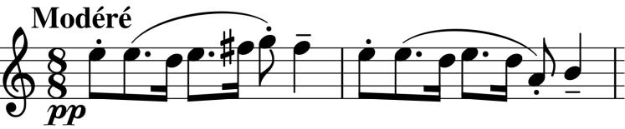

got their teeth into the fact that all the finalists were students of one particular jury member, the director of the Conservatoire resigned and was

replaced by the reforming Fauré (nicknamed Robespierre). Ravel's independent spirit had antagonised the conservative conservatoire – he sought out new musical and literary genres, such as the Gamelan and contemporary Russian music heard at the 1889 Paris exhibition. Around 1902 he joined Les Apaches (The Hooligans), a group of broadminded literary, musical and artistic contemporaries. The group was joined in 1909 by Stravinsky, and Ravel was commissioned by Diaghilev to write *Daphnis et Chloé* for the Ballets Russes. In 1913 Ravel joined Stravinsky at Clarens in Switzerland where they jointly orchestrated a piece by Musorgsky for Diaghilev and Ravel was shown the score of the yet-to-be-performed *The Rite of Spring*.When war broke out in 1914, Ravel was working on his Piano Trio in the French Basque commune of Saint-Jean-de-Luz near to his home town; he completed the work in five weeks before volunteering for military service. He was also working on a piano concerto (*Zazpiak Bat*) based on Basque themes, which was later abandoned, but whose main theme is identical in rhythm (though half speed) to the opening of the Trio (illustrated). The time signature is an unusual 8/8 – eight quavers in a bar, not the more usual 4/4 (four crotchets) since the quavers in each bar are grouped 3+2+3. This rocking rhythm is a dominant feature of the movement. Notice also how the theme moves in single note steps until a downward jump of a fourth near the end. The opening themes of the other three movements are similarly constructed—in the second and fourth movements, the jump is of a fifth.

The second movement is in the form of a Scherzo and Trio but mysteriously titled *Pantoum.* A pantoum is a Malaysia verse form in which two themes are interlocked by thesecond and fourth lines of each four line stanza become the first and third of the next. Debussy had previously set to music a pantoum-structured poem by Baudelaire, but Ravel appears to be doing something more ambitious. According to Brian Newbould the alternating development of two contrasting ideas in this movement follows a pantoum structure: the skittish opening theme, and the smoother rather breathless one that follows it. Combining this construction with a Scherzo and Trio form leads to an extraordinary passage where the strings continue to play in the Scherzo's 3/4 time while the piano introduces a new melody for the Trio in 4/2. The movement poses additional problems for the strings with each of a group of rapidly repeated notes having to be played in a different way including left hand *pizzicato*.

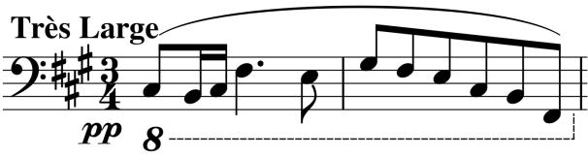

The slow dark *Passacaille* makes a fine contrast to the scherzo's scintillations and its theme (illustrated) is a slowed down version of the Pantoum's opening. The movement is arch-

shaped starting with a single voice, building to a climax and receding back to the solo piano.

The *Final* moves into the major and like the first movement is built on unusual Basque-inspired time signatures - here shifting between 5 and 7 beats in the bar with an occasional 4 or 6 thrown in. The opening texture is unusual and technically demanding for the violinist, who has to play an arpeggio consisting

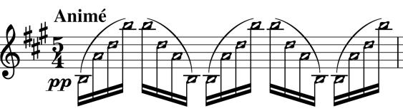

entirely of harmonics (illustrated). The difficulty here is that each of the four fingers has to lightly touch the string in *precisely* the right position or the note completely fails to sound.

After he had finished composing the Trio, Ravel's continuing applications to enlist were rejected on health grounds until finally in March 1916 he was accepted as a driver for the motor transport corps, naming his vehicle *Adélaïde* after his ballet, sub-titled *le langage des fleurs*.