Programme notes by Chris Darwin. Use freely for non-commercial purposes

**Sergei Prokofiev (1891-1953) Quartet No 1 Op 50 (1930)**

*Allegro*

*Andante molto - Vivace*

*Andante*

The only surviving child of an affluent and cultured Ukrainian family, Prokofiev played the piano and composed from an early age - by 10 he was well into his second opera (a sort of Robinson Crusoe tale)! During the following two summers, the young composer Glière taught Sergei at home and continued by correspondence in the winter. Glazunov encouraged the 12-year-old's parents to send him to the St Petersburg Conservatory. He emerged seven years later an accomplished pianist, but his compositions were more influenced by the St Petersburg 'Evenings of Contemporary Music' where his inherent modernist tendencies met a sympathetic reception. The public at the premier of his second piano concerto in 1913 were less sympathetic; many walked out with the prevailing view being: 'To hell with this futuristic music! The cats on the roof make better music!'. Soon after, he travelled to London and met Diaghilev, who commissioned the ballet 'Chout' (The Buffoon). Its subsequent premier in Paris in 1921 was attended both by Stravinsky who called it "the single piece of modern music [he could] listen to with pleasure",and Ravel for whom it was "a work of genius". Meanwhile Prokofiev had left Russia, and after an extended concert tour of the US settled in Paris.

Prokofiev only wrote two string quartets and little other chamber music. In 1924 he wrote a quintet for oboe, clarinet, violin, viola and double bass. It is an arrangement of his ballet, *Trapèze*, commissioned by an itinerant ballet troupe with 5-man band. However today'sfirst string quartet is quite a different creature. It was commissioned by the Elizabeth Sprague Coolidge Foundation for the Washington Library of Congress' collection of manuscripts by famous composers. The work is more classical in style than his recent expressionist operas – a change perhaps partly reflecting his conversion to Christian Science. In preparation, for the first quartet he made an intensive study of Beethoven’s quartets, 'chiefly in railway carriages on my way from one concert to another…'.

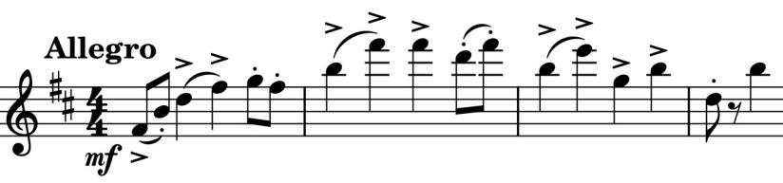

His study of Beethoven certainly gives this first quartet its confident classically contrapuntal craftsmanship, and perhaps those trains inspired the powerful propulsion of its opening (*illustrated*). This drive is soon contrasted with a slower gently restful theme from the viola (*illustrated*). The movement

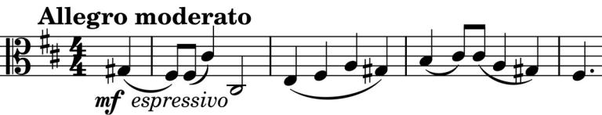

introduces us to more enjoyably contrasting melodies which are developed with wit and charm, and without the hard sardonic edge of some of Prokofiev's earlier work.

The second movement starts as an *Andante molto* which soon reveals itself as but an introduction to a substantial *Vivace* scherzo with a similar rhythmic impetus to the first movement. Its initial impatience on the cello is interrupted with a confidently calming reply from the violin (*illustrated*). The scherzo sandwiches a gentler trio section.

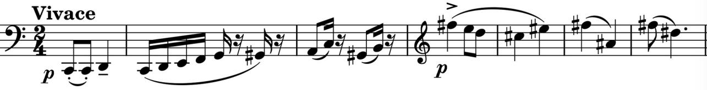

The third movement is the emotional heart of the piece, its opening sigh setting the tone. Some have commented that it reflects how Prokofiev missed his Russian homeland; he returned in 1932. Fellow composer Nikolai Miaskovsky wrote of the quartet: "…The composition is completely free of effects, something quite surprising for Prokofiev… There is true profundity in the sweeping melodic line and intensity of the finale. This movement strikes deep…"