**Programme note by Chris Darwin: Use freely for non-commercial purposes**

**Francis Poulenc (1889–1963) Sonata for Cello and Piano Op. 143 (1943)**

*Allegro - Tempo di marcia: Sans traîner*

*Cavatine. Très calme*

*Finale. Largo, très librement - Presto subito – Largo*

Had Poulenc's father Émile had his way, Francis would have joined the family pharmaceutical firm of Poulenc Frères, which later became Rhône-Poulenc. His father's family did however succeed in imbuing Francis with a deep Catholic faith. Although his father prohibited him from attending the music conservatoire until he had finished a conventional classical education, his mother's eclectic musical taste, able piano playing and family musical soirées stimulated her son's musical talents. He would listen to the soirées from under the grand piano, although it was a formative experience with a nickelodeon in a Paris arcade that convinced him that he wanted to be a composer. He ended up ' *moine ou voyou*' (half monk, half naughty boy / hooligan / rascal) with an underlying taste for 'adorable bad music', as well as a more serious ecclesiastical side.

Following Poulenc's parents' death, Ravel's close friend the pianist Ricardo Viñes was both a spiritual and musical guide and Stravinsky helped him to get his early work published. In the 1920s he became one of 'Les Six' with Milhaud, Honegger, Auric, Durey and Tailleferre – a group of friends with little musically in common.

The satirical, entertaining style of Poulenc's early music acquired a new seriousness after his friend and fellow composer Pierre-Octave Ferroud died in a car crash in 1936. He subsequently made a pilgrimage to Rocamadour - the monk disciplining, though not entirely successfully, the naughty boy. The Cello Sonata of 1943 reflects both 'moine' and 'voyou'.

Poulenc's chamber works for strings are less known than those for wind. Roger Nichols in Grove: *'Poulenc admitted to being unhappy writing for solo strings and had written and destroyed two violin sonatas (1919 and 1924) before the surviving example... (He) consigned a string quartet to the Paris sewers in 1947, rescuing three themes from it for his Sinfonietta.'* He also struggled with the cello sonata. He made the first sketches in1940 and only completed it in 1948, with technical help from cellist Pierre Fournier, its co-dedicatee.

Perhaps as a solution to some of these problems, Poulenc employs a 'compositional tic', in which the two instruments congenially echo each other in short phrases – usually of four bars, each instrument switching between melody and accompaniment. It crops up throughout the work - here is an example from bar 5 of the first movement.

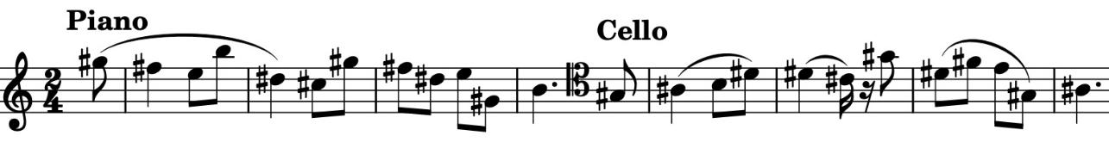

The movement presents us with a playful variety of episodes, perhaps more *voyou* than *moine*, some with taxingly uncellistic accompanying figures, and all with 'Poulenc'snonchalant approach to modulation'.

The *Cavatina* banishes the *voyou* though it does start in the daunting key signature of 6-sharps (*Très calme*). The pianist creates a wash of sound - *mettre beaucoup de pédale (dans un halo sonore)* to accompany the muted cello. After a few bars all six sharps are

jettisoned, along with the mute, and the cello enjoys 12 (*très intense*) bars of nostalgic melody with the piano accompaniment still awash - *très enveloppé de pédale*. Despite the cello occasionally having to accompany the piano's melody with rather pianistic arpeggios, this is a beautiful and effective movement.

Portentous chords interrupted by ghostly harmonics start the *Finale*, but are unceremoniously pushed aside by a rollicking *Presto.* A tender middle section leads back to the *Presto* before three bars of the portentous chords return only to be peremptorily dismissed - just kidding!