**Carl Nielsen (1865-1931) Quintet for Flute, Oboe / Cor Anglais, Clarinet, Horn & Bassoon Op 43 (1922)**

*Allegro ben moderato*

*Menuetto*

*Praeludium: Adagio. Tema con variazioni: Un poco andantino*

Carl Nielsen was the seventh of house painter and amateur musician Niels Jørgensen's 12 children. Why Nielsen rather than Jørgensen? Although the Danish aristocracy had long used hereditary surnames, many ordinary Danes stuck with the old patronymic system until the late 19th century. Carl followed his father in playing the violin and cornet, and composed from the age of 8. But his family did not encourage him to study music, apprenticing him aged 14 to a shopkeeper, who fortunately went broke almost immediately. Carl then became an army bugler and trombonist, and composed some works for brass ensemble. He was introduced to the composer Niels Gade, Professor at the Copenhagen Conservatoire, who took to the young man, and at 19, Nielsen began studying with him. After graduation, Nielsen taught violin and also played violin in the Royal Danish Orchestra.

Although he is now best known for his concertos and his six symphonies, in which brass instruments figure prominently, he also wrote some chamber music, most notably four string quartets and today's wind quintet.

The quintet is a relatively late work and was inspired by a phone call to a pianist friend who happened to be rehearsing the Mozart Sinfonia Concertante with four wind players. The piece was written very much with those overheard individuals in mind; it reveals the personalities both of the instruments and of the players, sometimes alone, more often in conversation or argument. The work is genial and entertaining, often with a Poulenc-like playfulness.

The last movement is the most complex. Like the last movement of Mozart's Sinfonia Concertante, it is a set of variations. They are introduced by a short Prelude in which each instrument makes a cadenza-like statement – the oboe being replaced briefly by the cor anglais. The variations are based

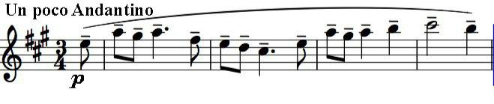

on Nielsen’s own chorale tune 'My Jesus, make my heart to love thee'. He describes them as '... now gay and grotesque, now elegiac and

solemn, ending with the theme itself, simply and gently expressed.' The reprised theme, marked *Andante festivo,* is in the more choraley 4/4 time rather than the opening version's 3/4 - a joyfully serious end to a warm-hearted piece.