**Program Notes by Chris Darwin. Use freely for non-commercial purposes.**

W. A. Mozart (1756-1791) Sinfonia Concertante in A, K.Anh.104 (320 e) (1779?) *Allegro*

A *Sinfonia Concertante* is a concerto for a group of solo players; it is usually lighter than a concerto and almost always in a major key. The form was particularly popular in Paris in the 1770s. Mozart visited Paris in 1778 and is commonly associated with just two Sinfonie Concertanti. The most frequently played, and the only one known to have been completed by Mozart, is K 364 in Eb for violin and viola with orchestra – a magnificent and justly popular work. Almost as well-known is that for oboe, clarinet, horn and bassoon with orchestra, K. 297b; however its only extant manuscript is an arrangement by another hand and scholarly opinion is divided as to its relationship to a lost earlier piece by Mozart for flute, oboe, horn, bassoon, and orchestra. Whatever its provenance the existing piece is deservedly popular and contains wonderful writing for wind. But Mozart wrote other symphonie concertanti. Two survive as fully fledged concertos (one for 2 pianos and another for flute and harp) and two others only survive as fragments including the one performed this evening. It was composed for solo violin, viola and cello with a strings, oboe and horn orchestra. Only its first 130-odd bars survive in Mozart's hand including the sprightly opening theme

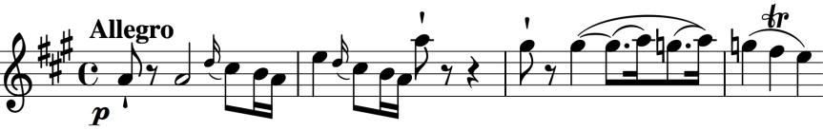

(illustrated). Why he gave up on it is not known, but there is speculation that it might

have been written either for the principals of the Mannheim-Munich orchestra, but aborted when the orchestra disbanded, or for the principals of the Salzburg orchestra, and discontinued when Mozart left Salzburg. Various hands have fashioned completions of the surviving movement fragment, and tonight's version is by Yorkshire composer Philip Wilby who also made the arrangement for piano quartet. The Notos Quartet add an extraordinary cadenza written for the ensemble by British composer David Paul Graham.

As in the well-known Eb Sinfonia Concertante for violin and viola, the viola part of tonight's A major piece is written for *scordatura* ('out-of-tune') viola. Here, the player is asked to tune each of the viola's strings up a whole tone, and then to play the *scordatura* part (which is written a tone lower in G major rather A major) in the normal way. There are two consequences. First, the instrument sounds brighter with the tighter strings and so more easily penetrates the orchestral accompaniment; second, G major is a friendlier key for the viola than A, with more open strings and fewer stretched intervals. In the better-known Eb Sinfonia Concertante Mozart asks for the viola to be tuned up only a semitone, writing

the part in D rather than Eb. Since modern instruments are naturally brighter than their 18th century forbears, the work is now often performed, as it is this evening, without *scordatura* tuning so that the player does not have to adjust to the changed responsiveness of the instrument.