Programme Note by Chris Darwin: please use freely for non-commercial purposes

**Wolfgang Amadeus Mozart (1756-1791)**

**Piano Sonata No 10 in C , K.330 (1784)**

*Allegro moderato*

*Andante cantabile*

*Allegretto*

This sonata is one of a group of four (K.330 – 333) that were originally thought to have been composed in 1778 during Mozart's stay in Paris, but are now known to date between 1781 and 1784 after Mozart had broken with the Archbishop of Salzburg and moved to Vienna. This move, in 1781, was much against the wishes of his father, as was his marriage the following year to Constanza Weber. The liberating effect of these assertive actions may have provided the emotional base for a remarkable outpouring of confident works of mature genius: the six string quartets that he dedicated to Haydn, the *Haffner* Symphony, numerous piano sonatas and concertos and the opera *Die Entführung aus dem Serail.* His fame leapt.

The early 1780s were not only a time of great change in Mozart's personal and musical fortunes, they also saw the arrival of substantially improved *fortepiano* instruments which had been developing in competition with the harpsichord and clavichord over the previous half century. Around 1780, Mozart acquired an instrument built by Anton Walter that had two tone-modifying devices: first, a pair of knee-levers that raised either all the dampers or only those in the treble. The second device was a hand-stop that acted as a mute by placing a thin strip of cloth between the hammers and the strings. This muting is acoustically quite different from *una corda,* the only modern equivalent, where the keyboard is shifted so that each hammer

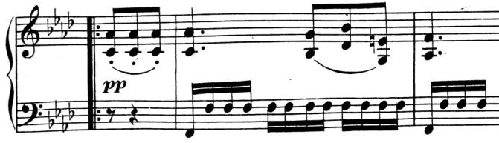

strikes only a single string. The second movement of tonight's sonata K.330 contains an excellent example of the use of this *sourdine* in its *pp* F minor middle section.

The sonata demonstrates an apparently easy mastery of classical form, structurally simple and beguiling innocent. Alfred Einstein describes it as *“…a masterpiece, in which every note belongs—one of the most lovable works Mozart ever wrote.”* However, one of itsmost poignant moments – the last four bars of the second movement – is apparently an afterthought, missing from the original manuscript, but present in the first edition. After sandwiching the F minor section illustrated above between two identical slices in F major Mozart brings the F minor music back in the major as a brief but magic coda.