!

*!"# $ %*  " # $% & !' (! )

*%

*&'* +) ( ,

|  |  |  |  |  |
| --- | --- | --- | --- | --- |
| - (! | | |  | |
| .! ) | | ! #& | | ) # |
|  | | | |  |
| % / ! | | | | |
| / ) | ) *) | | | |
| 0 |  | |  |  |
| ) ! | | | |  |
| ) | | | |  |
| ) | | | |  |
| ! |  | |  |  |
|  | 1 | | | |
| ! | |  | '" | |
| $ *% | | | | & |

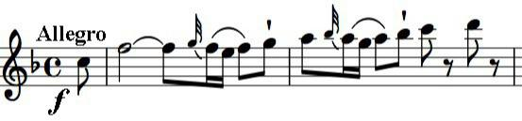

/ 23+&) ! ) ) 23+&) 434 !&2&) ) 40 * ! ) * &) ) * & '