**W.A. Mozart** (1756-1791) *Trio for clarinet, viola & piano in Eb (‘Kegelstatt’), K 498 (1786)*

1. *Andante*
2. *Menuetto*
3. *Rondeaux: Allegretto*

Mozart entered this work into his own list of works as "Ein Terzett für klavier, Clarinett und Viola" with no mention of a skittle alley (Kegelstatt). However, a few days earlier he had noted composing 12 duos for bassett horns (much less complex music) while playing skittles. The skittle-alley provenance was added to the trio by later publishers. The piece was dedicated to a student Franziska Jacquin, from a family with whom Mozart was close friends and was first played in the Jacquins’ house with Anton Stadler on clarinet, Mozart on viola and Franziska on piano. It was one of three pieces inspired by Stadler’s playing of the relatively new clarinet the others being the Clarinet Quintet and Clarinet Concerto. The piece was originally published by Artaria in 1788 with the clarinet part, also given as an alternative, arranged for violin; it is usually performed in its original form.

All three movements, unusually, have similar gentle tempi which bring out the lyrical possibilities of both clarinet and viola. Throughout, the viola and clarinet are equal partners, Mozart perhaps showing that his viola was capable of matching the wonders of Stadler’s new clarinet (or *vice versa*?).

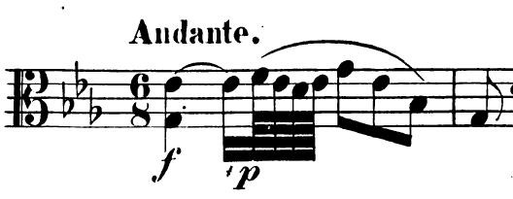

In contrast to the underlying gentle tempo, the opening dotted crotchet has a spectacularly rapid written-out turn which squashes four hemi-demi-semiquavers (64th notes) into its final semiquaver

(16th note). This rapid turn recurs in the expanded theme soon introduced by the clarinet and then keeps popping out at the listener as the theme is developed and tossed between the instruments. A similar contrast occurs in the Trio of the second movement where the viola takes off in energetic triplets in reply to a calmly innocuous enquiry from the clarinet. The structure of the Rondeaux third movement is AB–AC–AD–A. “A” is one of Mozart’s perfectly balanced soaring themes, which is contrasted with other episodes of differing mood and energy. Again the viola gets to show off in triplets.