**Programme Notes by Chris Darwin. Please use freely for non-commercial purposes. W.A.Mozart (1756-1791) String Quartet in D K.575 (1789)**

*Allegretto*

*Andante*

*Menuetto & Trio*

*Allegretto*

On 12 July 1789, from a Vienna whose economy was depressed by the ongoing Austro-Turkish war, a sick and impoverished Mozart wrote a bleak begging letter to his friend, benefactor and fellow Mason Michael Puchberg, asking for yet another loan of 500 gulden. As an indication of his prospects Mozart says that he is 'composing six easy klavier sonatas for Princess Friederike and six quartets for the King [Frederik William II of Prussia]'. In fact only one of the sonatas appeared (K.576 in D, his last), and three 'Prussian' quartets - tonight's in D together with K.589 and 590 completed the following year in 1790.

Mozart had recently returned from a visit to Berlin, undertaken in the hope of soliciting commissions from the king, whom Mozart knew to be an able cellist. Although Mozart was later paid 500 Friedrichsdor for tonight's quartet he received nothing for the other two, so it is unlikely that they were actually commissioned by the king. Indeed there is no evidence that he even met the king on that visit. However the king's renown on the cello very likely had an influence on the form of these quartets, and subsequently on the cello's role in the development of string quartet writing. Another influence was the virtuoso cellist Jean-Pierre Duport, the director of chamber music at the Prussian court, whom Mozart did in fact meet in Berlin. He had brought from Paris substantial improvements in cello technique which Mozart exploited.

These three 'Prussian' quartets, and particularly the first, are quite different from Mozart's seven earlier mature quartets – the six dedicated to Haydn and the subsequent 'Hofmeister'. The cello frequently takes the melodic lead in a high register, giving the bass line to the viola or even the second violin. The writing for all the parts is taxing, but especially so for the cello. The three quartets were actually published (with no dedication) at the end of 1791, a few weeks after Mozart's death. The W*iener Zeitung* described them as 'concertant quartets', a reference to a rather limited style of quartet writing popular in Paris at the time, where each instrument took it in turns to carry the melody. Such turn-taking helps give the king's cello a fair crack of the melodic whip but Mozart's creations far exceed the transient concertant style.

After all that, it might seem perverse that the cello is silent for the first 8 bars, but the *sotto voce,* transparent texture of the genial

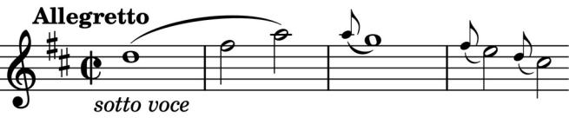

opening theme (*illustrated*) prepares us for the subsequent good-natured conversational

interchanges among equals between pairs of instruments, particularly the first violin and the cello in its high register.

The quartet has apparently acquired the nickname 'The Violet' from the similarity between the theme of the second movement and that of a 1785 setting by Mozart of a Goethe poem 'Das Veilchen' in which a lovesick violet is reconciled to being trodden underfoot by the shepherdess of his dreams. Here is the opening of the Andante (*illustrated*) compared with the Violet theme transposed

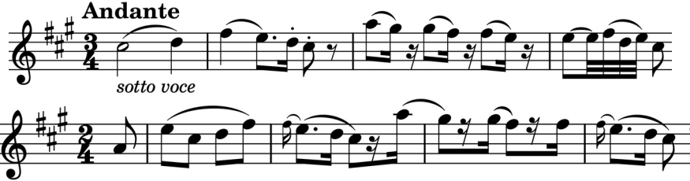

into the same key (*illustrated*). It is a beautiful movement with some wonderful solo episodes from the cello. The cello also

gets to shine throughout the Trio section of the third movement and then leads the way with the opening statement of

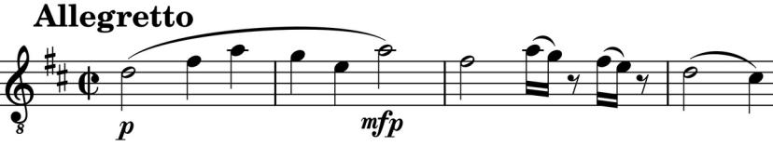

the last movement, whose outgoing theme (*illustrated*) is

closely related to the opening of the first movement.