**Wolfgang Amadeus Mozart (1756-1791) String Quartet in B*b* K.458 ‘The Hunt’ (1784)**

*Allegro vivace assai*

*Menuetto and Trio. Moderato*

*Adagio*

*Allegro assai*

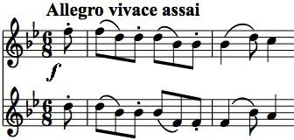

The “Hunt” quartet is one of the set of six quartets that were inspired by Haydn and were dedicated to him. This season the Heath quartet has played the Eb major K.428 from the same set and last season the Chilingirian played the A major K.464 and the Kuss the “Dissonant” K.465. The “Hunt”

nickname for the B*b* quartet was not Mozart's; it just refers to the jaunty opening theme, with the violins moving in parallel thirds and fourths in a Bb arpeggio, reminiscent of hunting horns. A contrasting simple figure with a semiquaver flourish (\*)

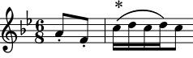

appears first on the 1st violin and then is passed down to the 2nd violin, viola and cello and then back up in turn to the 1st again before turning into the second subject proper. The development generously starts with a

new theme, but then a variant of the semiquaver flourish (\*) becomes the main material for the development. The entertaining exuberance of the whole movement appears effortless, yet for contemporary Vienna, in the words of Carl Ditters von Dittersdorf, these quartets "*because of their overwhelming and unrelenting artfulness are not to everyone's taste*". Fortunately, we are now more likely to marvel at art concealing art.

The short Minuet and its Trio with metronomic accompaniment lead to a very substantial *Adagio*. Its opening figure is hesitant, with

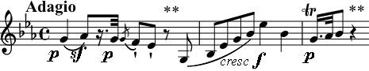

significant silences (\*\*). These silences set up the subsequent flowing song lines from the first violin and the cello against a pulsing accompaniment. One of the magic moments of

the movement comes when the lower parts build up a *piano* pulsing chord and the first violin enters *piano* with the tenderest of motifs. Mozart famously achieved a similar effect in the Eb *Adagio* of the Serenade K.361 for 13 wind instruments when the oboe enters on a high Bb above a pulsing accompaniment. Why are these entries so poignant?

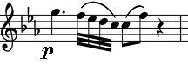

The boisterous mood of the first movement returns with the energetically engaging finale. In Mozart's codas we often get just a glimpse of the fertility of Mozart's imaginative creativity: “Here's a taste of what else I might have done if only I'd had the space”. But in this glorious movement it blossoms.

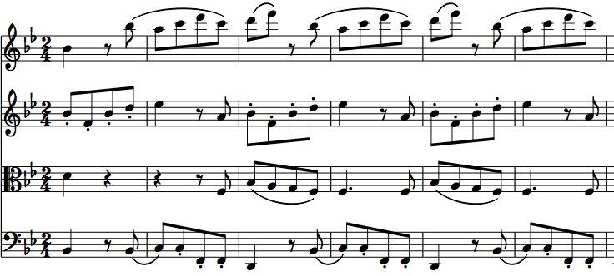

Perhaps the prime attribute that makes classical string quartets so rewarding both to play and to listen to is the independence of the four parts. Haydn pioneered this development, but Mozart brought the full weight of his genius to developing it. David Waterman (of the Endellion Quartet) points to one passage in the last movement where

each instrument represents a different character, just as in, say a vocal quartet from *The Marriage of Figaro* . Indeed Mozart's operatic writing, as well as his quartet writing, wasdeveloping rapidly at this time. He had had great success with *The Abduction from the*

*Seraglio* in 1782 and in 1783-4 was in the process of writing two other operas - *The Deluded Bridegroom, or The Rivalry of Three Women for One Lover* and *The Goose of Cairo*. These were abandoned when da Ponte produced the libretto of *Figaro* which was performed just two years after the Bb quartet in 1786.