*Regina Strinasacchi in*

*1795*

Program Notes by Chris Darwin. Please use freely for non-commercial purposes.

**W.A. Mozart (1756-1791) Sonata for pianoforte and violin in B**♭ **K.454 (1784)**

*Largo - Allegro*

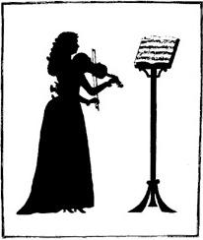

*Andante*

*Allegretto*

*'We now have the famous Strinasacchi from Mantua, a very good violinist. She has a great deal of taste and feeling in her playing. I am this moment composing a sonata which we are going to play together on Thursday at her concert in the theatre.'* [Mozart writing to his father 24 April 1784].

It is said that Mozart only had time to write down the violin part, and performed at the concert in front of Emperor Josef II and a blank sheet of paper. Whether the blank sheet was circus or necessity is not clear. He had certainly done a similar trick out of necessity four years earlier at a performance of his piano and violin sonata in G, K.379, which he had

composed the previous night *'between eleven and twelve... retained my own part in my head'*.

The portentous chords of the work's opening *Largo* warn us that we are in for something out of the ordinary. Composing for a visiting 23-year-old female virtuoso who played with 'taste and feeling' not only brought out the showman in Mozart but also produced an equality of parts that was unusual in sonatas then described as for 'pianoforte with violin accompaniment'. Particularly in the magnificent *Andante* second movement, the two instruments tenderly intertwine with unprecedented ease. However, near the end of the boisterous last movement Mozart cannot resist capping Strinasacchi's flamboyant triplet riff with even faster semiquavers. Droit de compositeur!