**Wolfgang Amadeus Mozart (1756-1791) String Quartet in E flat K.428 (1783)**

*Allegro non troppo*

*Andante con moto*

*Menuetto & Trio*

*Allegro vivace*

The early 1780s were a time of great change for Mozart. He had had a resounding success in Munich with his opera *Idomeneo*, a success which made him resentful of his junior status in the service of the Salzburg Archbishop Colloredo. Mozart forced a break with the Archbishop, allowing a move from Salzburg to Vienna in 1781, to the annoyance of his father Leopold. Mozart was also occupied in the Weber household, transferring his affections to Constanza, from her unobtainable sister Aloysia, and marrying her in August 1782, further souring relations with his father. Eventually, in the summer of 1783, Mozart and his wife made a three-month conciliatory visit to his father in Salzburg, leaving behind their infant son Raimund Leopold, who died shortly afterwards. Despite these emotional upheavals, the musical freedom gained by the move to Vienna allowed Mozart's composing to flourish. His opera *Die Entfüring* and the “Haffner” Symphony rocketed him to fame.

During this period, Mozart was working hard on the set of six quartets that he would dedicate to Haydn. These quartets were directly inspired by Haydn's Op 33, set and were famously, generously praised by Haydn, who in turn then wrote more quartets himself. Although Mozart, unlike Haydn, rarely composed works in remote keys, he was a master of chromatic invention. This E*b* quartet

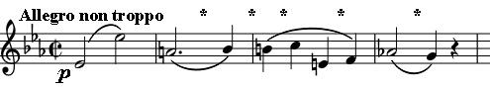

is the most chromatic of the set of “Haydn” quartets. The opening phrase, in unison across the four instruments, starts innocuously with an octave leap

on the tonic Eb, but immediately destroys this tonality with a tritone (“the devil in music”) down to A natural. Five of the next 7 intervals of this opening phrase are semitones (*), so that the first 10 notes have 9 of the 12 notes of the chromatic scale ! The whole movement explores close intervals: for example, the second subject creeps up and down the scale. The initial half

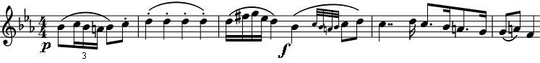

bar of this figure is contrasted in the development with boldly

leaping arpeggios, as if to emphasise its enclosed feel. Mozart brings us to the recapitulation with sadly drooping semitone slides in the first violin.

The cello opens the second movement with a moving figure whose semitone intervals (*) produce wonderful

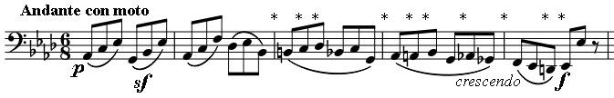

dissonances against a slowly descending scale in the top three instruments. After

such a chromatic opening, what does Mozart have in store for us? The answer is a bar that is often thought to be a misprint ! Shortly after the start of the second half of the movement, the viola and first violin are trading the arpeggios of the cello's opening phrase when the viola has a bar (48) that on first sight seems just wrong. The dissonance is so bizarre, the key so remote (B double-flat), that it must surely be a mistake! Yet provided the movement is played sufficiently “*con moto*”, the suspension becomes understandable (technically it echoes the Eb / A juxtaposition of the work's opening bar), but is still

outrageously ear-catching even of our modern ears; I bet Mozart loved playing that bar in his quartet with Haydn !

The third movement, a Minuet, again contrasts leaps and close intervals. Here the opening leaps are a couple of loud

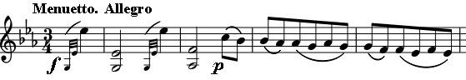

brays on the first violin, contrasted with quiet, closely-knit descending quavers, which are chromaticised

into sliding semitones in the trio. The final Rondo movement is less obviously chromatic, though even here, there are episodes of descending chromatic scales, just to remind us which quartet we are in!