**Programme notes by Chris Darwin. Use freely for non-commercial purposes W.A.Mozart (1756-1791) D minor Fantasie K.397 (1782)**

This powerful and popular work has an unusual mystery around the last 10 of its 100 or so bars. Everyone agrees they were not written by Mozart; but why did Mozart not finish it? And who did? It is generally agreed that those bars were written a few years after Mozart's death by an admirer August Eberhard Müller. But why did Mozart not finish the work himself?

One plausible theory is that he intended it to be the first part of a Prelude and Fugue pairing, similar to the contemporary Prelude (Fantasie) and Fugue in C, K.394. Mozart's interest in fugues had been stimulated by his friend the Baron von Swieten's returning from a visit to Berlin in early 1782 with a large number of scores by Bach and Handel which he lent to Mozart. Mozart's wife Constanze was very taken by Bach's fugues and encouraged Mozart to write some of his own. The C major K.394 Fantasie and Fugue was one result. So perhaps a planned fugal continuation to tonight's D minor Fantasie never actually materialised, leaving it stranded.

Relatively few of Mozart's works are composed in a minor key and within these, D minor is

particularly dramatic – think Don Giovanni and the Piano Concerto No. 22 K. 466. Tonight's

Fantasie packs seven dramatically different

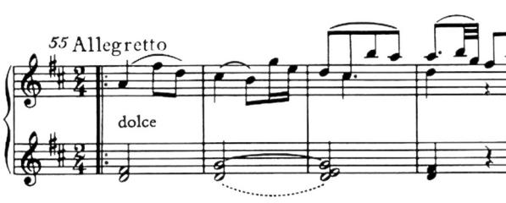

tempo sections into its 5 or so minutes: *Andante*

*– Adagio – Presto – Tempo primo – Presto – Tempo primo – Allegretto.* The guileless *Allegretto* theme in D major (*illustrated*) sees off the anxieties of the preceding episodes.