**Programme notes by Chris Darwin, use freely for non-profit activities**

**W.A. Mozart (1756-1791) Serenade No. 12 in C Minor, K. 388 (1782)**

*Allegro*

*Andante*

*Menuet & Trio*

*Allegro*

This Serenade was written during the boom years of 'Harmoniemusik' – music written for a court (or, less sophisticatedly, a military or street) wind band, generally as background music to dining or other socialising. An operatic example of Harmoniemusik comes during dinner in *Don Giovanni* when a Harmonie plays an arrangement of an aria from *Figaro*. Such aristocratic bands arose in the mid-18th century, and declined in the austerity years of the Napoleonic wars. The Harmonie's instruments came in pairs: at the core a pair of horns, underpinned by bassoons and overlaid by some combination of flutes, oboes, clarinets, basset horns, and cors anglais. There were usually 6 or 8 of these paired players along with an optional deep bass provided by a trombone, double bassoon, shawm or string bass.

Mozart wrote two early (1773) Divertimenti for a 10-piece Harmonie in Milan followed by five more in Salzburg for the more usual sextet (two each of oboe, bassoon, horn) - all light and witty, undemanding of the listener. Today's C minor Serenade was one of three much more substantial Harmonie Serenades, including the Gran Partita, written in 1781-2. It is scored for two each of oboes, clarinets in Bb, horns in Eb, and bassoons. Five years later, Mozart transcribed the work for two-viola string quintet retaining the key of C minor (K. 406). The wind Serenade's dark mood and technical sophistication raise the possibility that it was intended for a more discerning audience than the usual "Night music Serenade".

As befits a work in C minor, this Serenade is full of dramatic contrast, bearing out Alfred

Einstein's observation: *'If G minor is the fatalistic key for Mozart, then C minor is the*

*dramatic one, the key of contrasts*

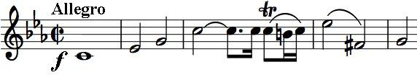

*between aggressive unisons and lyric*

*passages. The lyric quality is always*

*overtaken by gloomy outbursts.'* The

opening is just such an aggressive unison.

The second movement banishes aggression with 'the moonlit tones of an operatic love scene'. But the Minuet returns to a harsher intensity; it is simple enough, a strict canon with the two voices playing the

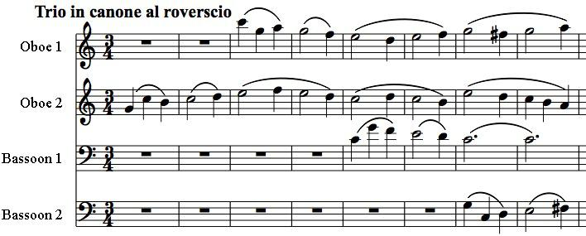

same music a bar apart. The milder Trio now plays a musical game of mind-boggling complexity. An oboe starts a theme; the other enters two bars later with the same theme turned upside down. Two bars later a bassoon enters with a slightly altered version of the original

theme, and a further two bars later the other bassoon enters with its upside-down version. All this wizardry is done with the lightest touch – most enjoy it oblivious to its technical brilliance. See if you can hear what happens in the second half of the Trio!

The Serenade ends with a set of variations on a theme announced by the oboe. The variations are notable for the variety of their textures and not least for the athleticism required of the bassoons; at the end the C minor clouds clear for a joyously major ending.