**!**

|  |  |  |  |  |  |  |  |  |
| --- | --- | --- | --- | --- | --- | --- | --- | --- |
|  | | | | | | ! | |  |
| "# # $# | | | | | |  | | |
| % & | | | | | | | | |
|  |  | | |  | | | |  |
| ' () | | | | # | | |  | |
| * | | | | | | | |  |
| # + ## | | | | | | | | |
| # # | | | | | ,) | | |  |
| + ## | | | | | | | | |
|  | |  |  |  |  |  |  |  |
| -. "(//0$+ (1- | | | | | | | |  |
| +'. & | | | " ##$ | | | | |  |
| # | | |  | #+# " | | | | |
|  | $ ' | | | | | | |  |
| (/)(23 #40/5#-. # | | | | | | | |  |
| # | |  | | +* | *!"* | | | |
| *#$%&* | | 6 78 | | | | *!* | | |
| *!&!"'* | | | | *!(* | |  |  |  |
| -. - | | | | | | | | |
|  | 7 4 + | | | | | | | |
| - -. + | |  | | | 9 | | | |
| : : -# | | | | | | | |  |
| ; - | | | | | | | |  |
| < % ' # | | | = | | | |  |  |
| ' + '(/)> | | | | | | |  |  |
| < ? | | | | | *"!* | | | |
| *" %")!# (* | | |  |  |  |  |  |  |
|  |  |  |  |  |  |  |  |  |

; (0 *2# @# @ ##9#@ # ! .. + -. & +

+  *(* " $

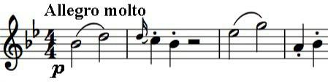

*\**  "9$ 9A%B (#-. +

? C # + # &

# ' #

++ 9 + *$*  ()01#

''-. # # 9

'#'

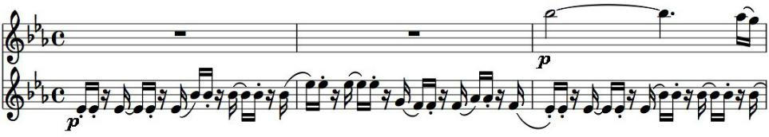

+

@

;.& +

% %-. &

#&# *(* + # &

|  |  |  |  |  |  |
| --- | --- | --- | --- | --- | --- |
| *(* # | | = # -. | | | |
|  | * ++ C | | | | |
| C @ | | | | |  |
| + | *(*& | | | | |
| ;+& | | | | |  |
| + # -. 9 = | | | | | |
| 4(/(D -. | | |  |  |  |
| # | | |  |  |  |
| + + | | |  |  |  |
| + | ' | | |  |  |
| >/" *+* | | |  |  |  |
| - | $-. + | |  |  |  |
| " $ | | |  |  |  |
| + + | | |  |  |  |
| + # | | # | | -. + |  |
| # ' 4(E | | | |  |  |

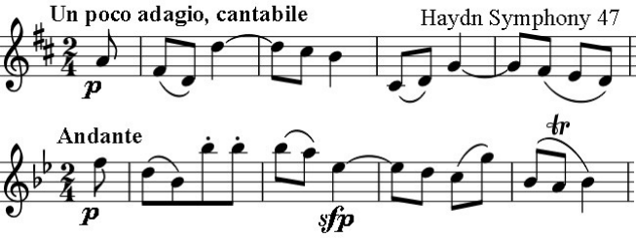

*+* (/)> %' *  *!&)!# ) ,& &- ) ,(*



" + $# 21 51# < #FF;:+