**Programme notes by Chris Darwin. Use freely for non-commercial purposes**

**Wolfgang Amadeus Mozart (1756-1791) Clarinet Quintet in A, K581 (1789)**

*Allegro*

*Larghetto*

*Menuetto – Trio 1 – Trio 2*

*Allegretto con variazioni*

The Clarinet Quintet is one of three pieces that Mozart wrote for his friend Anton Stadler – the other two being the Kegelstatt Trio and the Clarinet Concerto. He was a fellow Freemason and a close friend, although it is said that Mozart was swindled by him. Their nicknames for each other, dreamt up on a long stage-coach journey to Prague, were *Natschibinitschibi* (Stadler) and *Punkitititi* (Mozart). Stadler usually played second clarinetto his younger brother Johann in the Vienna Court Orchestra, perhaps because he preferred the lower registers of the instrument. Around 1788, he collaborated with the clarinet maker Theodor Lotz to extend its range down a major third to the C below middle

1. The resulting extended instrument is now known as a Basset Clarinet (not Basset Horn) but we know little about its original appearance. Mozart wrote both his Clarinet Concerto and this “Stadler's Quintet” for the new Basset Clarinet in A, but both autographs are lost. The quintet was first published by Johann André in 1802 with changes to fit the range of the more common clarinet in A, so it is not clear exactly what Mozart wrote.

The quintet dates from 1789, two years before Mozart's death, and is contemporary with *Cosi fan tutte* and the first two of the “Prussian” string quartets (K.575 & 589). In style, itbelongs more with earlier works of the 1780s than with the more economic, austere and contrapuntal style of his later works. The quintet is deservedly one of Mozart's best-loved works and shows his extraordinary ability to exploit the varied sides of the newly-created instrument's character: by turns lyrical, sombre, jaunty, threatening. The strings have a generous share in the glories of the piece, introducing both main themes in the first movement and having the whole of the first of two Trios to themselves. The viola in particular matches the clarinet for poignant lyricism in the third of the last movement's variations; perhaps *Punkitititi* was showing *Natschibinitschibi* that his viola was a match for the new-fangled Basset Clarinet. Mozart himself played viola to Stadler's clarinet in the first performance on December 22, 1789. What a pity that time travel is still so tricky.

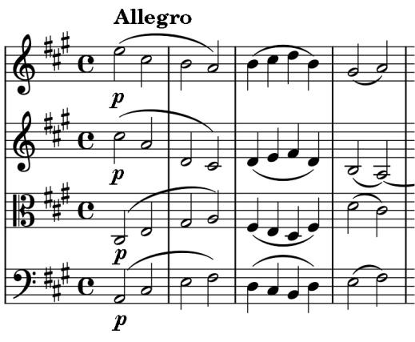

The work's opening (*illustrated* ) immediately creates a world of calm serenity. Mozart achieves this by the simplest of means - descending arpeggios in the violins, ascending in the viola and cello. These are bars for my desert island. Their magic may perhaps have inspired Ravel at the start of his own string quartet, which carries us into a similar world using very similar means. The clarinet is clearly taken by the strings' opening and makes an encouraging two-bar comment which turns the rising arpeggio into quavers and the descending one into semi-quavers, thus providing more of the raw material for this wonderful movement.

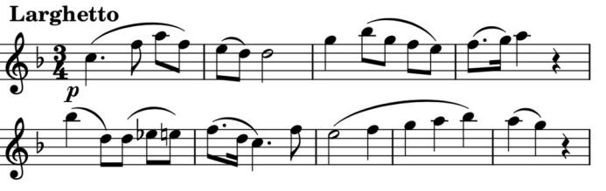

The clarinet opens the *Larghetto* over muted

strings with a most poignant melody

(*illustrated*). Its emotional effect is intensified

by an apparently simple trick. Mozart extends

the normal 8 bars to 9, by making the note lengths in the last 3 bars double what you or I might have written. Time seems to slow even further as the violin and clarinet in turn use light, rapidly-ascending scales to decorate the other's exquisitely slow melody.

Then mutes are off for a boisterous *Menuetto* forming a triple-decker sandwich with two contrasting *Trios -* the first in the minor without the clarinet, the second back in the major now led by an arpeggio-popping clarinet.

A jaunty, traditionally 8x2-bar theme provides material for four contrasting variations, the third of which stars *Punkitititi's* viola in a plangent minor outpouring. The clarinet then plugs us back into the major with virtuoso arpeggios, the pace quickens and the viola (with the second violin) has the last word.