**Felix Mendelssohn (1809-1847) Piano Trio No. 2 in C minor Op. 66 (1845)**

*Allegro energico e fuoco*

*Andante espressivo*

*Scherzo: Molto allegro quasi presto*

*Finale: Allegro appassionato*

Mendelssohn's second piano trio was written just two years before his death in a rare quiet period between times when he was recklessly busy. Since 1835 he had been conductor and then also musical director of the Leipzig Gewandhaus; then, in 1841 he accepted King Frederick William IV of Prussia's invitation to be his *Kapellmeister*, a post which included composing royal commissions as well as the usual producing and conducting obligations. He continued to juggle these two appointments, as well as travelling to London to conduct his work and to entertain Queen Victoria and Prince Albert with, for example, improvisations on '*Rule, Britannia!* '. In 1843 he opened the Leipzig Conservatoire where he taught composition, singing and instrumental performance, along with Ferdinand David (violin) and Robert Schumann (piano and score reading). In September 1844, shortly after finishing the long-gestated Violin Concerto, he asked the king to be released from his service, a request that the king partly acceded to, retaining Mendelssohn to compose special commissions. In the summer of 1845, after turning down an invitation to conduct in New York, and also having taken sabbatical leave from his Leipzig conducting, he had time to enjoy family life in Frankfurt where he composed a variety of choral and instrumental music including today's piano trio. The trio is dedicated to the violinist and composer Louis Spohr who later visited Mendelssohn in Leipzig. The only chamber work that Mendelssohn wrote after this trio was the anguished string quartet lamenting the death of his sister Fanny. Mendelssohn himself died just six months later.

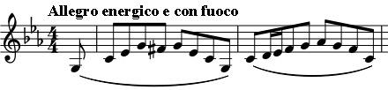

The restless first movement opens *pianissimo* with a surging arch-shaped figure in the piano, soon followed by a slower but similarly shaped theme in

the violin and cello against rippling semiquavers in the piano; this theme mutates into the second theme proper introduced fortissimo in the

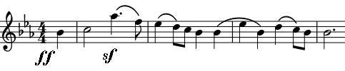

major by violin and cello against forceful semiquavers in the piano. The movement follows traditional sonata form; as this material is

developed, the piano barely pausies in its headlong accompanying quavers and semiquavers. The *Andante* pulses gently in E*b* major with the charm of one of Mendelssohn's “Songs without Words”. The *Scherzo,* as so often with Mendelssohn, effectively evokes again the fairy world that he precociously revealed, aged 17, in his “*A Midsummer Night's Dream*” overture. The fairies are

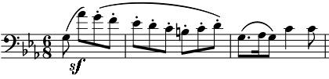

banished at the start of the *Finale*, as the cello leaps an unusual 9th and then chuckles down the scale. This figure also forms the unlikely asides from the

strings to the piano's introduction of a contrasting chorale theme ("*Before Your Throne*" from the Geneva Psalter of 1551). The chorale becomes grander, and the asides less chuckley as the movement ends in style.