**Programme notes by Chris Darwin. Use freely for non-commercial purposes**

**Felix Mendelssohn (1809-1847) String Quartet in F minor, Op 80 (1847)**

*Allegro vivace assai*

*Allegro assai*

*Adagio*

*Finale: Allegro molto*

Felix Mendelssohn was born into an intellectual and affluent household: his grandfather Moses was the pre-eminent Jewish philosopher of the Enlightenment, and both his father and his mother’s family were bankers. Felix and his sister Fanny were outstandingly precocious and were driven hard by their parents.

Mendelssohn’s string quartets fall into four groups: an early (even for Mendelssohn) quartet from 1823; the Op 12 & 13 quartets written in 1829 & 1827 respectively; the three Op 44 quartets from 1837-8, and finally today's F minor quartet: a personal outpouring of grief written in 1847 in response to Fanny’s unexpected death, and only a few months before his own.

On the 12th May 1847 Mendelssohn returned to Leipzig, exhausted from conducting six performances of *Elijah* in England. Just two days later, he learned that Fanny had died suddenly and unexpectedly of a stroke during a rehearsal of one of his works. He was devastated. Two weeks later he went on a recuperative trip to Thun and Interlaken where he appeared severely aged and walking with a stoop, seeking solace in painting. Back in Leipzig in October he played the F minor quartet to his friend, the pianist Ignaz Moscheles, who wrote *"The passionate nature of the entire piece seems to me to be consistent with his deeply disturbed frame of mind. He is still grappling with grief at the loss of his sister."* A month later Mendelssohn himself was dead after a series of strokes.

Three of the movements are marked very fast; only the slow third movement escapes the agitated anger of Mendelssohn's hopeless grief. The agitation is there from the start of the piece: surging semiquavers

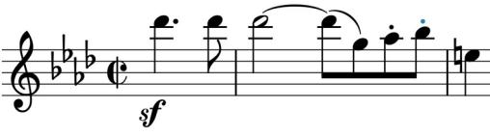

leading to a cry of anguish (*illustrated*). More unsettled quavers and triplets reach a climax from which emerges a tender reminiscence (*illustrated*) which lulls us to a rest. But this is immediately shattered by the returning

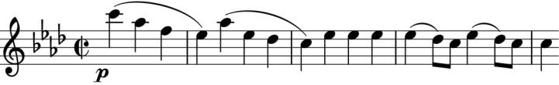

opening semiquavers. They lead to a questioning passage as the first violin looks for a key that would explain

things. To no avail of course. The movement ends with a *Presto* outburst of unremitting anguish.

After all that we crave respite, but Mendelssohn cannot relent. The second movement is a Scherzo in form but not in name and certainly, like the corresponding movement in Beethoven's F minor quartet, is no joke - a life-time away from the light trippings of Mendelssohn's youth. *Forte*, very fast, its demons torment us, stabbing. The *Trio* is darkly, nervously threatening as we know the demons will soon return. Finally, they fade away, leaving us exhausted. Only now can we recollect in tranquillity.

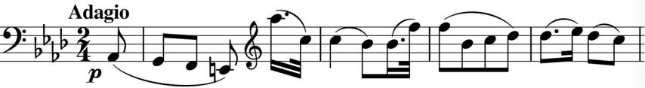

The cello opens the *Adagio* with a calm descent and the violin sighs poignantly

(illustrated) with the gentlest of transformations of the original cry of anguish. Deep, tender affection permeate this wonderful movement. But the equilibrium does not hold, and the *Allegro molto* last movement throws us back into a 'disturbed mind'. The demonic stabs ofthe second movement return as quivering bursts of semi -quavers. The first violin flies off in relentlessly thrashing, uninhibited triplets, soaring to a high C. The work ends with no hint of reconciliation.